**CHAPTER 2**

**Effects of climate and temporal trends in forest songbird communities and abundance**

**along latitudinal and elevational gradients in the Appalachian Mountains**

**Introduction**

Wildlife populations naturally fluctuate over time from local to regional scales. However, consistent and widespread declines over long time periods are likely connected to specific environmental or anthropogenic drivers, as may be the case for bird species breeding in the forests of eastern North America. Prevailing evidence suggests that forest songbird populations have been decreasing in abundance during the past century. Past qualitative investigations note that numbers of certain breeding songbirds in eastern deciduous forests declined from the mid-1930s to the 1970s (Temple and Temple 1976, Ambuel and Temple 1982). More contemporary quantitative studies using annual, nationwide breeding bird surveys indicate that numerous bird species, many of which breed in forests (Robbins et al. 1989), have experienced decreases in their populations throughout the eastern United States from 1966 to 2011 (Sauer et al. 2013). In that time period, at least 25 eastern forest obligate bird species declined by 24% (Sauer et al. 2013). Most recently, data from multiple and independent monitoring networks demonstrate bird population losses across much of North America since 1970, including a negative change within the range of -15.6% to -19.2% in birds breeding in eastern forests, with 63.5% of those species in decline (Rosenberg et al. 2019).

In addition to multiple other factors, global climate change may contribute to declining populations of forest songbirds in eastern North America (Stephens et al. 2016, Rosenberg et al. 2019). Rising temperatures associated with climate change can negatively impact birds through direct and indirect interactions (Trautmann 2018). Warmer temperatures directly affect behavior (e.g., activity levels), thermoregulation, and incubation (Robbins 1981, Crick 2004), and temperature variability can affect energy expenditure, with consequences for reproductive output (Pendlebury et al. 2004). Temperature can also interact with landscape factors to lower songbird reproductive success (Cox et al. 2013*a*), and increasing temperatures may elevate rates of nest predation (Cox et al. 2013*b*). Furthermore, there is strong evidence that rising temperatures cause phenological mismatches between birds and vegetation budding dates and emergence of or peaks in their insect prey (Visser et al. 2006, Waite and Strickland 2006). In North America, the interval between spring green-up and arrival of migratory passerine species has increased, with certain species unable to keep pace (Mayor et al. 2017). These phenological changes can have fitness consequences; species populations may begin to decline if they fail to advance their egg-laying dates in response to increasing spring temperatures over time (Pearce-Higgins et al. 2015, Franks et al. 2018, Koleček et al. 2020). Changing precipitation patterns associated with climate change may also have direct and indirect negative effects on bird populations. Precipitation directly affects thermoregulation (Leech and Crick 2007), nest site selection (Martin 2001), and nest success and juvenile survival (Sherry et al. 2015). In the northeastern United States, precipitation was determined to influence bird species abundance (Duclos et al. 2019). Previous studies have also found lagged correlations between bird population trends and precipitation from the prior year (Pearce-Higgins et al. 2015). Overall, climate change appears to play a role in declining forest songbird populations in eastern North America through synergistic effects of changing temperatures and precipitation patterns.

However, climate change is unlikely to affect all forest songbird species unilaterally. Negative impacts from warming temperatures may be most pronounced for cold-associated species (i.e., those that breed primarily in regions with colder temperatures, such as northern latitudes or high elevations), whereas climate generalist species (i.e., those that breed in regions with wide-ranging temperatures, without a strong association with particular latitudes or certain elevations) and warm-associated species (i.e., those that breed primarily in regions with warmer temperatures, such as southern latitudes or low elevations) may have a neutral or positive relationship with temperatures. For instance, studies often indicate that cold-associated species that occur at high elevations are particularly vulnerable to climate change (Siegel et al. 2014). As little as 1° C warming in the future could reduce more than half of the currently suitable habitat for high-elevation bird species in the northeastern United States (Rodenhouse et al. 2008). Meanwhile, the distribution of warm-associated, low-elevation species in that region is expanding (DeLuca and King 2017). In sum, climate change is expected to result in changes in the numbers of cold-associated species vs. climate generalist species vs. warm-associated species (i.e., climate-related guild richness) (Rodenhouse et al. 2008, Stralberg et al. 2009), with climate specialists and cold-associated species likely to be more negatively affected by higher temperatures than climate generalists or warm-associated species (Pearce-Higgins et al. 2015).

Although it may be possible to broadly predict the effects of rising temperatures on forest songbird species based on their climate guild, there is less certainty concerning the additional effects of precipitation, particularly across latitudinal and elevational gradients. The importance of considering latitude and elevation in combination with climate change has been highlighted by multiple studies that track shifts in bird species distributions over time. Previous evidence suggests that species distributions are shifting northward in response to climate change (Thomas and Lennon 1999, Hitch and Leberg 2007, La Sorte and Thompson III 2007), and simultaneous latitudinal and elevational shifts have been documented and projected for the future (Pounds et al. 1999, Rodenhouse et al. 2008). For instance, populations of cold-associated, high-elevation species are likely to decline and warm-associated, low-elevation species may begin to expand into higher elevations in response to increasing temperatures (Forero-Medina et al. 2011, Tingley et al. 2012). However, elevational shifts are not always upward; along elevational gradients, climate change has caused heterogeneous range shifts, as rising temperature pushes species upslope while increased precipitation pulls them downslope (Tingley et al. 2012). A common assumption in these studies is that relationships with temperature and precipitation are static across latitudinal and elevational gradients. However, to accurately predict how climate change will affect forest songbirds in the future and to better inform conservation efforts, it is imperative to verify whether the influence of changing temperatures and precipitation amounts is mediated by latitude and elevation.

Looking forward, there is a critical need to address this research question, as climate change is affecting and will continue to affect the forest songbirds of eastern North America. Over the last several decades, this region has become warmer and wetter (Hayhoe et al. 2007, Huntington et al. 2009), though there is spatial variation in precipitation patterns. These trends of increasing temperatures and precipitation amounts are projected to continue in the future (Trenberth 2011, Rogers et al. 2016, Fernandez and Zegre 2019). To understand the role that temperature and precipitation have played in the ongoing declines in forest songbird populations in eastern North America and to predict the effects of future climate change, we need to study historic temporal changes in abundance of individual species and in diversity of avian communities (Magurran et al. 2010, Rittenhouse et al. 2010) across both latitudinal and elevational gradients, such as provided by the Appalachian Mountains.

The Appalachian Mountains, which first formed ~480 million years ago during the Ordovician Period, are a dominant land feature of the eastern United States. They contain a range of elevations and primarily forested habitats, from temperate deciduous forests at lower latitudes/elevations to boreal coniferous forests at higher latitudes/elevations. The biota in this extensive region reflects that habitat diversity, with forest songbird communities comprising species from a plethora of families. With their elevational variability and latitudinal range, the Appalachian Mountains provide a twofold gradient over which to study avian communities and allow for the opportunity to simultaneously study multiple climate-related guilds. Within the Appalachian Mountains, there are cold-associated species that can be divided into 2 sub-categories: northern species which occur only in the northern and central latitudinal gradient of the mountain range (hereafter, Northern and Central Appalachians) and trailing species with core populations in the northern latitudes and trailing-edge populations at higher elevations in the central and southern latitudes (i.e., Central and Southern Appalachians). Warm-associated species in the Appalachian Mountains comprise southern species which occur only in the Central and Southern Appalachians, and climate generalist species can be found throughout the entire mountain range.

**Purpose, objectives, and hypotheses**

The purpose of this collaborative study was to quantify how forest songbird communities are affected by climate factors and to explore additional temporal trends across latitudinal and elevational gradients within the Appalachian Mountains. My specific objectives were to apply interactions with latitude and elevation in quantifying and comparing how temperature, precipitation, and other temporal factors influence climate-related guild richness and the abundance of specific focal species during the breeding season. To better capture the potential effects of climate factors and limit habitat variability, I focused exclusively on sampling sites located in mature, primarily deciduous or mixed forests that had not been harvested in >60 years.

In this study, I tested the hypothesis that systematic changes in the structure of forest songbird communities during the breeding season are associated with changes in both temperature and precipitation, but those relationships are mediated by latitude and elevation. I predicted that relationships with climate factors and long-term temporal trends would vary by guild designation, latitude, and elevation. Alternatively, forest songbird community changes may not be associated with changes in either temperature or precipitation, or there may not be a significant interaction with either latitude or elevation. To holistically compare these competing hypotheses, I focused on overall species richness, 4 guild designations, and 16 focal forest songbird species (Table 1) and assessed statistical significance and effect sizes of linear relationships, two-way interactions with latitude and elevation, and three-way interactions between latitude and elevation.

**METHODS**

**Study area**

Sampling sites for this study were located throughout 3 study regions within the northern, central, and southern Appalachian Mountains (Figure 1). I used data from a total of 1733 sampling sites (Figure 2), consisting of 373 sampling sites in the Hubbard Brook Experimental Forest (HBEF) in the White Mountains of New Hampshire (~43.9° latitude), 1149 sampling sites in the Monongahela National Forest (MNF) in the Allegheny Mountains of West Virginia (~38.5° latitude), and 211 sampling sites in the Pisgah and Nantahala National Forests (PNF / NNF; collectively referred to as NCNF hereafter) in the Blue Ridge Mountains of North Carolina (~35.2° latitude). All sampling sites used in this study were located in forest stands that had not been harvested in >60 years at the time of sampling, and distances between sampling sites were at least 200 m.

HBEF is located in north-central New Hampshire and was the source of data for the Northern Appalachians study region. The experimental forest was established in 1955 by the U.S. Forest Service and consists of a 3,160-ha bowl-shaped valley within the White Mountains National Forest. HBEF lies in the New England physiographic province, specifically the Northern Appalachian and Atlantic Maritime Highlands ecoregion, and is characterized by sloping and steep terrain, ranging from 222–1015 m in elevation. The majority of HBEF consists of second-growth, uneven-aged, and unmanaged northern hardwoods that grade into boreal forests at higher elevations (Holmes 2011). The forest has remained uncut since the early 1900s, but periodic severe weather events, such as ice storms, contribute to heterogeneity in vegetation structure. Average annual precipitation is ~140 cm, of which 25–33% is snow. Vegetation consists primarily of sugar maple (*Acer saccharum*), American beech (*Fagus grandifolia*), and yellow birch (*Betula alleghaniensis*), with white ash (*Fraxinus americana*) on lower and middle slopes and eastern hemlock (*Tsuga canadensis*) near stream drainages. At high elevations, red spruce (*Picea rubens*), balsam fir (*Abies balsamea*), and white birch (*Betula papyrifera* var. *cordifolia*) are common. The understory generally contains seedlings and saplings of the major tree species, as well as hobblebush (*Viburnum alnifolium*), striped (*Acer pensylvanicum*) and mountain maple (*A. spicatum*), and various ferns and forbs (Holmes 2011).

MNF is located in east-central West Virginia and was the source of data for the Central Appalachians study region. The national forest was established in 1920 and encompasses 371,906 ha of public, federally owned land. It stretches across a latitudinal range of nearly 200 km and lies within 2 ecoregions / physiographic provinces, the Central Appalachians (Allegheny Mountains) and the Ridge and Valley. The eastern section, which overlaps the Ridge and Valley physiographic province, lies in the rain shadow of the Allegheny Mountains, so it receives significantly less precipitation (~75 cm per year) compared to the rest of the forest, which experiences 115–150 cm per year. Elevation ranges from 275–1480 m. MNF is comprised primarily of 70–100 year-old stands with high regional tree diversity and 4 major forest zones (mixed mesophytic, northern hardwoods, red spruce, and dry oaks). Mixed mesophytic forests are present at low elevations (<900 m), with northern red oak (*Quercus rubra*), hickory (*Carya* spp.), and yellow-poplar (*Liriodendron tulipifera*) as the dominant species. Northern hardwoods, including sugar maple, American beech, and black cherry (*Prunus serotina*), dominate mid-elevations. At the highest elevations (>1150 m), remnant boreal forest ecosystems consist of red spruce. Dry oaks are common in the Ridge and Valley area, consisting of white (*Quercus alba*), chestnut (*Q. prinus*), scarlet (*Q. coccinea*), and black (*Q. velutina*) oaks, as well as pines (*Pinus* spp).

PNF and NNF are located in western North Carolina and were the sources of data for the Southern Appalachians study region. PNF was established in 1911 and comprises >20,200 ha of primarily hardwood forest, whereas NNF was established in 1920 and covers ~214,950 ha in area. Both national forests have elevations ranging 360–1770 m and lie within the Blue Ridge ecoregion and physiographic province, with a mean annual precipitation of 152 cm. Vegetation in PNF and NNF consists of mature (i.e., >75 years since last logging) southern Appalachian hardwood forest dominated by oaks and other hardwood species, including yellow birch, black birch (*Betula lenta*), sugar maple, and American beech.

**Guild designations**

To assess climate relationships and temporal trends for overall species richness and guild richness, I used a specific subset of forest songbird species. Although a total of 153 bird species were detected across all surveys in all years from all 3 study regions, I limited the richness analyses to 40 species (see Appendix A for full list) in Order Passeriformes that were mature forest obligates with breeding ranges that overlapped at least 1 of the 3 study regions. I enacted these species restrictions for several reasons: (1) the bird count data were from avian point count surveys, which are primarily designed to detect passerines (i.e., songbirds); (2) this study focused on breeding birds rather than migrants; and (3) by concentrating on bird species with similar breeding habitat requirements or preferences, I sought to minimize differences in species responses due to forest habitat change, since the primary variables of interest were climate factors.

Climate-related guild designations for the 40 forest songbird species were assigned based on their ranges within the Appalachian Mountains and comprised 4 mutually exclusive categories (Appendix A): north, south, trailing, and general. Species in the north guild were only found in the Northern or Central Appalachians study regions, whereas species in the south guild were only found in the Southern or Central Appalachians study regions. Species in the trailing guild could be found in all 3 study regions in the Appalachian Mountains but had trailing-edge populations that were limited to higher elevations in the Central or Southern Appalachians study regions. In contrast, species in the general guild were found throughout all 3 study regions in the Appalachian Mountains.

**Focal species**

To assess climate relationships and temporal trends for focal species belonging to each guild designation, I selected 16 forest songbird species commonly found within the Appalachian Mountains (Table 1). In addition to limiting the focal species by taxonomic order, breeding range, and primary breeding habitat as described above for the richness analyses, I considered only long-distance migrants to keep migration status consistent and selected at least 3 relatively abundant (i.e., >250 detections; Appendix A) species from the 3 taxonomic families (Parulidae, Turdidae, and Tyrannidae) with the most species meeting all the criteria. These selection decisions were made to ensure that models would run efficiently and to compare any potential differences between the 4 guilds within taxonomic families.

**Bird count data**

Historical avian point count survey data were collected at each of the 3 study regions from 1999–2002 and 2005–2019 at 373 HBEF sampling sites, from 1993–2013 and 2017–2020 at 1149 MNF sampling sites, and from 1997–2018 and 2020 at 211 NCNF sampling sites. Avian point count surveys were not collected every year at all sampling sites. The number of years of data associated with each sampling site ranged 1–19 years (mean = 17.5 ± 1.6 years) in HBEF, 1–17 years (mean = 4.6 ± 3.9 years) in MNF, and 8–23 years (mean = 17.6 ± 3.3 years) in NCNF. Within a year that avian point count survey data were collected, the number of replicate surveys ranged 1–5 replicates (mean = 3.0 ± 0.8 replicates) in HBEF and 1–4 replicates (mean = 1.2 ± 0.4 replicates) in MNF; in NCNF, only 1 avian point count survey was completed per year. I included all replicate surveys per sampling site per year in my data analyses.

Avian point count surveys were conducted from mid-May to early July (i.e., during the bird breeding season) and consisted of 10-minute stationary counts, during which a single observer recorded the species and number of all birds heard or seen. Surveys began within 30 minutes of sunrise and continued until approximately 4 hours after sunrise. No surveys were conducted on days with rain, heavy fog, or high wind speed, following the guidelines of Ralph et al. (1993). Up to 4 detection covariates were recorded for each survey: date, start time, wind code or wind speed, and sky code. While date was recorded for all surveys, a subset of surveys was missing start times (55% of MNF data, 4% of NCNF data), wind codes or wind speeds (59% of MNF data, 7% of NCNF data), or sky codes (<1% of HBEF data, 60% of MNF data, 7% of NCNF data). For data standardization, any recorded wind speed measurements were converted to wind codes using the Beaufort wind scale.

The 10-minute point count survey was divided into 3 time intervals: 0:00–3:20, 3:21–6:40, and 6:41–10:00 minutes (HBEF); 0:00–3:00, 3:01–5:00, and 5:01–10:00 minutes (MNF); or 0:00–3:59, 4:00–5:59, and 6:00–10:00 minutes (NCNF). For each individual bird that was detected, observers recorded the corresponding time interval and distance band (≤50 m or >50 m). During point count surveys within HBEF, each 3:20-minute interval was treated as a new sampling period (i.e., the presence of an individual bird would be recorded 3 separate times if the bird sang in all 3 time intervals), but observers indicated if a bird appeared for the first time or not during a time interval. During point count surveys within MNF and NCNF, individual birds were only recorded the first time they were observed, following removal sampling methods. To limit detection variability due to distance, I restricted all data analyses to birds detected within 50 m.

**Environmental data**

The full set of site covariates included year of data collection, latitude, elevation, 4 focal climate variables, and 4 environmental variables that were included to control for their known effects (Table 2). Latitude corresponded to the center point of the sampling site. Mean elevation within 50 m of each sampling site was calculated using Shuttle Radar Topography Mission digital elevation data (Table 2). The focal climate variables consisted of mean breeding season (i.e., 15 May to 30 June) temperature during the year of data collection (hereafter mean temperature), standard deviation of mean breeding season temperature (hereafter SD temperature), and mean total breeding season precipitation during the year of data collection and during the previous year (hereafter current precipitation and previous precipitation, respectively). All climate data were calculated from PRISM Climate Group daily temperature and precipitation data (Daly et al. 2008) corresponding to 15 May through 30 June of each survey year. The 4 additional environmental variables consisted of aspect, topographic position index (TPI), dominant (i.e., occupying the greatest proportion of area within 50 m of the sampling site) forest type (deciduous, mixed, or coniferous), and proportion of any type of forest cover within 1 km of the sampling site. Mode aspect and mode TPI within 50 m of each sampling site were derived from Shuttle Radar Topography Mission digital elevation data. To determine the dominant forest type and proportion of forest cover, I downloaded the 2001, 2004, 2006, 2008, 2011, 2013, 2016, and 2019 National Land Cover Databases (NLCD), which all have a resolution of 30 m (Jin et al. 2019). All calculations were made using land cover data from the closest year available (i.e., I used the 2001 NLCD data for surveys conducted in 2002 or earlier, 2004 NLCD data for surveys conducted in 2003 or 2004, 2006 NLCD data for surveys conducted in 2005–2007, 2008 NLCD data for surveys conducted in 2008 or 2009, 2011 NLCD data for surveys conducted in 2010–2012, 2013 NLCD data for surveys conducted in 2013 or 2014, 2016 NLCD data for surveys conducted in 2015–2017, and 2019 NLCD data for surveys conducted in 2018 or later).

**Data analysis**

*Determining overall species and guild richness from a hierarchical community model*

To calculate overall species richness and guild richness at each sampling site in each year of the study, I estimated the individual species occupancy of the 40 forest songbird species simultaneously in a hierarchical community model (see Appendix B for JAGS code) and then derived the corresponding sums for all species and each guild designation. Community-level parameters were incorporated to inform species-specific intercepts and slope coefficients of site covariates for modeling species-specific site occupancy and to inform slope coefficients of detection covariates for modeling species-specific detection probability. Thus, I assigned community-level prior distributions the intercept of the occupancy model and for the slope coefficients for each site covariate (N = 6) and each detection covariate (N = 4). Within the occupancy model, each species-specific intercept and slope coefficient for each site covariate drew upon prior distributions defined by the community-level parameters.

For the species-specific occupancy model within the hierarchical community model, I assumed that species occurrence was a Bernoulli random variable and used a logit link to model linear relationships with the 6 site covariates, which consisted of latitude, elevation, aspect, TPI, dominant forest type, and proportion of forest. All continuous site covariates were centered and scaled prior to analysis. Due to missing detection data and inconsistencies in time intervals of avian point count survey periods among the 3 study regions, I had to customize the elements of the species-specific detection model within the hierarchical community model. I assumed that detection / non-detection was a Bernoulli random variable and used a logit link to model linear relationships with the 4 detection covariates, which consisted of ordinal day (centered and scaled prior to analysis), time since sunrise (measured as decimal hours and centered and scaled prior to analysis), a dummy variable for wind (0 = wind codes of 0, 1, or 2; 1 = wind codes >2), and a dummy variable for sky (0 = sky codes of 0, 1, or 2; 1 = sky codes >2). I imputed study region-specific detection covariates for avian point count surveys that were lacking data on time, wind code, or sky code. I assumed that time since sunrise was a Gaussian random variable with region-specific mean and variance and that the wind and sky dummy variables were Bernoulli random variables with region-specific probability of success. Imputation of the unknown values for each detection variable were informed by the observed data. In addition, because any given time interval (i.e., within-survey replicate) during the avian point count survey period ranged from 2 minutes to 5 minutes, I modeled the adjusted probability of detection (adjusted.p) for each 1-minute time interval using the following equation:

adjusted.ps,y,r,sp = 1 – (1 – ps,y,r,sp)t

where s = sampling site, y = year, r = within-survey replicate across all survey replicates from that sampling site and year, sp = species, t = time length of within-survey replicate, and p = probability of detection.

The hierarchical community model yielded species-specific estimates of occupancy at each sampling in each year based on observed data from replicate surveys. I then derived the overall species richness for each sampling site in each year by summing the occupancy of the 40 forest songbird species and guild-specific richness by summing the occupancy of the subset of forest songbird species that belonged to each guild designation.

I was able to integrate distinct detection processes and explicitly account for the effects of different sampling methods in each study region within the hierarchical community model by using a Bayesian framework, implemented with Markov chain Monte Carlo methods. For all community-level and species-specific parameters, I used prior distributions which were meant to provide little information(Appendix B). All gamma prior distributions, often used for variance parameters, had a shape parameter of 1 and rate parameter of 1, and all Gaussian prior distributions, such as for the community-level slope coefficients for each site covariate, had a mean of 0 and precision of either 0.1 or 1. I fit the models in JAGS (Plummer 2003) using the “jagsUI” package (Kellner and Meredith 2021) in Program R (R Core Team 2022). I used the “autojags” function to run 3 chains for each model with a burn-in of 2,500 iterations, thinning rate of 1 iteration, and iteration increment of 1,000; models iteratively ran until reasonable convergence (R̂ ≤ 1.1) was achieved (Gelman et al. 2014), resulting in 3,000 posterior draws.

*Determining relationships with climate factors and temporal trends for overall species and guild richness*

After I derived detection-corrected overall species and guild richness from the hierarchical community model, I then incorporated those estimates into corresponding generalized linear mixed effects models, with overall species or guild richness as the response variable and incorporating the 4 climate variables as predictor variables. I assumed that the number of species at each site in each year (i.e., overall species richness or guild richness) to be a Poisson random variable and used a log link to model relationships with controlling habitat factors and interactions between year, elevation, and mean temperature, which was highly correlated with and used as an index for latitude, such that north, central, and south regional designations corresponded to the mean temperatures across all sampling sites in HBEF (14.3°C), MNF (16.3°C), and NCNF (18.6°C), respectively. All continuous predictor variables were centered and scaled prior to analysis. The total number of slope coefficients was 22, corresponding to 8 single site covariates (year, elevation, mean temperature, SD temperature, current precipitation, previous precipitation, dominant forest type, and proportion of forest), 9 two-way interactions (elevation × year, elevation × mean temperature, elevation × SD temperature, elevation × current precipitation, elevation × previous precipitation, mean temperature × year, mean temperature × SD temperature, mean temperature × current precipitation, and mean temperature × previous precipitation), and 4 three-way interactions (elevation × mean temperature × year, elevation × mean temperature × SD temperature, elevation × mean temperature × current precipitation, elevation × mean temperature × previous precipitation). Because my data included repeated observations at each sampling site over the course of multiple years, all of the generalized linear mixed effects models also incorporated a random site effect for log expected richness. To propagate uncertainty from the original hierarchical community model results, I ran 3,000 iterations of the generalized linear mixed effects models for overall species richness and for each guild designation, cycling through the values from each of the 3,000 posterior draws. In result, the models yielded a posterior distribution of 3,000 for each slope coefficient, from which I derived the mean and 95% credible intervals.

I fit all generalized linear mixed effects models using the “lme4” package (Bates et al. 2015) in Program R (R Core Team 2022). Specifically, I used the “glmer” function with family = “poisson”, optimizer = “bobyqa” (i.e., a specific optimizing function used by the model), and nAGQ = 0. The nAGQ is the number of points per axis for evaluating the adaptive Gauss-Hermite approximation to the log-likelihood. A value of zero uses a form of parameter estimation for generalized linear mixed effects models by optimizing the random effects and the fixed-effects coefficients in the penalized iteratively reweighted least squares step.

*Determining relationships with climate factors and temporal trends for individual focal species*

To quantify and compare how temperature, precipitation, and other temporal factors influence specific focal species during the breeding season, I estimated the abundance of 16 forest songbird species (Table 1) independently in stacked N-mixture models (see Appendix C for JAGS code). For the abundance model within the hierarchical stacked N-mixture model, I assumed that species count was a Poisson random variable and used a log link to model relationships with controlling habitat and topographical factors and interactions between year, elevation, and mean temperature, which was used as an index for latitude in the same way as for the generalized linear mixed effects models. All continuous predictor variables were centered and scaled prior to analysis. The total number of slope coefficients was 24, corresponding to 10 single site covariates (year, elevation, aspect, TPI, mean temperature, SD temperature, current precipitation, previous precipitation, dominant forest type, and proportion of forest) and the same 9 two-way interactions and 4 three-way interactions as in the generalized linear mixed effects models. Because my data included repeated observations at each sampling site over the course of multiple years, the stacked N-mixture models also incorporated a random site effect for log expected count.

Due to missing detection data and inconsistencies in time intervals of avian point count survey periods among the 3 study regions, I had to customize the detection models within the hierarchical stacked N-mixture model. I assumed that the observed count was a binomial random variable and used a logit link to model linear relationships with the 4 detection covariates, which consisted of ordinal day (scaled prior to analysis), time since sunrise (measured as decimal hours and scaled prior to analysis), a dummy variable for wind (0 = wind codes of 0, 1, or 2; 1 = wind codes >2), and a dummy variable for sky (0 = sky codes of 0, 1, or 2; 1 = sky codes >2). I used the same methods as for the hierarchical community model to impute study region-specific detection covariates for avian point count surveys that were lacking data on time, wind code, or sky code. I also modeled the adjusted probability of detection for each 1-minute time interval during the avian point count survey period, using the same equation and methods as I did for the hierarchical community model.

The stacked N-mixture models were constructed in a Bayesian framework, implemented with Markov chain Monte Carlo methods. For all model parameters, I used low-information (i.e., vague) prior distributions, which are listed in Appendix C. All gamma prior distributions had shape and rate parameters of 0.01 or 0.1, and all Gaussian prior distributions had a mean of 0 and precision of 0.01. I fit the models in JAGS (Plummer 2003) using the “jagsUI” package (Kellner and Meredith 2021) in Program R (R Core Team 2022). I used the “autojags” function to run 3 chains for each model with a burn-in of 2,000–21,000 iterations (Appendix D), thinning rate of 3 iterations, and iteration increment of 3,000; models iteratively ran until reasonable convergence (R̂ ≤ 1.1) was achieved (Gelman et al. 2014), resulting in 3,000 posterior draws.

*Determining variable importance and significance of relationships and interactions*

When assessing an individual variable, its importance and the significance of its relationship with overall species or guild richness or with focal species abundance was determined by looking at whether the 95% credible intervals of the slope coefficient values overlapped zero; if the credible intervals did not overlap zero, I considered the variable to be important and the relationship to be significant. Interactions were also significant when the 95% credible intervals of their slope coefficient values did not overlap zero or when the relationship between guild richness and the variable of interest changed in magnitude or direction over varying levels of one of the interacting variables. Effect sizes for the climate factors were also compared to assess the relative effects of temperature vs. precipitation; because all continuous predictor variables were scaled prior to analysis, the magnitude of their slope coefficients were directly comparable.

**RESULTS**

I derived detection-corrected overall species richness and guild richness from the single hierarchical community model, and then I ran 3,000 generalized linear mixed effects models to quantify relationships with overall species richness and richness corresponding to each guild designation. For all guilds, 6 or 7 of the 8 total linear environmental predictor variables were important (i.e., 95% credible interval for any of the associated slope coefficients did not overlap zero) (Table 3, Figure 3). Dominant forest type and proportion of forest were included to control for their known effects and were important for all 4 guild designations but not overall species richness (for which only proportion of forest was important).

I ran a stacked N-mixture model for each of the 16 focal forest songbird species. The total number of important linear environmental predictor variables for each species ranged from 4 (for blackpoll warbler [*Setophaga striata*], yellow-bellied flycatcher [*Empidonax flaviventris*], worm-eating warbler [*Helmitheros vermivorum*], and Canada warbler [*Cardellina canadensis*]) to 9 (for ovenbird [*Seiurus aurocapilla*]) (Table 3, Figure 4). Aspect, TPI, dominant forest type, and proportion of forest were included to control for their known effects and at least one was important for all focal forest songbird species, although the forest variables tended to be more frequently important than the topographical variables.

**Importance of temperature**

Looking at the marginal effects of the 2 temperature variables (mean temp current and SD temp, Table 3, Figures 5–6), they both affected overall species richness and many of the focal forest songbird species, although they varied in frequency of importance and in effect size. Mean temperature was an important predictor variable for overall species richness and for 13 of the 16 total focal forest songbird species, whereas SD temperature was an important predictor variable for overall species richness and for only 5 focal species. Mean temperature had a higher effect size than SD temperature on overall species richness and higher mean effect size on the focal species.

The importance, effect sizes, and linear relationships of the 2 temperature variables varied by guild designation (Table 3, Figure 5), and those differences were often reflected in the focal forest songbird species belonging to each guild. Mean temperature was an important predictor variable for all 4 guilds and for all 3 north guild species, all 3 south guild species, 3 of the 6 total trailing guild species, and all 4 general guild species. It had the highest effect size on south guild richness and highest mean effect size on the south guild species, and it had the lowest effect size on trailing guild richness and lowest mean effect size on the trailing guild species. Both south and general guild richness and all of the south and general guild species had positive linear relationships with mean temperature, whereas north and trailing guild richness, all 3 north guild species, and 2 trailing guild species had significant negative linear relationships with mean temperature. In contrast, SD temperature was an important predictor variable for only 2 guilds (north and south) and for 1 of the 3 south guild species, 2 of the 6 trailing guild species, and 2 of the 4 general guild species. It was not important for any of the north guild species. SD temperature had the highest effect size on south guild richness and highest mean effect size on the south guild species, and it had the lowest effect size on trailing guild richness and lowest mean effect size on the north guild species. For all guilds and most focal species (N = 14), the effect size of SD temperature was lower than that of mean temperature. Both north and south guild richness had negative linear relationships with SD temperature, but the relationships with individual focal species within each guild designation tended to vary in direction.

**Importance of precipitation**

Looking at the marginal effects of the 2 precipitation variables (Table 3, Figures 5–6), they both affected overall species richness and many of the focal forest songbird species, although they varied in frequency of importance and in effect size. Current precipitation was an important predictor variable for overall species richness and for 6 of the 16 total focal forest songbird species, whereas previous precipitation was an important predictor variable for overall species richness and for 10 focal species. Current precipitation had a lower effect size than previous precipitation on overall species richness and lower mean effect size on the focal species.

The importance, effect sizes, and linear relationships of the 2 precipitation variables varied by guild designation (Table 3, Figure 5), and those differences were often reflected in the focal forest songbird species belonging to each guild. Current precipitation was an important predictor variable for 3 of the 4 guild designations and for 1 of the 3 south guild species, 3 of the 6 trailing guild species, and 2 of the 4 general guild species. It was not important for general guild richness nor any of the north guild species. Current precipitation had the highest effect size on south guild richness and highest mean effect size on the south guild species, and it had the lowest effect size on general guild richness and lowest mean effect size on the general guild species. Both north and south guild richness and most of the north and south guild species had negative linear relationships with current precipitation, whereas trailing guild richness and most of the trailing guild species had positive linear relationships. In contrast, previous precipitation was an important predictor variable for all 4 guilds and for 1 of the 3 north guild species, all 3 south guild species, 3 of the 6 trailing guild species, and 3 of the 4 general guild species. It had the highest effect size on north guild richness and highest mean effect size on the south guild species, and it had the lowest effect size on general guild richness and lowest mean effect size on the trailing guild species. In addition to previous precipitation being more frequently important, its effect size was higher than that of current precipitation for 3 of the 4 guilds and most focal species (N = 12). Both north and trailing guild richness, all 3 north guild species, and 4 of the 6 trailing guild species had positive linear relationships with previous precipitation, whereas south and general guild richness, all 3 south guild species, and 3 of the 4 general guild species had negative linear relationships.

In comparison to the importance of the 2 temperature variables, mean temperature was the most frequently important climate variable among all the focal forest songbird species and among the 3 north guild species and 4 general guild species (Table 3). Previous precipitation tended to be the second most frequently important climate variable and was just as often important as mean temperature among the 3 south guild species and 6 trailing guild species. Meanwhile, current precipitation was more frequently important than SD temperature among all focal species and among the trailing guild species but equally as important among the north, south, and general guild species. Following those trends, mean temperature had the highest effect sizes on overall species richness, north guild richness, south guild richness, trailing guild richness, and general guild richness, and it had the mean highest effect sizes among all the focal species and among the species of each guild designation. SD temperature had the next highest effect sizes on north and south guild richness, and the next highest mean effect sizes among all focal species, north guild species, south guild species, trailing guild species, and general guild species.

**Importance of temporal trends**

Looking at the marginal effects of year (Table 3, Figures 5–6), there were no significant temporal trends in overall species richness, but year was an important predictor variable for guild richness and for 14 of the 16 total focal forest songbird species. In addition, there was guild-specific and corresponding species variation in direction and magnitude of the temporal trends. Year had the highest effect size on south guild richness and highest mean effect size on the south guild species, and it had the lowest effect size on general guild richness and lowest mean effect size on the trailing guild species. Both north and trailing guild richness and most of the north and trailing guild species had positive linear relationships with year, whereas south and general guild richness, all 3 south guild species, and most of the general guild species had negative linear relationships. In comparison to the importance and effect sizes of the 4 climate variables, year was generally as frequently important as mean temperature but had lower effect sizes. It was more frequently important compared to SD temperature and previous or current precipitation and tended to have higher effect sizes than those 3 individual climate variables on guild richness and on the majority of the focal species.

**Two-way interactions with latitude**

Overall species richness, south guild richness, trailing guild richness, general guild richness, and certain focal forest songbird species had significant two-way interactions with SD temperature and latitude, with differences among the guild designations (Table 4, Figures 7–9). The effect of SD temperature depended on latitude, such that: overall species richness had a weaker negative relationship in the Southern Appalachians; south guild richness had a negative relationship in the Central Appalachians but not in the Southern Appalachians; trailing guild richness had a negative relationship in the Northern Appalachians, no relationship in the Central Appalachians, and a positive relationship in the Southern Appalachians; and general guild richness had a negative relationship in the Northern Appalachians, a positive relationship in the Central Appalachians, and a stronger positive relationship in the Southern Appalachians. Several focal species followed similar trends as their guild designations, including hooded warbler (*Setophaga citrina*), blackburnian warbler (*Setophaga fusca*), black-throated green warbler (*Setophaga virens*), veery (*Catharus fuscescens*), and American redstart (*Setophaga ruticilla*).

Overall species richness and several focal forest songbird species had significant two-way interactions with current precipitation and latitude, but trends in guild richness were either insignificant or showed little change across latitudes (Table 4, Figures 7–9). For overall species richness, the effect of current precipitation depended on latitude, such that there was no relationship in the Northern Appalachians, a negative relationship in the Central Appalachians, and a stronger negative relationship in the Southern Appalachians. There did not appear to be consistent trends among the species within each guild designation; Swainson’s thrush (*Catharus ustulatus*), worm-eating warbler, American redstart, and wood thrush (*Hylocichla mustelina*) had significant relationships with current precipitation in either the Northern or Southern Appalachians, while black-throated green warbler exhibited an increasingly stronger positive relationship going from the Northern to Southern Appalachians.

Overall species richness, trailing guild richness, general guild richness, and certain focal forest songbird species had significant two-way interactions with previous precipitation and latitude, with differences between the trailing and general guilds (Table 4, Figures 7–9). The effect of previous precipitation depended on latitude, such that: overall species richness had an increasingly stronger negative relationship going from the Northern to Southern Appalachians; trailing guild richness had an increasingly weaker positive relationship going from the Northern to Southern Appalachians; and general guild richness had no relationship in the Northern Appalachians, a negative relationship in the Central Appalachians, and a stronger negative relationship in the Southern Appalachians. Several focal species mirrored the direction of the relationship of their guild designation but did not follow the same pattern consistently.

Temporal trends in overall species richness, north guild richness, south guild richness, general guild richness, and certain focal forest songbird species varied among latitudes, with differences among the guild designations (Table 4, Figures 7–9). The effect of year depended on latitude, such that: overall species richness was declining over time in the Northern Appalachians, showed no change in the Central Appalachians, and was increasing over time in the Southern Appalachians; north guild richness was increasing at a slower rate in the Central Appalachians compared to the Northern Appalachians; south guild richness was declining at a faster rate in the Central Appalachians compared to the South Appalachians; and general guild richness was declining at a slower rate in the Central Appalachians compared to the Northern Appalachians but showed no change in the Southern Appalachians. Swainson’s thrush and American redstart abundance followed the same temporal trends as their respective guild designations, while the 3 south guild species were all declining over time in the Central Appalachians but not the Southern Appalachians.

**Two-way interactions with elevation**

Overall species richness, south guild richness, trailing guild richness, general guild richness, and several focal forest songbird species had significant two-way interactions with mean temperature and elevation, with differences among the guild designations (Table 4, Figures 8 and 10–11). The effect of mean temperature depended on elevation, such that: overall species richness, south guild richness, and general guild richness all had increasingly weaker positive relationships going from lower to higher elevations; and trailing guild richness had an increasingly weaker negative relationship going from lower to higher elevations. Certain focal species followed similar trends as their guild designations, such as Acadian flycatcher and blackburnian warbler, while others increased or decreased in effect size going from lower to higher elevations in the opposite pattern as their guild designation, including hooded warbler, worm-eating warbler, and black-throated green warbler. Several of the trailing guild species only had significant relationships with mean temperature at mid or high elevations.

Overall species richness, north guild richness, south guild richness, trailing guild richness, general guild richness, and certain focal forest songbird species had significant two-way interactions with SD temperature and elevation, with differences among the 4 guild designations (Table 4, Figures 8 and 10–11). The effect of SD temperature depended on elevation, such that: overall species richness and south guild richness both had weaker negative relationships at mid elevations compared to low elevations and no relationships at high elevations; north guild richness had a stronger negative relationship at high elevations compared to mid elevations and no relationship at low elevations; trailing guild richness had a positive relationship at low elevations, no relationship at mid elevations, and a negative relationship at high elevations; and general guild richness had a negative relationship at low elevations, no relationship at mid elevations, and a positive relationship at high elevations. Several focal species fully or partially followed similar trends as their guild designations, including hooded warbler, blackburnian warbler, black-throated blue warbler (*Setophaga caerulescens*), American redstart, and wood thrush.

Overall species richness, trailing guild richness, and 3 focal forest songbird species had significant two-way interactions with current precipitation and elevation, but trends in richness of the other 3 guild designations were either insignificant or showed little change across elevations (Table 4, Figures 8 and 10–11). For overall species richness, the effect of current precipitation depended on elevation, such that there was a positive relationship at low elevations, a negative relationship at mid elevations, and a stronger negative relationship at high elevations. Trailing guild richness had a weaker positive relationship at high elevations compared to low and mid elevations. Within the trailing guild, black-throated green warbler showed an increasingly stronger positive relationship going from low to high elevations, and veery had a significant positive relationship only at low elevations. American redstart had a weaker positive relationship at mid elevations compared to low elevations and no relationship at high elevations.

Overall species richness, north guild richness, south guild richness, trailing guild richness, general guild richness, and certain focal forest songbird species had significant two-way interactions with previous precipitation and elevation, with differences between the north and trailing vs. south and general guilds (Table 4, Figures 8 and 10–11). The effect of previous precipitation depended on elevation, such that: overall species richness had an increasingly stronger negative relationship going from lower to higher elevations; north guild richness had a weaker positive relationship at high elevations compared to low and mid elevations; south and general guild richness had no relationship at low elevations, a negative relationship at mid elevations, and a stronger negative relationship at high elevations; and trailing guild richness had an increasingly weaker positive relationship going from lower to higher elevations. Swainson’s thrush, blackburnian warbler, black-throated blue warbler, ovenbird, and wood thrush followed similar patterns as their respective guild designations.

Temporal trends in overall species richness, south guild richness, trailing guild richness, general guild richness, and certain focal forest songbird species varied among elevations, with differences among the guild designations (Table 4, Figures 8 and 10–11). The effect of year depended on elevation, such that: overall species richness was declining over time at a slower rate in the mid elevations compared to low elevations and not changing at high elevations; south guild richness was declining and trailing richness was rising at increasingly slower rates going from lower to higher elevations; and general guild richness was declining at a slower rate at high elevations compared to low and mid elevations. Abundance of the 3 south guild species, 2 of the trailing guild species, and 2 of the general guild species followed the same general temporal trends as their respective guild designations.

**Three-way interactions with latitude and elevation**

Overall species richness, north guild richness, south guild richness, trailing guild richness, general guild richness, and certain focal forest songbird species had significant three-way interactions with SD temperature, latitude, and elevation, with differences among the 4 guild designations (Table 5, Figures 12–14). The effect of SD temperature depended on both latitude and elevation, with the direction of relationships switching from negative at low and mid elevations in the Central Appalachians and at low elevations in the Southern Appalachians to positive at high elevations in the Central Appalachians and at mid and high elevations in the Southern Appalachians for south guild richness. Similarly, general guild richness had a negative relationship with SD temperature in the Northern Appalachians, which became weaker going from lower to higher elevations, and at low elevations in the Central Appalachians, but a positive relationship at mid and high elevations in the Central and Southern Appalachians, with the strongest positive relationship at high elevations in the Southern Appalachians. The 3 south guild species and 2 of the general guild species appear to follow a similar pattern. Meanwhile, trailing guild richness had a negative relationship at high elevations in the Northern, Central, and Southern Appalachians and at mid elevations in the Northern Appalachians, no relationship at low elevations in the Northern Appalachians and at mid elevations in the Central and Southern Appalachians, and positive relationships at low elevations in the Central and Southern Appalachians. Most of the trailing guild species also showed varying relationships at different combinations of latitude and elevation, although there was little consistency in patterns among those species.

Overall species richness, north guild richness, south guild richness, trailing guild richness, general guild richness, and certain focal forest songbird species had significant three-way interactions with current precipitation, latitude, and elevation, with differences among the 4 guild designations (Table 5, Figures 12–14). The effect of current precipitation depended on both latitude and elevation, with significant relationships only at certain combinations of latitudes and elevations for overall species richness (e.g., no relationship in the Northern Appalachians or at low elevations in the Central and Southern Appalachians), south guild richness (e.g., no relationship at high elevations in the Southern Appalachians), trailing guild richness (e.g., no relationship at high elevations in the Central or Southern Appalachians), and general guild richness (e.g., no relationship in the Northern or Central Appalachians or at mid elevations in the Southern Appalachians). In addition, the relationship between current precipitation and abundance of 2 focal species (black-throated blue warbler and ovenbird) switched direction at a certain latitude and elevation combination.

Overall species richness, north guild richness, south guild richness, trailing guild richness, general guild richness, and certain focal forest songbird species had significant three-way interactions with previous precipitation, latitude, and elevation, with minor differences among the 4 guild designations (Table 5, Figures 12–14). The effect of previous precipitation depended on both latitude and elevation, with increasingly weaker positive or stronger negative relationships with overall species richness, north guild richness, trailing guild richness, and general guild richness going from northern to southern latitudes and lower to higher elevations. Swainson’s thrush, black-throated green warbler, black-throated blue warbler, American redstart, and ovenbird followed a similar overall pattern.

Temporal trends in overall species richness, north guild richness, south guild richness, trailing guild richness, general guild richness, and certain focal forest songbird species varied among latitudes and elevations, with differences among the 4 guild designations (Table 5, Figures 12–14). The effect of year depended on both latitude and elevation, such that: overall species richness was declining over time in the Northern Appalachians and at low elevations in the Central and Southern Appalachians but increasing over time at high elevations in the Central Appalachians and at mid and high elevations in the Southern Appalachians; north guild richness was increasing at the lowest rate at high elevations in the Central Appalachians; south guild richness was declining in the Central Appalachians and at low and mid elevations in the Southern Appalachians but increasing at high elevations in the Southern Appalachians; trailing guild richness had the most strongly positive relationship at low elevations in the Northern Appalachians; and general guild richness was declining throughout the Northern and Central Appalachians and at low elevations in the Southern Appalachians but increasing over time at high elevations in the Southern Appalachians. Many focal species followed the general pattern of their respective guild designation, such as blackburnian warbler, black-throated blue warbler, hooded warbler, worm-eating warbler, Acadian flycatcher, American redstart, northern parula (*Setophaga americana*), and wood thrush.

**Discussion**

This study quantified the marginal and interactive effects of climate factors on forest songbird communities and species abundance during the breeding season across latitudinal and elevational gradients within the Appalachian Mountains. I also investigated concurrent long-term temporal trends beyond climate change and determined how they were mediated by latitude and elevation. Model results supported the hypothesis that both temperature and precipitation were important in influencing the structure of forest songbird communities during the breeding season, with significant interactive effects of both latitude and elevation (Tables 3–5). Based on the relative importance and marginal effect sizes of the focal climate variables in this study, mean temperature had more influence than precipitation, and the amount of precipitation likely had lagged effects on forest songbird communities and species abundance. I further found that relationships with climate factors and long-term temporal trends varied by climate-related guild designation, latitude, and elevation, such that the different guilds showed distinct trends that varied among regions and elevations within the Appalachian Mountains. Because temperatures are expected to rise and precipitation patterns will be altered in the future due to climate change (Trenberth 2011, Rogers et al. 2016, Fernandez and Zegre 2019), it is critical to incorporate this new understanding of dynamic relationships with climate factors across latitudinal and elevational gradients to improve region-specific predictions of how climate change will affect cold-associated, warm-associated, and climate generalist species. In addition, the significance of negative temporal trends that were not related to climate factors indicates the need for additional research and conservation efforts for certain climate-related guilds in specific regions.

At a broad scale, climate change could potentially result in a slight increase in net overall species richness at sites across the Appalachian Mountains. Considering just the marginal effects of the predictor variables (Table 3), overall species richness had a strong positive relationship with mean temperature, but weak negative relationships with SD temperature, current precipitation, and previous precipitation. However, the effect of climate change on the net abundance of forest songbird species will likely be species-specific. Based on significant marginal relationships (Table 3, Figure 6), rising mean temperatures may benefit 8 of the 16 focal forest songbird species (including American redstart, northern parula, ovenbird, hooded warbler, worm-eating warbler, wood thrush, Acadian flycatcher, and veery) but lower the abundance of 5 species (including blackpoll warbler, blackburnian warbler, black-throated green warbler, Swainson’s thrush, and yellow-bellied flycatcher). Meanwhile, 6 focal species (American redstart, blackburnian warbler, black-throated green warbler, black-throated blue warbler, Canada warbler, and Swainson’s thrush) also had significant positive relationships with increasing precipitation, whereas 5 focal species (ovenbird, hooded warbler, worm-eating warbler, wood thrush, and Acadian flycatcher) responded negatively.

Results from this study underscore the importance of climate-related guild designation, with results indicating that the 4 guilds in the Appalachian Mountains would respond differently to climate change across the entire region (Table 3, Figure 5). North guild species seem to be most at risk from climate change. Warming temperatures would decrease north guild richness, abundance of all 3 north guild species, trailing guild richness, and abundance of most trailing guild species but increase south guild richness, abundance of all 3 south guild species, general guild richness, and abundance of all 4 general guild species. Temperature extremes (e.g., increase in SD temperature) would decrease north guild richness, south guild richness, and the abundance of 1 species each in the south, trailing, and general guilds. Increasing precipitation would decrease south guild richness, abundance of all 3 south guild species, general guild richness, and abundance of 2 of the 4 general guild species but increase trailing guild richness and abundance of 4 of the 6 trailing guild species.

Notably, declines in overall species and guild richness in response to climate change appear to be more likely at certain latitudes, elevations, and combinations of latitude and elevation (Figures 9, 11, and 14). Assuming relationships with climate remain stationary through time and that future climate conditions do not surpass unknown biological thresholds in tolerance, I would expect warming temperatures to result in the steepest decreases in trailing guild richness and blackburnian warbler, black-throated blue warbler, and Canada warbler abundance at lower elevations and in black-throated green warbler, Swainson’s thrush, and least flycatcher (*Empidonax minimus*) abundance at high elevations. Temperature extremes would result in decreases in: overall species richness at low elevations and particularly at low elevations in the Northern Appalachians; north guild richness at high elevations; Swainson’s thrush and veery abundance in the Northern Appalachians and particularly at low elevations in the Northern Appalachians; south guild richness at more northerly latitudes, at low and mid elevations, and particularly at low elevations in the Central and Southern Appalachians; hooded warbler and Acadian flycatcher abundance at more northerly latitudes and at low elevations; trailing guild richness at high elevations and particularly at high elevations in the Southern Appalachians; blackburnian warbler abundance in the Northern Appalachians and particularly at low elevations in the Northern Appalachians; black-throated green warbler abundance in the Northern Appalachians, at low elevations, and particularly at low elevations in the Northern Appalachians; black-throated blue warbler abundance at high elevations in the Southern Appalachians; Canada warbler abundance in the Northern Appalachians and at high elevations; general guild richness in the Northern Appalachians, at low elevations, and particularly at low elevations in the Northern Appalachians; and northern parula and wood thrush abundance in the Northern Appalachians, at low elevations, and particularly at low elevations in the Northern Appalachians. Increasing precipitation would most negatively affect: overall species richness and general guild richness in the Southern Appalachians, at high elevations, and particularly at high elevations in the Southern Appalachians; hooded warbler, wood thrush, and Acadian flycatcher abundance in the Southern Appalachians and at high elevations; worm-eating warbler abundance in the Southern Appalachians; trailing guild richness and black-throated blue warbler abundance at high elevations in the Southern Appalachians; northern parula abundance in the Southern Appalachians; and ovenbird abundance at high elevations. Across the 4 guilds and 16 focal forest songbird species, changing temperatures may have the most negative impact in the Northern Appalachians, at low elevations, and at low and high elevations in the Northern Appalachians, while increasing precipitation may pose the most risk in the Southern Appalachians, at high elevations, and at mid and high elevations in the Southern Appalachians.

The findings from my study build upon the previous literature focused on climate change and forest songbirds in various portions of the Appalachian Mountains. In terms of the potential effects of climate change, a study from the northeastern United States agreed with my study’s implications that northern and high-elevation species are most at risk from warming temperatures (Rodenhouse et al. 2008). In addition, Duclos et al. (2019) explored direct and indirect effects of climate on bird abundance along elevation gradients in the Northern Appalachians, with an overlap in 7 of the focal forest songbird species from my study. They found that climate exerts direct influences on bird abundance, as well as indirect influences mediated by vegetation composition and structure (Duclos et al. 2019). Although there were differences in methodology and metrics, climate relationships with abundance of 3 focal species were consistent with my results. DeLuca and King (2017) also focused on forest songbirds in the Northern Appalachians, noting both upslope and downslope shifts in elevational boundaries. In support of the potential for negative effects of warming temperatures at low elevations in the Northern Appalachians highlighted by my study, DeLuca and King (2017) documented upward movement of the upper elevational boundary of black-throated blue warblers over time and overall upslope shifts in occurrence for black-throated blue warblers, ovenbirds, American redstarts, Canada warblers, and blackburnian warblers. Their study corroborated the importance of elevational gradients when considering the impacts of climate change, as did a climate mitigation review article focusing on the Southern Appalachians (Conroy et al. 2011). The authors of the latter paper predicted that both latitudinal and elevational gradients might mediate the influence of climate, such that birds at lower elevations near the edge of their southern range would be especially sensitive to climate drivers, which is what my study showed.

I included a temporal variable in this study to distinguish long-term changes in forest songbird communities that could not be attributed to the focal climate factors or the controlling habitat factors (Table 2). At a broad scale, there was no general trend over time for overall species richness, but certain individual focal forest songbird species exhibited clear declines (e.g., American redstart, northern parula, hooded warbler, worm-eating warbler, wood thrush, veery, Acadian flycatcher) or increases (e.g., ovenbird, blackpoll warbler, blackburnian warbler, black-throated green warbler, black-throated blue warbler, Swainson’s thrush, least flycatcher) in abundance at sites across the Appalachian Mountains (Table 3, Figures 5–6). Just as with the climate factors, relationships with year varied by climate-related guild designation (Figure 5). Across all the sampling sites, north guild richness, 2 of the 3 north guild species, trailing guild richness, and 4 of the 6 trailing guild species were significantly and positively influenced by year, whereas south guild richness, all 3 south guild species, general guild richness, and 3 of the 4 general guild species had significant negative relationships.

Temporal trends in guild richness and focal species abundance were mediated by both latitude and elevation (Figures 9, 11, and 14). For example, overall species richness was decreasing over time in the Northern Appalachians and at low elevations but increasing in the Southern Appalachians and particularly at high elevations in the Southern Appalachians. South guild species were experiencing the steepest declines at more northerly latitudes (e.g., Central Appalachians), at low elevations, and particularly at low elevations in the Central and Southern Appalachians. Similarly, general guild species were declining the most in the Northern Appalachians, at low elevations, and particularly at high elevations in the Northern Appalachians and low elevations in the Southern Appalachians. Interestingly, both south guild richness and general guild richness were increasing over time at high elevations in the Southern Appalachians, which may suggest that an elevational shift is occurring in that region. Across the 4 guilds and 16 focal forest songbird species, temporal trends were most frequently negative in the Central and Northern Appalachians, at low elevations, and particularly at low elevations in the Central and Southern Appalachians. More investigation is needed to determine what factors were driving these temporal trends.

Other studies and datasets suggest similar temporal trends in the abundance of our focal forest songbird species and have documented regional variation in those trends along latitudinal gradients. For example, my results regarding temporal trends in the 3 northern guild species align with those of a study that used data from 1993–2003 from the White Mountains of New Hampshire (King et al. 2008). As another example, Wilson et al. (2011) used North American Breeding Bird Survey data from 1982–2007 and detected a difference in percent change in mean abundance per year in the Atlantic Northern Forest Bird Conservation Region (which contains the HBEF study region) vs. the Northern Appalachian Mountains Bird Conservation Region (which contains the MNF study region) vs. the Southern Appalachian Mountains Bird Conservation Region (which contains the NCNF study region). In those regions, mean abundance of American redstarts tended to be declining, which was also reflected in my study results. When compared to regional temporal trends in the abundance of the 16 focal forest songbird species from 1993–2019 North American Breeding Bird Survey data (Ziolkowski et al. 2022) and 2007–2021 eBird trends data (Fink et al. 2022), which both aggregated their data across larger spatial regions, my results were in general agreement for 43% of the instances (see Appendix E). Disparities in individual species trends over time were likely due to differences in spatial scales, since North American Breeding Bird Survey data were summarized by bird conservation regions and states, whereas my data reflected patterns in focal forest songbird species abundance at my 3 specific study regions within the Appalachian Mountains. Indeed, it is important to note that my findings were extrapolated from protected, federally owned forests that have a history of virtually no timber harvest within the past 60 years; thus, my results are unlikely to accurately represent the status of forest songbirds breeding on privately owned properties throughout the Appalachian Mountains, which comprise the majority of forested land in the region.

**Conclusions**

Here, I establish that guild richness and abundance of forest songbirds breeding in the Appalachian Mountains are influenced by both temperature and precipitation, and those relationships are mediated by latitude and elevation. The results of this study are valuable for understanding historical effects of changing climate factors and improving predictions of future climate change impacts on forest songbirds in the Appalachian Mountains by verifying and delineating the dynamic nature of the relationships with temperature and precipitation across latitudinal and elevational gradients. They will also help to inform forest songbird conservation efforts in the Appalachian Mountains because they quantify the effects of temperature and precipitation on climate-related guilds and forest songbird species and identify the specific regions in which they are at the highest risk from climate change and other temporal factors. Based on my models, climate mitigation strategies for forest songbirds in the Appalachian Mountains are most needed for northern guild species and the Northern Appalachians. In addition, research efforts should be made to figure out why abundance of southern guild species and general guild species were declining over time, particularly at low elevations throughout the Appalachian Mountains.

**Acknowledgments**

This research was supported by the National Science Foundation Graduate Research Fellowship under Grant No. DGE-1102689. I thank my project collaborators --- Scott Sillett, Matthew Ayres, Mike Hallworth, Catherine Johnson, Bob Cooper, Richard Chandler, and Sheryl Bryan --- for offering input during the project development stage and for facilitating access to or directly providing much of the bird data. Additional thanks to Donna Ray for helping to track down the data from the Pisgah and Nantahala National Forests.

**Literature Cited**

Ambuel, B., and S. A. Temple. 1982. Songbird populations in southern Wisconsin forests: 1954 and 1979. Journal of Field Ornithology 53:149–158.

Bates, D., M. Mächler, B. M. Bolker, and S. C. Walker. 2015. Fitting linear mixed-effects models using lme4. Journal of Statistical Software 67:1–48.

Conroy, M. J., M. C. Runge, J. D. Nichols, K. W. Stodola, and R. J. Cooper. 2011. Conservation in the face of climate change: The roles of alternative models, monitoring, and adaptation in confronting and reducing uncertainty. Biological Conservation 144:1204–1213.

Cox, W. A., F. R. Thompson III, and J. L. Reidy. 2013b. The effects of temperature on nest predation by mammals, birds, and snakes. The Auk 130:784–790.

Cox, W. A., F. R. Thompson, J. L. Reidy, and J. Faaborg. 2013a. Temperature can interact with landscape factors to affect songbird productivity. Global Change Biology 19:1064–1074.

Crick, H. Q. P. 2004. The impact of climate change on birds. Ibis 146:48–56.

Daly, C., M. Halbleib, J. I. Smith, W. P. Gibson, M. K. Doggett, G. H. Taylor, J. Curtis, and P. P. Pasteris. 2008. Physiographically sensitive mapping of climatological temperature and precipitation across the conterminous United States. International Journal of Climatology 28:2031–2064.

DeLuca, W. V., and D. I. King. 2017. Montane birds shift downslope despite recent warming in the northern Appalachian Mountains. Journal of Ornithology 158:493–505.

Duclos, T. R., W. V. DeLuca, and D. I. King. 2019. Direct and indirect effects of climate on bird abundance along elevation gradients in the Northern Appalachian mountains. Diversity and Distributions 25:1670–1683.

Fernandez, R., and N. Zegre. 2019. Seasonal changes in water and energy balances over the Appalachian region and beyond throughout the twenty-first century. Journal of Applied Meteorology and Climatology 58:1079–1102.

Fink, D., T. Auer, A. Johnston, M. Strimas-Mackey, S. Ligocki, O. Robinson, W. Hochachka, L. Jaromczyk, A. Rodewald, C. Wood, I. Davies, and A. Spencer. 2022. eBird Status and Trends, Data Version: 2021; Released: 2022. Cornell Lab of Ornithology, Ithaca, New York.

Forero-Medina, G., J. Terborgh, S. J. Socolar, and S. L. Pimm. 2011. Elevational ranges of birds on a tropical montane gradient lag behind warming temperatures. PLoS ONE 6:e28535.

Franks, S. E., J. W. Pearce‐Higgins, S. Atkinson, J. R. Bell, M. S. Botham, T. M. Brereton, R. Harrington, and D. I. Leech. 2018. The sensitivity of breeding songbirds to changes in seasonal timing is linked to population change but cannot be directly attributed to the effects of trophic asynchrony on productivity. Global Change Biology 24:957–971.

Gelman, A., J. B. Carlin, H. S. Stern, and D. B. Rubin. 2014. Bayesian data analysis. Third edition. CRC Press, Boca Raton, Florida, USA.

Hayhoe, K., C. P. Wake, T. G. Huntington, L. Luo, M. D. Schwartz, J. Sheffield, E. Wood, B. Anderson, J. Bradbury, A. DeGaetano, T. J. Troy, and D. Wolfe. 2007. Past and future changes in climate and hydrological indicators in the US Northeast. Climate Dynamics 28:381–407.

Hitch, A. T., and P. L. Leberg. 2007. Breeding distributions of North American bird species moving north as a result of climate change. Conservation Biology 21:534–539.

Holmes, R. T. 2011. Avian population and community processes in forest ecosystems: Long-term research in the Hubbard Brook Experimental Forest. Forest Ecology and Management 262:20–32.

Huntington, T. G. H. G., A. D. R. D. Richardson, K. J. M. J. McGuire, and K. H. Hayhoe. 2009. Climate and hydrological changes in the northeastern United States: recent trends and implications for forested and aquatic ecosystems. Canadian Journal of Forest Research 39: 199–212.

Jin, S., C. Homer, L. Yang, P. Danielson, J. Dewitz, C. Li, Z. Zhu, G. Xian, and D. Howard. 2019. Overall methodology design for the United States National Land Cover Database 2016 products. Remote Sensing 11:2971.

Kellner, K., and M. Meredith. 2021. Package “jagsUI.” <http://mcmc-jags.sourceforge.net>.

King, D. I., J. D. Lambert, J. P. Buonaccorsi, and L. S. Prout. 2008. Avian population trends in the vulnerable montane forests of the Northern Appalachians, USA. Biodiversity and Conservation 17:2691–2700.

Koleček, J., P. Adamík, and J. Reif. 2020. Shifts in migration phenology under climate change: temperature vs. abundance effects in birds. Climatic Change 159:177–194.

La Sorte, F. A., and F. R. Thompson III. 2007. Poleward shifts in winter ranges of North American birds. Ecology 88:1803–1812.

Leech, D. I., and H. Q. P. Crick. 2007. Influence of climate change on the abundance, distribution and phenology of woodland bird species in temperate regions. Ibis 149:128–145.

Magurran, A. E., S. R. Baillie, S. T. Buckland, J. M. Dick, D. A. Elston, E. M. Scott, R. I. Smith, P. J. Somerfield, and A. D. Watt. 2010. Long-term datasets in biodiversity research and monitoring: Assessing change in ecological communities through time. Trends in Ecology & Evolution 25:574–582.

Martin, T. E. 2001. Abiotic vs. biotic influences on habitat selection of coexisting species: Climate change impacts? Ecology 82:175–188.

Mayor, S. J., R. P. Guralnick, M. W. Tingley, J. Otegui, J. C. Withey, S. C. Elmendorf, M. E. Andrew, S. Leyk, I. S. Pearse, and D. C. Schneider. 2017. Increasing phenological asynchrony between spring green-up and arrival of migratory birds. Scientific Reports 7:1902.

Pearce-Higgins, James W, N. Ockendon, D. J. Baker, J. Carr, E. C. White, R. E. A. Almond, T. Amano, E. Bertram, R. B. Bradbury, C. Bradley, S. H. M. Butchart, N. Doswald, W. Foden, D. J. C. Gill, R. E. Green, W. J. Sutherland, and E. V. J. Tanner. 2015. Geographical variation in species’ population responses to changes in temperature and precipitation. Proceedings of the Royal Society B: Biological Sciences 282:20151561.

Pearce-Higgins, J. W., S. M. Eglington, B. Martay, and D. E. Chamberlain. 2015. Drivers of climate change impacts on bird communities. Journal of Animal Ecology 84:943–954.

Pendlebury, C. J., M. G. MacLeod, and D. M. Bryant. 2004. Variation in temperature increases the cost of living in birds. Journal of Experimental Biology 207:2065–2070.

Pounds, J. A., M. P. L. Fogden, and J. H. Campbell. 1999. Biological response to climate change on a tropical mountain. Nature 398:611–615.

Ralph, C.J., S. Droege, J.R. Sauer. 1993. Managing and monitoring birds using point counts: standards and applications. General Technical Report PSW-GTR-149. U.S. Forest Service, Albany, California, USA.

Rittenhouse, C. D., A. M. Pidgeon, T. P. Albright, P. D. Culbert, M. K. Clayton, C. H. Flather, C. Huang, J. G. Masek, S. I. Stewart, and V. C. Radeloff. 2010. Conservation of forest birds: Evidence of a shifting baseline in community structure. PLoS ONE 5:e11938.

Robbins, C. 1981. Bird activity levels related to weather. Studies in Avian Biology 6:301–310.

Robbins, C. S., J. R. Sauer, R. S. Greenberg, and S. Droege. 1989. Population declines in North American birds that migrate to the neotropics. Proceedings of the National Academy of Sciences 86:7658–7662.

Rodenhouse, N. L., S. N. Matthews, K. P. McFarland, J. D. Lambert, L. R. Iverson, A. Prasad, T. S. Sillett, and R. T. Holmes. 2008. Potential effects of climate change on birds of the Northeast. Mitigation and Adaptation Strategies for Global Change 13:517–540.

Rogers, B. M., P. Jantz, S. J. Goetz, and D. M. Theobald. 2016. Vulnerability of tree species to climate change in the Appalachian Landscape Conservation Cooperative. Pages 212–233 in Climate Change in Wildlands: Pioneering Approaches to Science and Management. Island Press, Washington, DC.

Rosenberg, K. V, A. M. Dokter, P. J. Blancher, J. R. Sauer, A. C. Smith, P. A. Smith, J. C. Stanton, A. Panjabi, L. Helft, M. Parr, and P. P. Marra. 2019. Decline of the North American avifauna. Science 366:120–124.

Sauer, J. R., W. A. Link, J. E. Fallon, K. L. Pardieck, and D. J. Ziolkowski. 2013. The North American Breeding Bird Survey 1966–2011: summary analysis and species accounts. North American Fauna 79:1–32.

Sherry, T. W., S. Wilson, S. Hunter, and R. T. Holmes. 2015. Impacts of nest predators and weather on reproductive success and population limitation in a long-distance migratory songbird. Journal of Avian Biology 46:559–569.

Siegel, R. B., P. Pyle, J. H. Thorne, A. J. Holguin, C. A. Howell, S. Stock, and M. W. Tingley. 2014. Vulnerability of birds to climate change in California’s Sierra Nevada. Avian Conservation & Ecology 9:7.

Stephens, P. A., L. R. Mason, R. E. Green, R. D. Gregory, J. R. Sauer, J. Alison, A. Aunins, L. Brotons, S. H. M. Butchart, T. Campedelli, T. Chodkiewicz, P. Chylarecki, O. Crowe, J. Elts, V. Escandell, R. P. B. Foppen, H. Heldbjerg, S. Herrando, M. Husby, F. Jiguet, A. Lehikoinen, Å. Lindström, D. G. Noble, J. Y. Paquet, J. Reif, T. Sattler, T. Szép, N. Teufelbauer, S. Trautmann, A. J. Van Strien, C. A. M. Van Turnhout, P. Vorisek, and S. G. Willis. 2016. Consistent response of bird populations to climate change on two continents. Science 352:84–87.

Stralberg, D., D. Jongsomjit, C. A. Howell, M. A. Snyder, J. D. Alexander, J. A. Wiens, and T. L. Root. 2009. Re-shuffling of species with climate disruption: a no-analog future for California birds? PLoS ONE 4:e6825.

Temple, S. A., and B. L. Temple. 1976. Avian population trends in central New York State, 1935-1972. Bird-Banding 47:238.

Thomas, C. D., and J. J. Lennon. 1999. Birds extend their ranges northwards. Nature 399:213.

Tingley, M. W., M. S. Koo, C. Moritz, A. C. Rush, and S. R. Beissinger. 2012. The push and pull of climate change causes heterogeneous shifts in avian elevational ranges. Global Change Biology 18:3279–3290.

Trautmann, S. 2018. Climate change impacts on bird species. Pages 217–234 in Bird Species. Springer, Cham.

Trenberth, K. E. 2011. Changes in precipitation with climate change. Climate Research 47:123–138.

Visser, M. E., L. J. M. Holleman, and P. Gienapp. 2006. Shifts in caterpillar biomass phenology due to climate change and its impact on the breeding biology of an insectivorous bird. Oecologia 147:164–172.

Waite, T. A., and D. Strickland. 2006. Climate change and the demographic demise of a hoarding bird living on the edge. Proceedings of the Royal Society B: Biological Sciences 273:2809–2813.

Wilson, S., S. L. Ladeau, A. P. Tøttrup, and P. P. Marra. 2011. Range-wide effects of breeding-and nonbreeding-season climate on the abundance of a Neotropical migrant songbird. Ecology 92:1789–1798.

Ziolkowski Jr., D. J., M. Lutmerding, V. I. Aponte, and M-A. R. Hudson. 2022. North American Breeding Bird Survey Dataset 1966 - 2021: U.S. Geological Survey data release.

**Tables**

Table 1. List of the common name, scientific name, species code, taxonomic family, and climate-related guild designation of the 16 focal forest songbird species used in the focal species analyses. An asterisk following the common name indicates a species of regional conservation concern (i.e., listed as an Appalachian Mountains Joint Venture Priority Species or North American Bird Conservation Initiative’s Watch List species).

|  |  |  |  |
| --- | --- | --- | --- |
| **Common Name**  **(*Scientific Name*)** | **Species Code** | **Taxonomic Family** | **Guild Designation** |
| Blackpoll warbler*  (*Setophaga striata*) | BLPW | Parulidae | north |
| Swainson's thrush  (*Catharus ustulatus*) | SWTH | Turdidae | north |
| Yellow-bellied flycatcher*  (*Empidonax flaviventris*) | YBFL | Tyrannidae | north |
| Acadian flycatcher*  (*Empidonax virescens*) | ACFL | Tyrannidae | south |
| Hooded warbler*  (*Setophaga citrina*) | HOWA | Parulidae | south |
| Worm-eating warbler*  (*Helmitheros vermivorum*) | WEWA | Parulidae | south |
| Blackburnian warbler*  (*Setophaga fusca*) | BLBW | Parulidae | trailing |
| Black-throated blue warbler  (*Setophaga caerulescens*) | BTBW | Parulidae | trailing |
| Black-throated green warbler  (*Setophaga virens*) | BTNW | Parulidae | trailing |
| Canada warbler*  (*Cardellina canadensis*) | CAWA | Parulidae | trailing |
| Least flycatcher  (*Empidonax minimus*) | LEFL | Tyrannidae | trailing |
| Veery  (*Catharus fuscescens*) | VEER | Turdidae | trailing |
| American redstart  (*Setophaga ruticilla*) | AMRE | Parulidae | general |
| Northern parula*  (*Setophaga americana*) | NOPA | Parulidae | general |
| Ovenbird  (*Seiurus aurocapilla*) | OVEN | Parulidae | general |
| Wood thrush*  (*Hylocichla mustelina*) | WOTH | Turdidae | general |

Table 2. List of temporal (N = 1), location (N = 1), topographical (N = 3), climate (N = 4), and habitat (N = 2) variables with detailed descriptions including units, identification of data sources including the spatial resolution of the dataset, and notes on the type of variable and its corresponding range in values.

|  |  |  |
| --- | --- | --- |
| **Variable** | **Description (Unit)** | **Data Source (resolution)** |
| Year | Year of data collection; variable type: discrete; range: 1993–2020 | Bird survey data |
| Latitude | Latitude (decimal degrees) of the central point of the sampling site; variable type: continuous; range: 35.00585–43.95997 | Bird survey data |
| Elevation | Mean elevation (m) within 50 m of each sampling site; variable type: continuous; range: 240–1881 m | Shuttle Radar Topography Mission digital elevation data (~20–25 m), Consultative Group on International Agricultural Research – Consortium for Spatial Information |
| Aspect | Mode aspect (degrees) within 50 m of each sampling site; variable type: continuous; bounded between 0 and 360 degrees | Shuttle Radar Topography Mission digital elevation data (~20–25 m), Consultative Group on International Agricultural Research – Consortium for Spatial Information |
| Topographical Position Index (TPI) | Mode TPI within 50 m of each sampling site; higher positive values indicate ridges, lower positive values indicate upper to mid slopes, values near 0 indicate flat areas, higher negative values indicate lower slopes, and lower negative values indicate valleys; variable type: continuous; range: -4.125–4.625 | Shuttle Radar Topography Mission digital elevation data (~20–25 m), Consultative Group on International Agricultural Research – Consortium for Spatial Information |
| Mean Temperature | Average of daily mean temperatures (degrees Celsius) from 15 May–30 June (i.e., breeding season) during the year of data collection within 50 m of the sampling site; variable type: continuous; range: 12.2–24.0 °C | PRISM Climate Group daily temperatures (4 km) |

Table 2. Continued.

|  |  |  |
| --- | --- | --- |
| **Variable** | **Description (Unit)** | **Data Source (resolution)** |
| SD Temperature | Standard deviation of daily mean temperatures (degrees Celsius) from 15 May–30 June (i.e., breeding season) during the year of data collection within 50 m of the sampling site; variable type: continuous; range: 1.3–5.7 °C | PRISM Climate Group daily temperatures (4 km) |
| Current Precipitation | Sum of daily total precipitation (mm) from 15 May–30 June (i.e., breeding season) during the year of data collection within 50 m of the sampling site; variable type: continuous; range: 42–808 mm | PRISM Climate Group daily precipitation (4 km) |
| Previous Precipitation | Sum of daily total precipitation (mm) from 15 May–30 June (i.e., breeding season) from the year prior to the year of data collection within 50 m of the sampling site; variable type: continuous; range: 42–808 mm | PRISM Climate Group daily precipitation (4 km) |
| Dominant Forest Type | Forest type (deciduous or mixed / coniferous) occupying the greatest proportion of area within 50 m of the sampling site; variable type: dummy; 1 = deciduous forest; 0 = not deciduous forest (i.e., mixed and coniferous forest) | National Land Cover Database (30 m), U.S. Geological Survey |
| Proportion Forest | Proportion of any type of forest cover (including deciduous, mixed, and coniferous) within 1 km of the sampling site; variable type: continuous; bounded between 0 and 1 | National Land Cover Database (30 m), U.S. Geological Survey |
|  |  |  |

Table 3. Direction (indicated by color) and statistical significance (indicated by bold type) of slope coefficients for the 10 linear predictor variables (YR = year, EL = elevation, ASP = aspect, TPI = topographic position index, DFT = dominant forest type, PF = proportion forest, MT = mean temperature, SDT = SD temperature, CP = current precipitation, PP = previous precipitation) corresponding to overall species richness (ALL), the 4 guild designations (NORTH, SOUTH, TRAILING, and GENERAL), and the 16 focal forest songbird species (SPP; see Table 1 for species codes), arranged by guild designation and family (PA = Parulidae, TU = Turdidae, TY = Tyrannidae).

|  |  |  |  |  |  |  |  |  |  |  |  |  |
| --- | --- | --- | --- | --- | --- | --- | --- | --- | --- | --- | --- | --- |
| **GUILD** | **FAMILY** | **SPP** | **YR** | **EL** | **ASP** | **TPI** | **DFT** | **PF** | **MT** | **SDT** | **CP** | **PP** |
| ALL |  |  | -0.002 | **-0.066** |  |  | -0.005 | **0.028** | **0.123** | **-0.013** | **-0.004** | **-0.013** |
| NORTH |  |  | **0.050** | -0.127 |  |  | **-0.915** | **0.175** | **-0.305** | **-0.076** | **-0.039** | **0.052** |
|  | PA | BLPW | **0.246** | -0.182 | -0.194 | 0.297 | **-2.427** | **2.124** | **-0.352** | 0.220 | -0.151 | 0.188 |
|  | TU | SWTH | **0.173** | **-0.226** | 0.049 | 0.039 | **-0.971** | **0.488** | **-0.717** | 0.031 | -0.056 | **0.152** |
|  | TY | YBFL | -0.154 | 0.305 | **-0.301** | 0.311 | **-2.308** | **3.918** | **-0.597** | 0.086 | 0.044 | 0.163 |
| SOUTH |  |  | **-0.228** | 0.071 |  |  | **0.603** | **-0.155** | **0.435** | **-0.151** | **-0.050** | **-0.023** |
|  | PA | HOWA | **-0.457** | 0.062 | 0.056 | -0.023 | **0.220** | **-0.161** | **1.172** | **-0.431** | -0.030 | **-0.122** |
|  | PA | WEWA | **-0.622** | 0.019 | 0.064 | **-0.096** | 0.144 | 0.010 | **1.670** | 0.074 | -0.137 | **-0.316** |
|  | TY | ACFL | **-0.682** | **-0.247** | -0.012 | **-0.417** | **0.829** | **-0.203** | **0.983** | -0.138 | **-0.112** | **-0.141** |
| TRAILING |  |  | **0.069** | **0.136** |  |  | **-0.276** | **0.127** | **-0.190** | -0.003 | **0.014** | **0.039** |
|  | PA | BLBW | **0.101** | **-0.334** | **-0.055** | -0.001 | **-0.560** | **0.317** | **-0.316** | -0.021 | **0.078** | **0.096** |
|  | PA | BTNW | **0.053** | **-0.046** | -0.003 | 0.035 | 0.041 | **0.193** | **-0.211** | -0.022 | **0.099** | -0.007 |
|  | PA | BTBW | **0.052** | **-0.156** | **-0.103** | -0.023 | -0.095 | **0.361** | -0.067 | 0.039 | **0.061** | **0.113** |
|  | PA | CAWA | -0.007 | **0.556** | 0.005 | -0.145 | **-0.832** | 0.076 | -0.113 | **-0.138** | 0.005 | **0.175** |
|  | TU | VEER | **-0.071** | **0.834** | -0.104 | -0.043 | **0.825** | **-0.178** | **0.251** | -0.051 | 0.052 | 0.017 |
|  | TY | LEFL | **0.427** | **0.931** | **-0.255** | -0.226 | **0.742** | -0.180 | -0.127 | **0.651** | -0.085 | -0.115 |
| GENERAL |  |  | **-0.047** | **-0.344** |  |  | **0.537** | **-0.071** | **0.268** | 0.009 | 0.002 | **-0.012** |
|  | PA | AMRE | **-0.484** | **-0.551** | -0.034 | -0.051 | **1.350** | 0.043 | **0.432** | **0.160** | **0.106** | **0.105** |
|  | PA | NOPA | **-0.323** | **-0.178** | -0.105 | **-0.147** | -0.052 | **-0.186** | **0.939** | **-0.514** | 0.027 | -0.113 |
|  | PA | OVEN | **0.103** | **-0.639** | **0.090** | **0.079** | **0.274** | **0.091** | **0.427** | 0.005 | **-0.088** | **-0.081** |
|  | TU | WOTH | **-0.487** | -0.103 | **0.183** | -0.078 | **0.802** | **-0.179** | **1.017** | -0.123 | -0.027 | **-0.128** |

Table 4. Direction (indicated by color) and statistical significance (indicated by bold type) of slope coefficients for the two-way interactions between elevation (EL) or mean temperature (MT) and year (YR), SD temperature (SDT), current precipitation (CP), and previous precipitation (PP) corresponding to overall species richness (ALL), the 4 guild designations (NORTH, SOUTH, TRAILING, and GENERAL), and the 16 focal forest songbird species (SPP; see Table 1 for species codes), arranged by guild designation and family (PA = Parulidae, TU = Turdidae, TY = Tyrannidae).

|  |  |  |  |  |  |  |  |  |  |  |  |
| --- | --- | --- | --- | --- | --- | --- | --- | --- | --- | --- | --- |
| **GUILD** | **FAMILY** | **SPP** | **ELxYR** | **ELxMT** | **ELxSDT** | **ELxCP** | **ELxPP** | **MTxYR** | **MTxSDT** | **MTxCP** | **MTxPP** |
| ALL |  |  | **0.006** | **-0.020** | **0.012** | **-0.005** | **-0.008** | **0.010** | 0.003 | **-0.004** | **-0.006** |
| NORTH |  |  | -0.001 | -0.034 | **-0.052** | -0.001 | **-0.019** | -0.024 | 0.016 | 0.002 | 0.004 |
|  | PA | BLPW | 0.108 | 0.147 | **0.816** | -0.128 | -0.056 | 0.132 | **0.317** | -0.164 | 0.327 |
|  | TU | SWTH | 0.020 | **-0.166** | 0.054 | 0.022 | -0.044 | -0.071 | **0.183** | 0.047 | 0.029 |
|  | TY | YBFL | 0.127 | 0.014 | **0.598** | -0.157 | **-0.314** | -0.098 | 0.232 | -0.034 | 0.165 |
| SOUTH |  |  | **0.130** | **-0.121** | **0.154** | **0.024** | **-0.020** | **0.155** | **0.142** | **0.025** | 0.014 |
|  | PA | HOWA | **0.268** | 0.009 | **0.348** | 0.053 | -0.039 | **0.400** | **0.373** | 0.000 | -0.029 |
|  | PA | WEWA | **0.397** | 0.073 | **0.293** | 0.018 | 0.013 | **0.618** | **0.213** | 0.045 | 0.032 |
|  | TY | ACFL | **0.235** | -0.018 | **0.281** | **-0.181** | -0.048 | **0.687** | **0.398** | 0.044 | **0.199** |
| TRAILING |  |  | **-0.031** | **0.082** | **-0.024** | **-0.006** | **-0.026** | **0.009** | **0.022** | -0.001 | **-0.007** |
|  | PA | BLBW | **-0.091** | **0.134** | -0.039 | 0.031 | -0.035 | 0.003 | **0.109** | 0.003 | -0.016 |
|  | PA | BTNW | -0.006 | **-0.061** | **0.065** | **0.033** | **-0.049** | **0.078** | **0.095** | **0.030** | **-0.045** |
|  | PA | BTBW | **-0.040** | **0.302** | **-0.053** | -0.011 | **-0.085** | -0.004 | **0.051** | **-0.042** | -0.009 |
|  | PA | CAWA | 0.048 | **0.372** | -0.020 | -0.031 | **-0.065** | **-0.142** | 0.044 | **0.093** | **0.085** |
|  | TU | VEER | **0.119** | **0.140** | **0.068** | **-0.047** | -0.026 | **0.161** | **0.211** | -0.017 | -0.024 |
|  | TY | LEFL | 0.089 | **-0.299** | -0.151 | 0.048 | 0.035 | **-0.703** | -0.157 | 0.167 | -0.110 |
| GENERAL |  |  | **-0.012** | **0.052** | **0.033** | -0.002 | **-0.015** | **0.040** | **0.033** | -0.002 | **-0.010** |
|  | PA | AMRE | **0.168** | 0.138 | **0.165** | -0.077 | **-0.111** | **0.350** | **0.270** | -0.085 | -0.050 |
|  | PA | NOPA | 0.088 | 0.069 | **0.223** | -0.051 | -0.014 | **0.393** | **0.281** | -0.034 | 0.013 |
|  | PA | OVEN | **-0.044** | **0.440** | -0.040 | **-0.092** | **-0.173** | -0.024 | 0.038 | **0.047** | -0.005 |
|  | TU | WOTH | **0.146** | **0.207** | **0.288** | 0.028 | -0.074 | **0.423** | **0.218** | -0.059 | **0.116** |

Table 5. Direction (indicated by color) and statistical significance (indicated by bold type) of slope coefficients for the three-way interactions among mean temperature (MT) and elevation (EL) and year (YR), SD temperature (SDT), current precipitation (CP), and previous precipitation (PP) corresponding to overall species richness (ALL), the 4 guild designations (NORTH, SOUTH, TRAILING, and GENERAL), and the 16 focal forest songbird species (SPP; see Table 1 for species codes), arranged by guild designation and family (PA = Parulidae, TU = Turdidae, TY = Tyrannidae).

|  |  |  |  |  |  |  |
| --- | --- | --- | --- | --- | --- | --- |
| **GUILD** | **FAMILY** | **SPP** | **MTxELxYR** | **MTxELxSDT** | **MTxELxCP** | **MTxELxPP** |
| ALL |  |  | **0.007** | **-0.013** | -0.002 | -0.002 |
| NORTH |  |  | **-0.030** | **-0.025** | 0.012 | -0.013 |
|  | PA | BLPW | **-0.471** | 0.052 | 0.015 | 0.183 |
|  | TU | SWTH | **-0.126** | 0.009 | **0.171** | -0.041 |
|  | TY | YBFL | -0.112 | 0.070 | 0.155 | 0.113 |
| SOUTH |  |  | **-0.020** | **-0.066** | **-0.014** | **0.014** |
|  | PA | HOWA | -0.019 | **-0.105** | -0.029 | -0.057 |
|  | PA | WEWA | -0.090 | **-0.150** | -0.044 | 0.009 |
|  | TY | ACFL | 0.034 | -0.009 | 0.067 | **0.139** |
| TRAILING |  |  | -0.005 | **-0.019** | 0.001 | **-0.011** |
|  | PA | BLBW | **-0.076** | **-0.145** | -0.005 | **-0.111** |
|  | PA | BTNW | -0.015 | 0.026 | **0.050** | -0.018 |
|  | PA | BTBW | 0.007 | **-0.081** | **-0.073** | **-0.054** |
|  | PA | CAWA | -0.013 | 0.041 | -0.029 | **-0.162** |
|  | TU | VEER | -0.062 | **-0.074** | 0.047 | -0.009 |
|  | TY | LEFL | 0.045 | -0.087 | -0.059 | -0.101 |
| GENERAL |  |  | **0.030** | 0.000 | -0.002 | -0.001 |
|  | PA | AMRE | -0.032 | 0.036 | -0.027 | -0.114 |
|  | PA | NOPA | 0.060 | **-0.111** | 0.002 | -0.036 |
|  | PA | OVEN | **0.064** | **0.065** | **0.072** | 0.032 |
|  | TU | WOTH | 0.023 | **-0.117** | -0.063 | 0.078 |

**Figures**

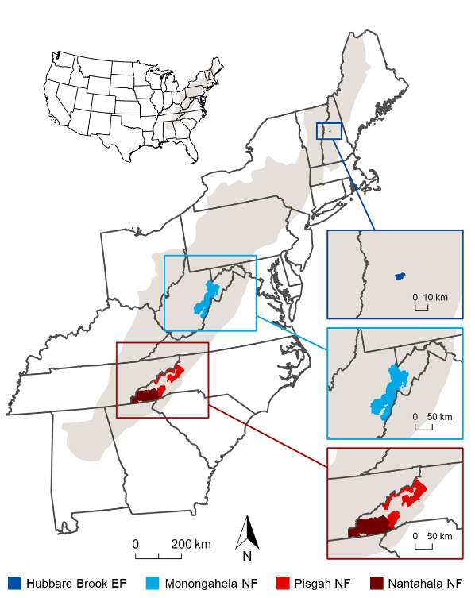

Figure 1. Location and extent of the 3 study regions in the Appalachian Mountains (shaded in gray): Hubbard Brook Experimental Forest (EF) in the White Mountains of New Hampshire (i.e., Northern Appalachians); Monongahela National Forest (NF) in the Allegheny Mountains of West Virginia (i.e., Central Appalachians); and Pisgah and Nantahala National Forests (NF) in the Blue Ridge Mountains of North Carolina (i.e., Southern Appalachians).

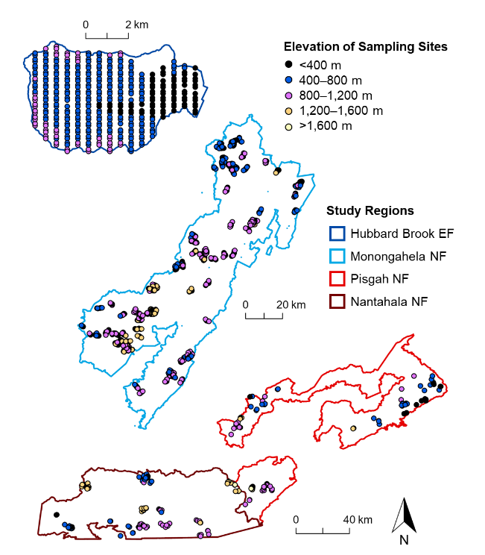

Figure 2. Locations and elevations (m) of the 373 sampling sites in the Hubbard Brook Experimental Forest (EF) (i.e., Northern Appalachians study region); 1,149 sampling sites in the Monongahela National Forest (NF) (i.e., Central Appalachians study region); and 211 sampling sites in the Pisgah and Nantahala National Forests (NF) (i.e., Southern Appalachians study region).

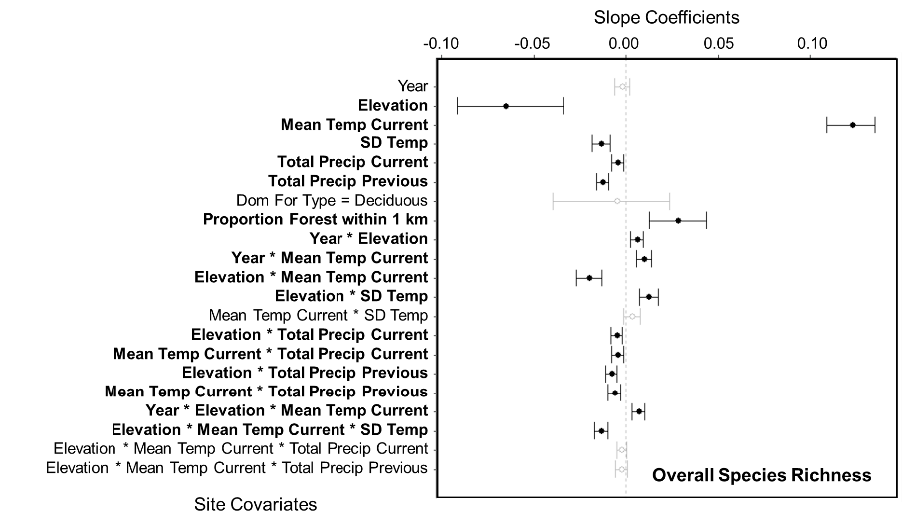

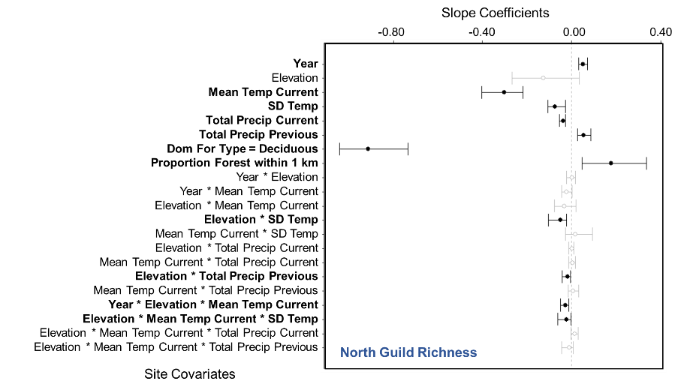

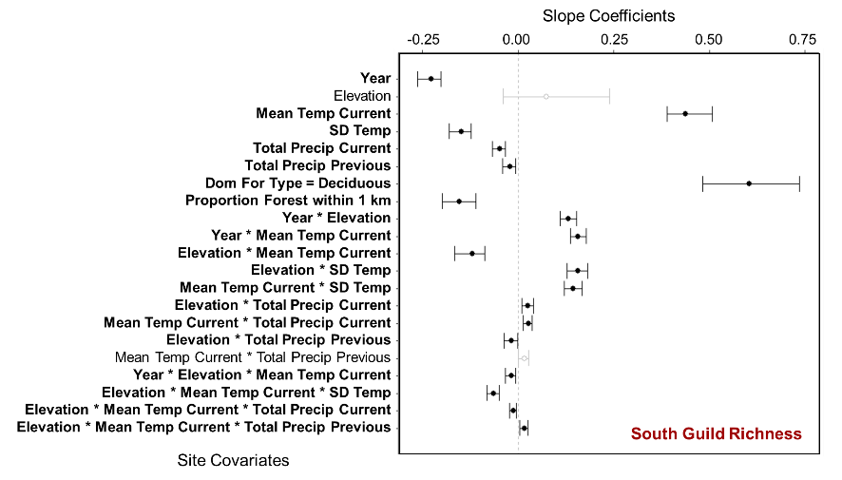

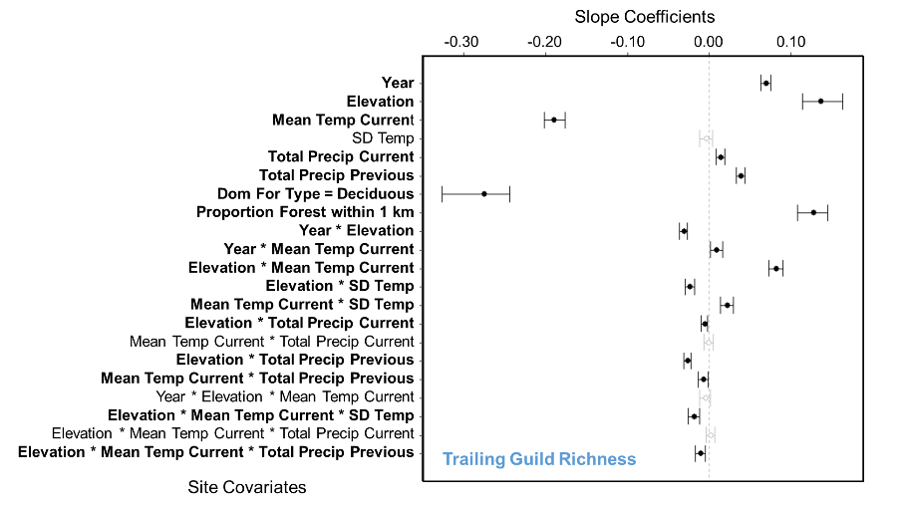

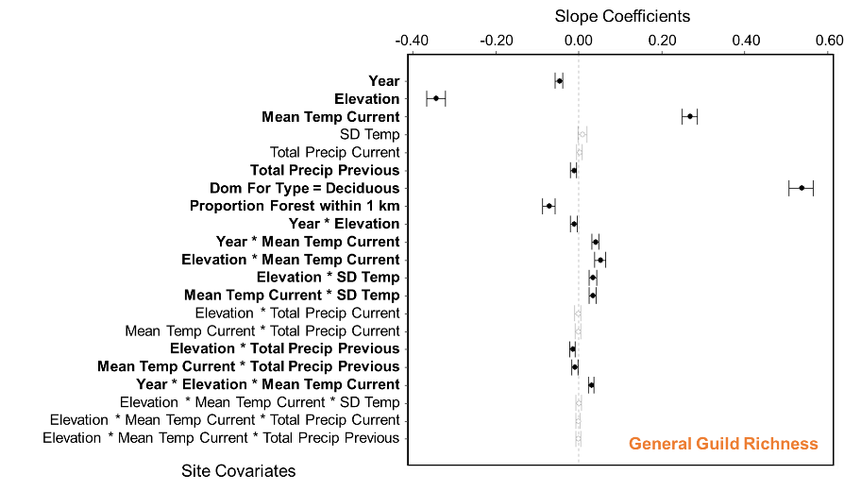

Figure 3. Whisker plots for overall species richness and guild richness (see Appendix A for guild designations and associated forest songbird species), displaying the slope coefficients of the predictor variables (i.e., site covariates), which consisted of year, elevation, mean breeding season (i.e., 15 May to 30 June) temperature during the year of data collection (Mean Temp Current), standard deviation of breeding season temperature (SD Temp), total breeding season precipitation during the year of data collection (Total Precip Current), total breeding season precipitation during the previous year (Total Precip Previous), dominant forest type within 50 m as deciduous forest (Dom For Type = Deciduous), and proportion of any type of forest cover within 1 km (Proportion Forest within 1 km). Points are located at the mean values for the posterior distributions and the corresponding whiskers encompass the 95% credible intervals. Black points with closed circles and black whiskers, along with bolded text, indicate statistical significance (i.e., credible intervals do not overlap zero).

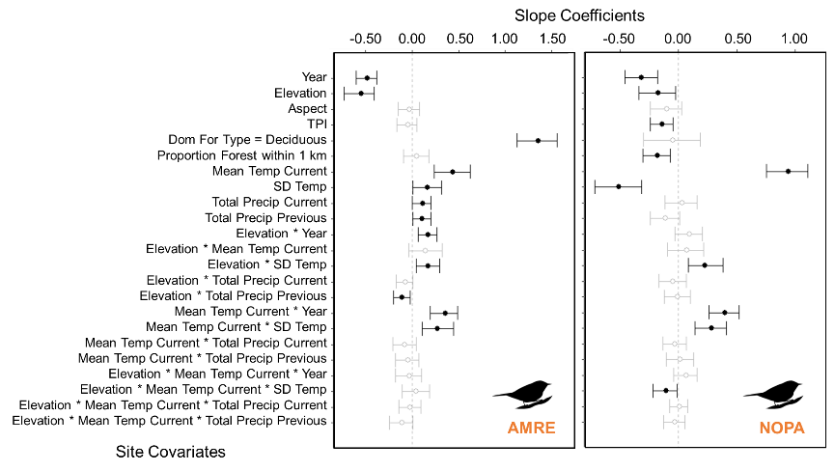

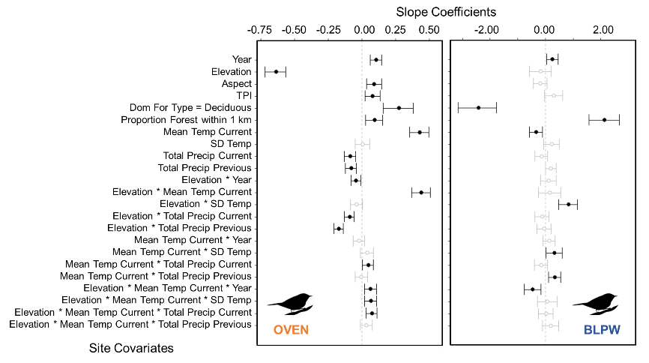

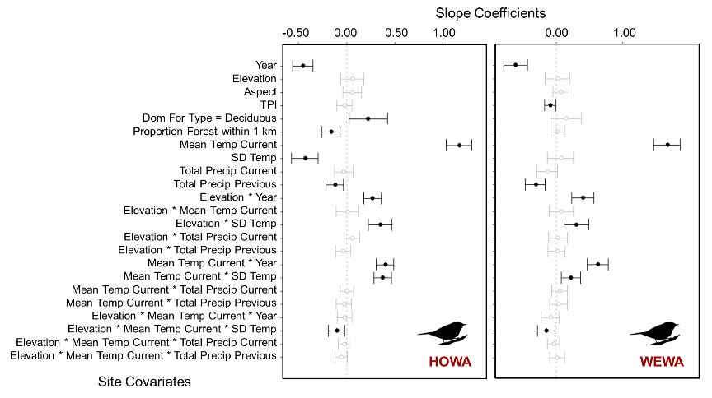

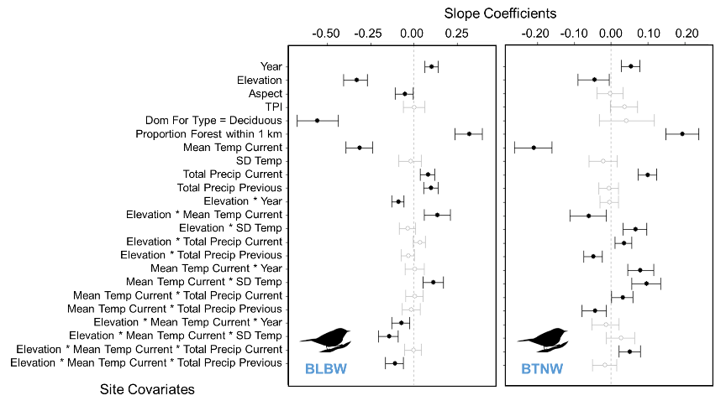

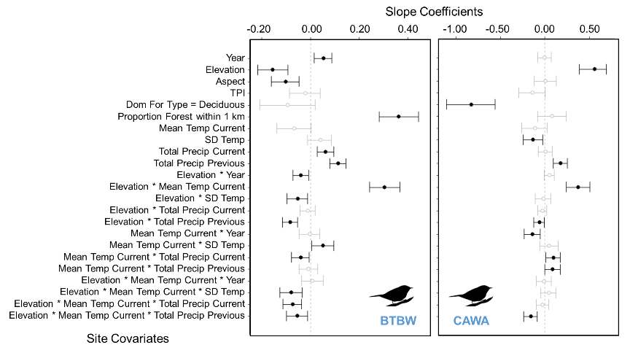

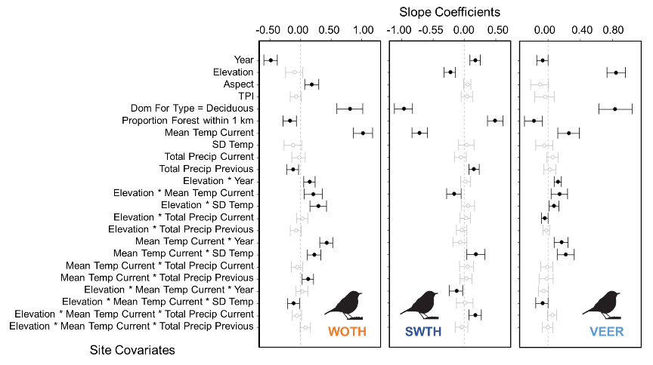

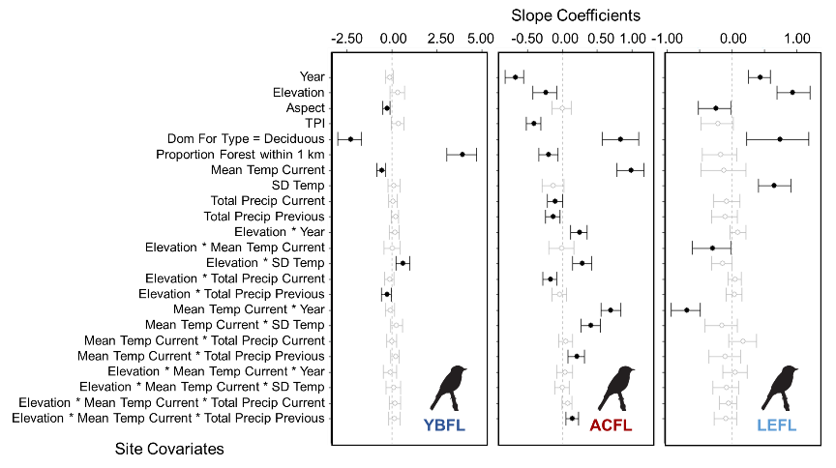

Figure 4.Whisker plots for each focal species (Table 1), displaying the slope coefficients of the predictor variables (i.e., site covariates), which consisted of year, elevation, aspect, topographic position index (TPI), dominant forest type within 50 m as deciduous forest (Dom For Type = Deciduous), proportion of any type of forest cover within 1 km (Proportion Forest within 1 km), mean breeding season (i.e., 15 May to 30 June) temperature during the year of data collection (Mean Temp Current), standard deviation of breeding season temperature (SD Temp), total breeding season precipitation during the year of data collection (Total Precip Current), and total breeding season precipitation during the previous year (Total Precip Previous). Points are located at the mean values for the posterior distributions and the corresponding whiskers encompass the 95% credible intervals. Black points with closed circles and black whiskers indicate statistical significance (i.e., credible intervals do not overlap zero). Color of the 4-letter species code indicates its guild designation (dark blue = north guild, red = south guild, light blue = trailing guild, and orange = general guild), and the bird silhouette indicates its taxonomic family (warbler, thrush, or flycatcher).

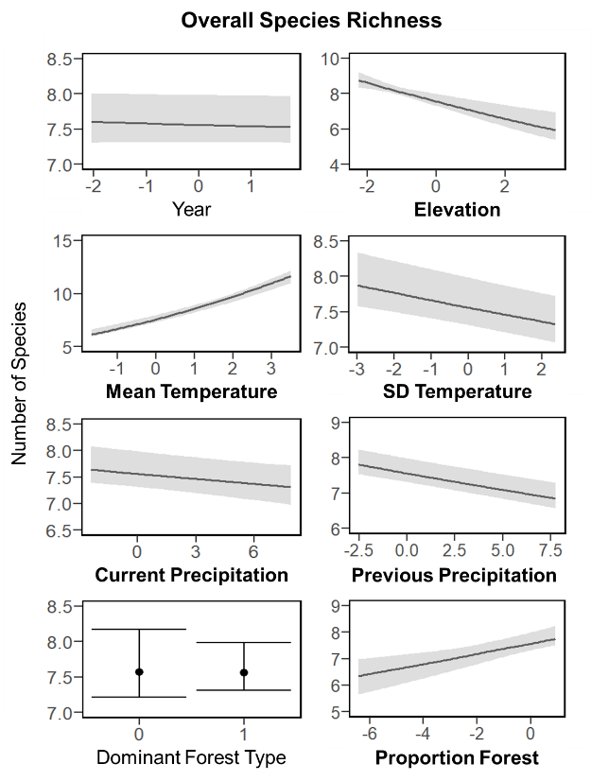

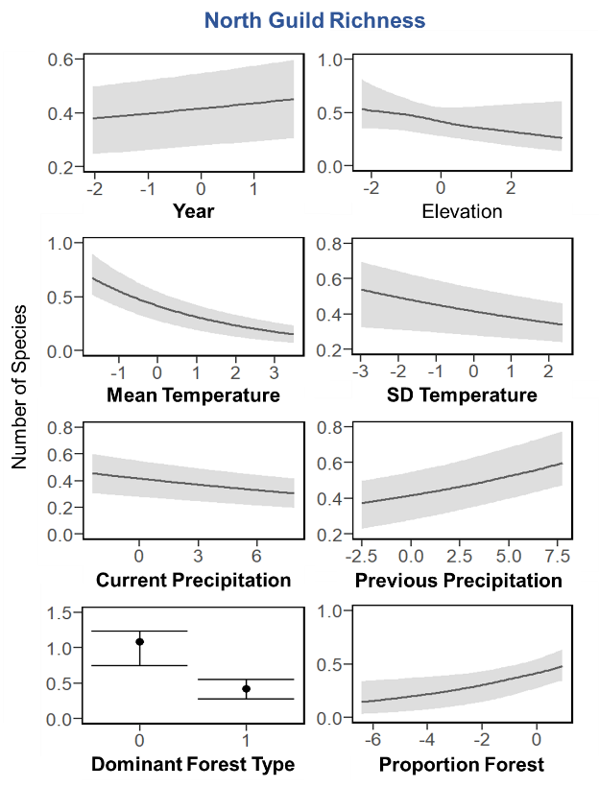

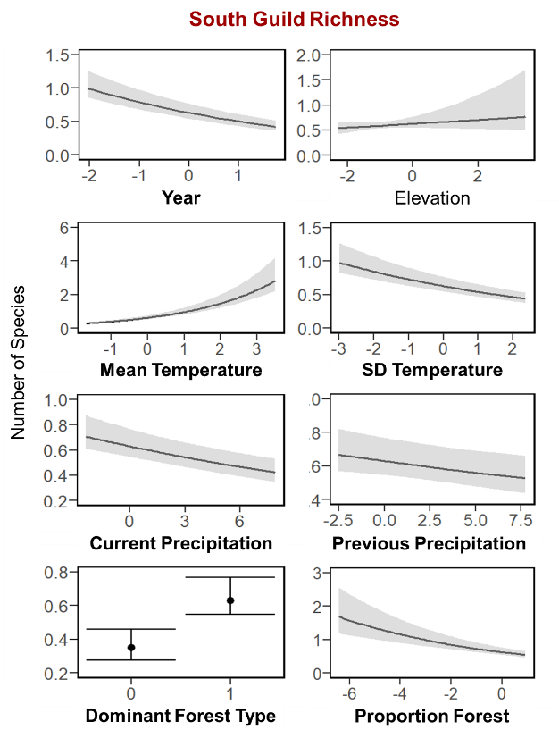

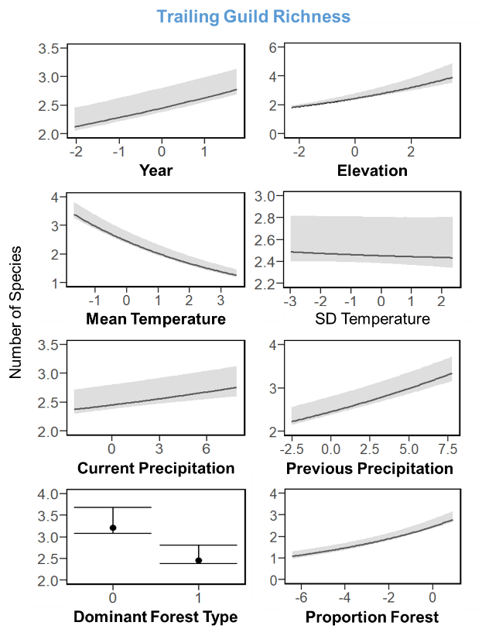

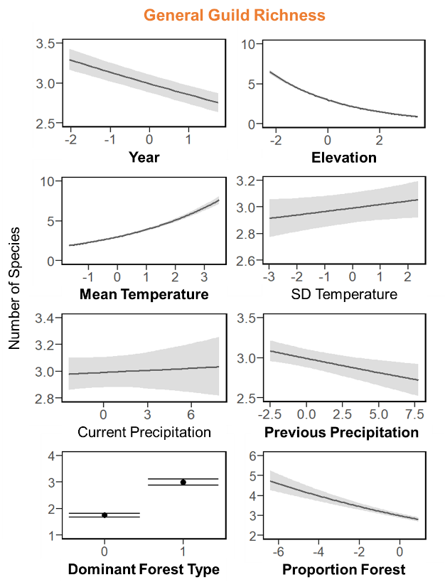

Figure 5. Plots of the linear relationships between the median expected number of species (black line or black point) belonging to each guild (see Appendix A for guild designations and associated forest songbird species) and the predictor variables, which consisted of year, elevation, mean breeding season (i.e., 15 May to 30 June) temperature during the year of data collection (Mean Temperature), standard deviation of breeding season temperature (SD Temperature), total breeding season precipitation during the year of data collection (Current Precipitation), total breeding season precipitation during the previous year (Previous Precipitation), dominant forest type within 50 m (Dominant Forest Type, where 0 = non-deciduous forest and 1 = deciduous forest), and proportion of any type of forest cover within 1 km (Proportion Forest). The gray shading or black whiskers indicate 95% credible intervals. The continuous predictor variables are scaled, such that zero is the mean value, and reflect the range of the data. Bolded predictor variables have statistically significant slope coefficients (i.e., credible intervals do not overlap zero).

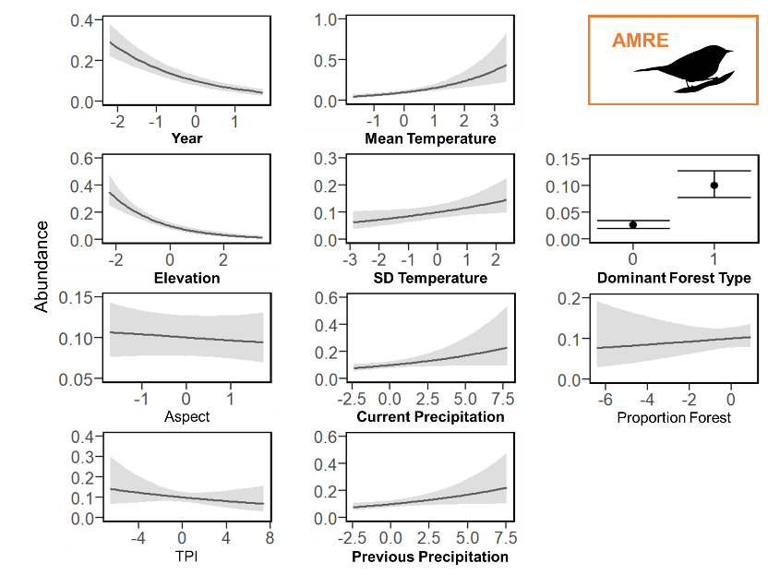

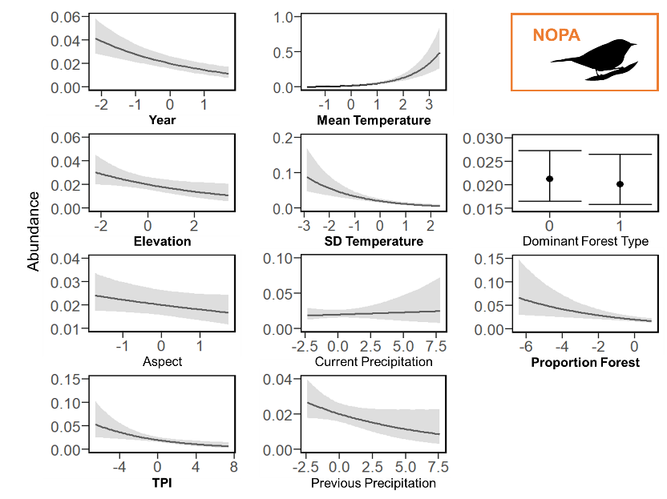

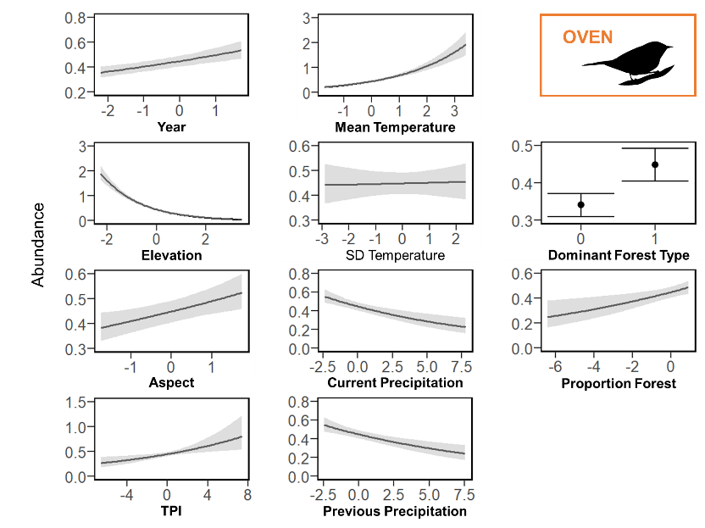

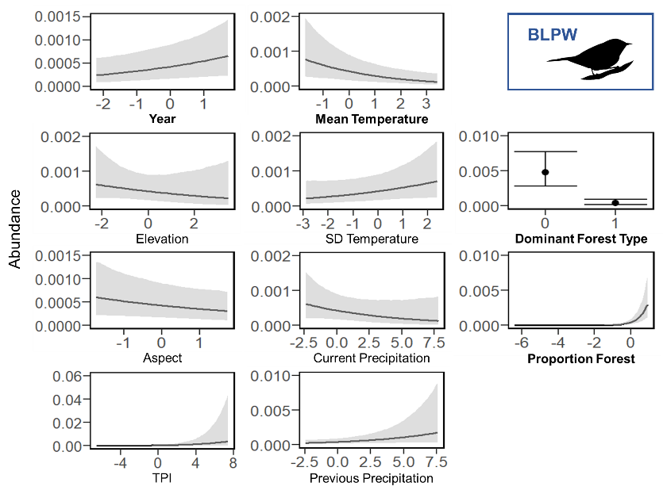

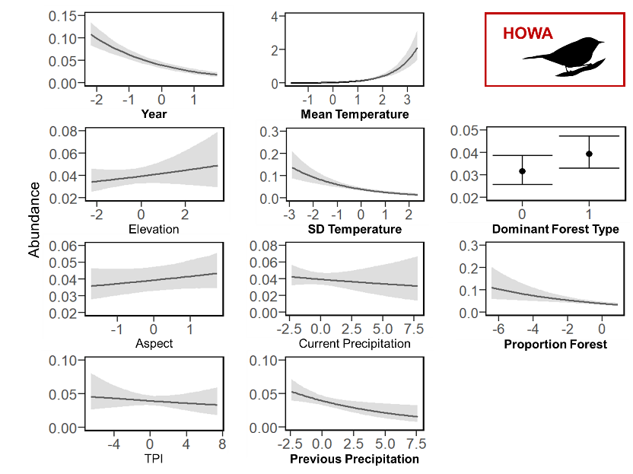

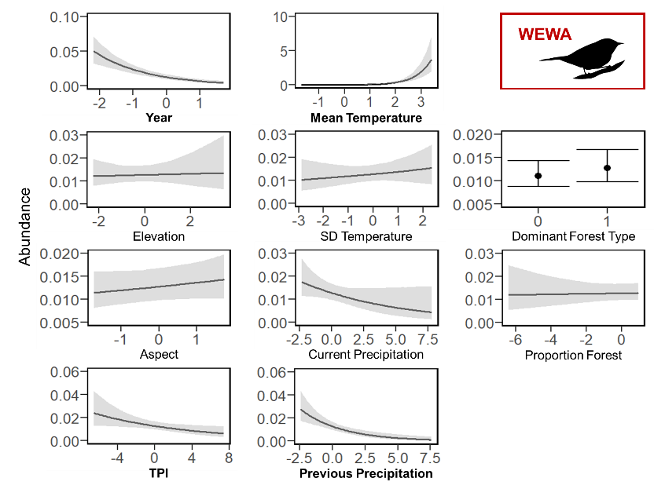

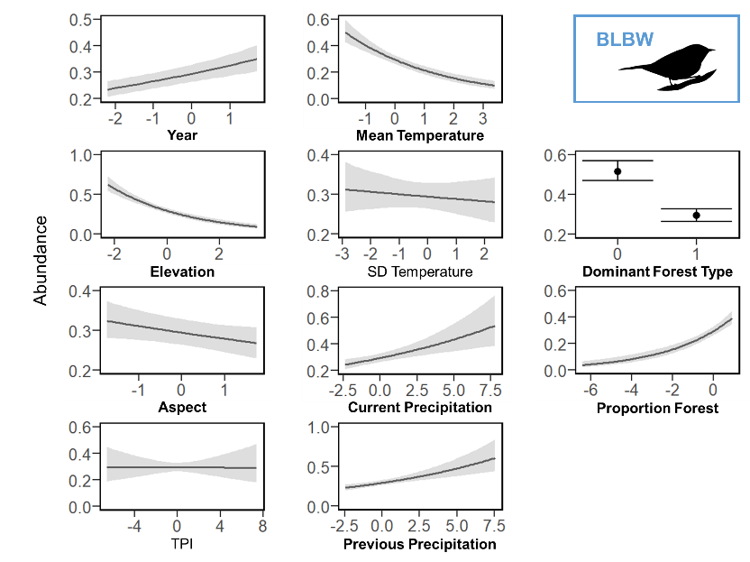

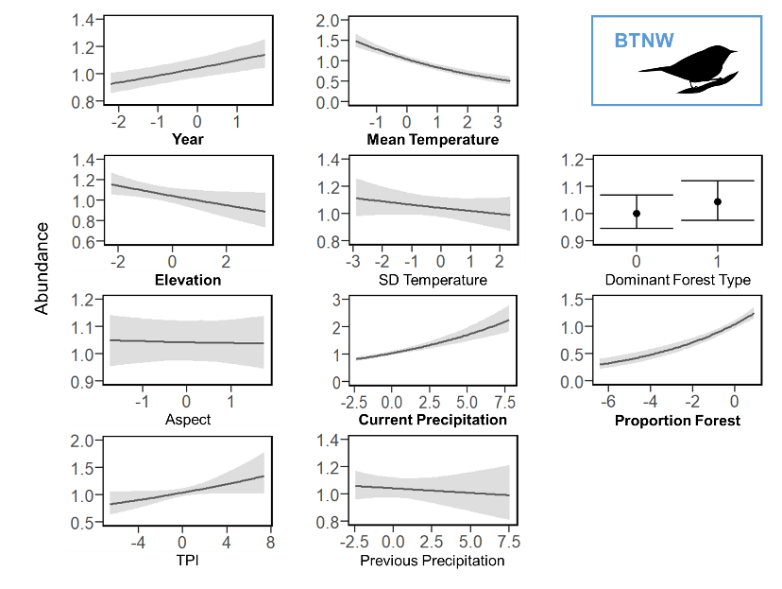

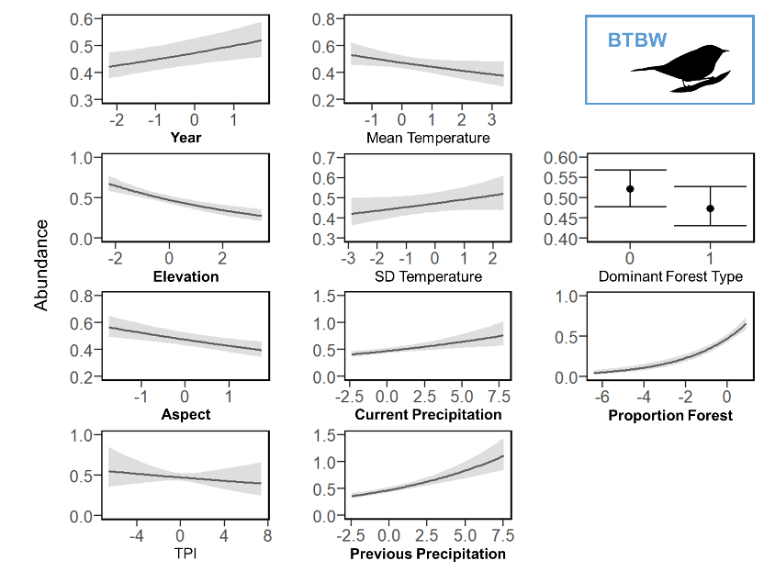

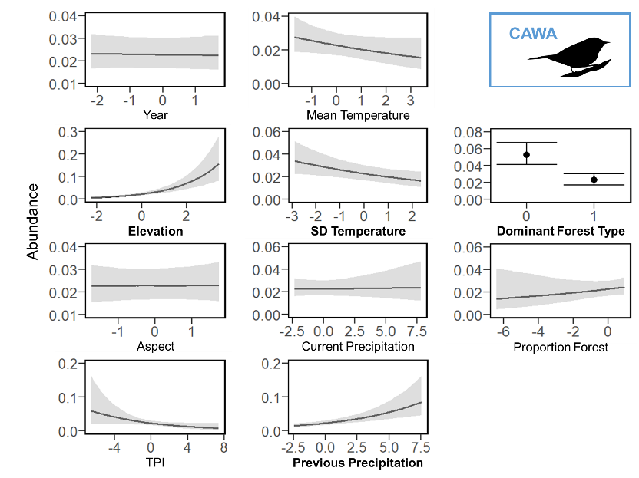

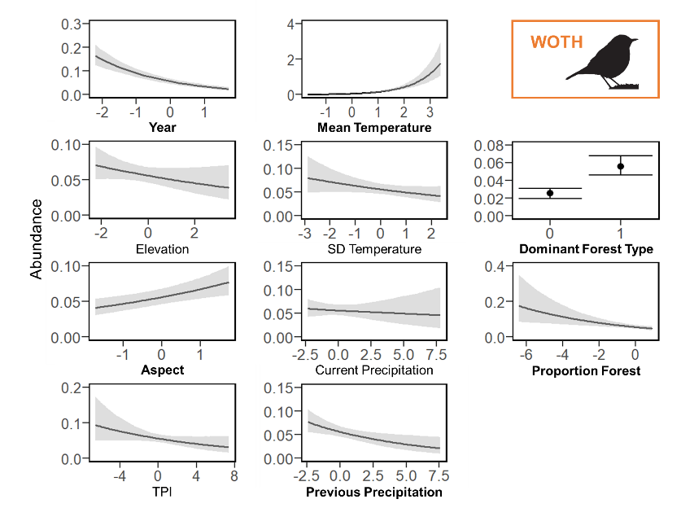

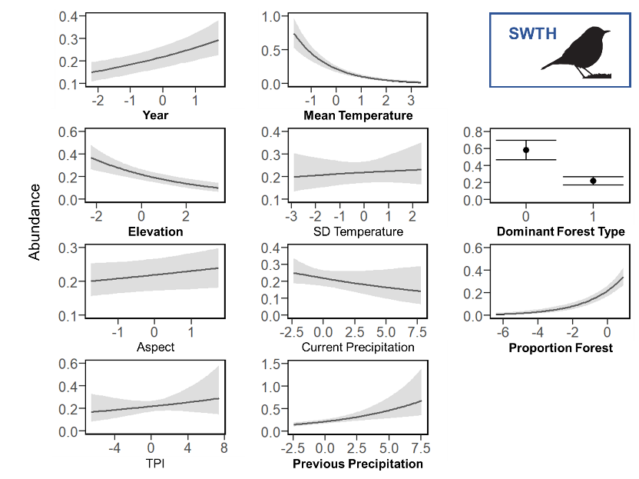

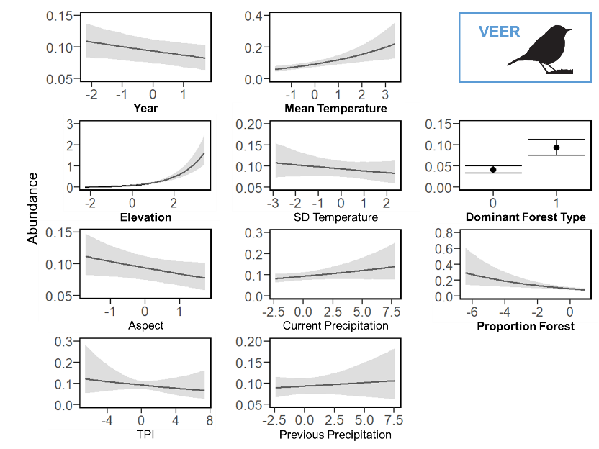

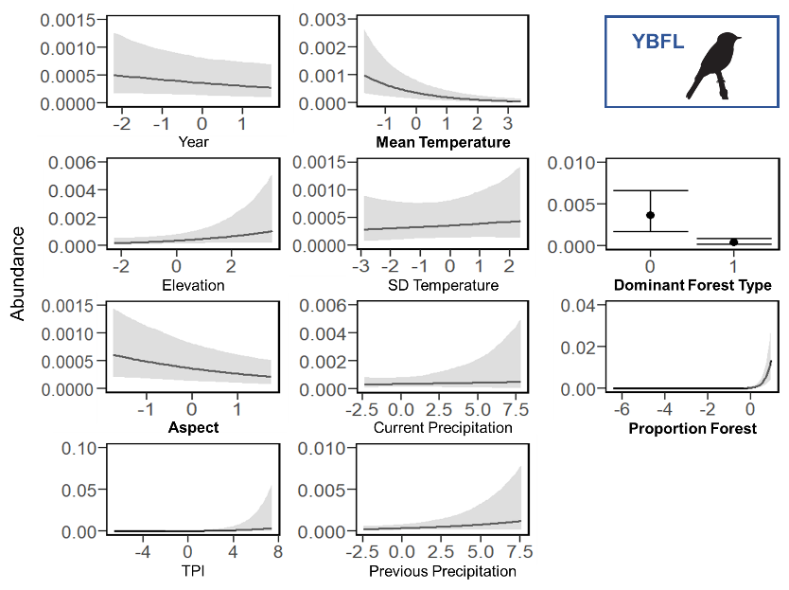

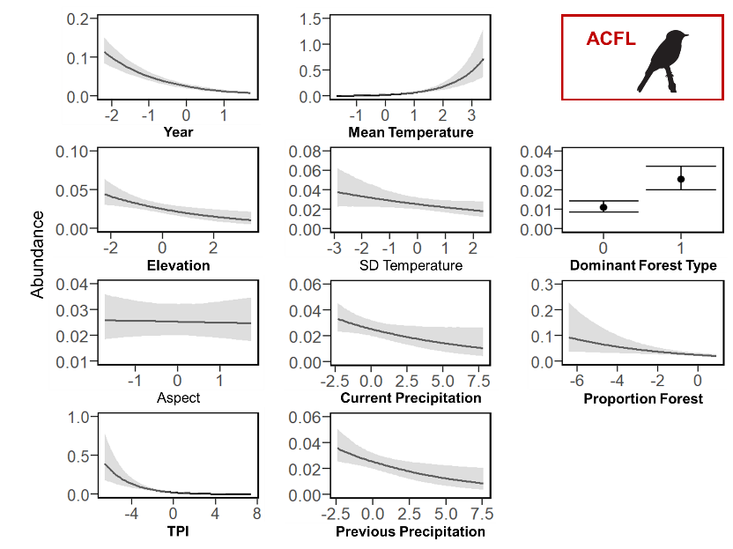

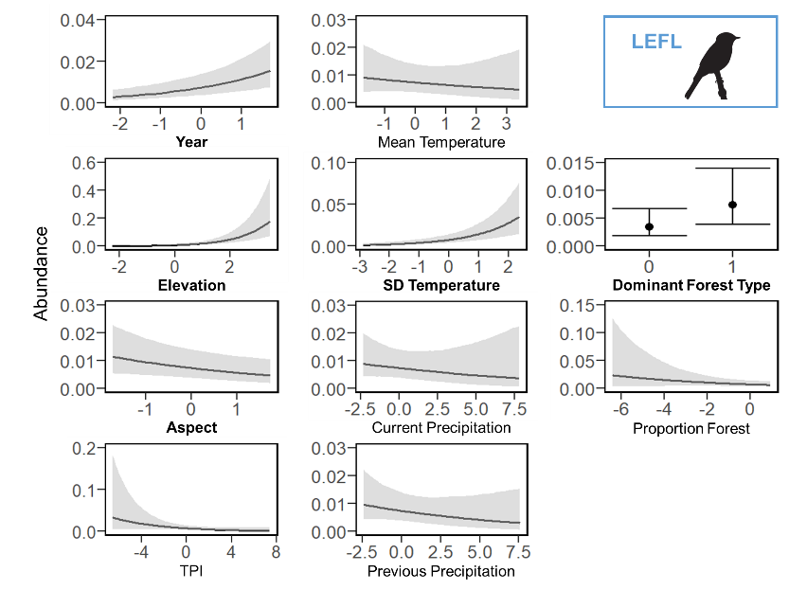

Figure 6. Plots of the linear relationships between the median expected count (i.e., abundance; portrayed by the black line or black point) for each of the focal species (Table 1) and the predictor variables, which consisted of year, elevation, aspect, topographic position index (TPI), mean breeding season (i.e., 15 May to 30 June) temperature during the year of data collection (Mean Temperature), standard deviation of breeding season temperature (SD Temperature), total breeding season precipitation during the year of data collection (Current Precipitation), total breeding season precipitation during the previous year (Previous Precipitation), dominant forest type within 50 m (Dominant Forest Type, where 0 = non-deciduous forest and 1 = deciduous forest), and proportion of any type of forest cover within 1 km (Proportion Forest). The gray shading or black whiskers indicate 95% credible intervals. The continuous predictor variables are scaled, such that zero is the mean value, and reflect the range of the data. Bolded predictor variables have statistically significant slope coefficients (i.e., credible intervals do not overlap zero). Color of the 4-letter species code indicates its guild designation (dark blue = north guild, red = south guild, light blue = trailing guild, and orange = general guild), and the bird silhouette indicates its taxonomic family (warbler, thrush, or flycatcher).

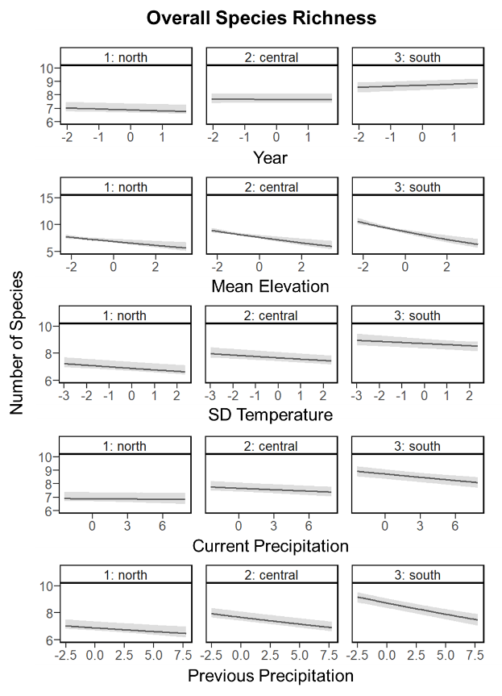

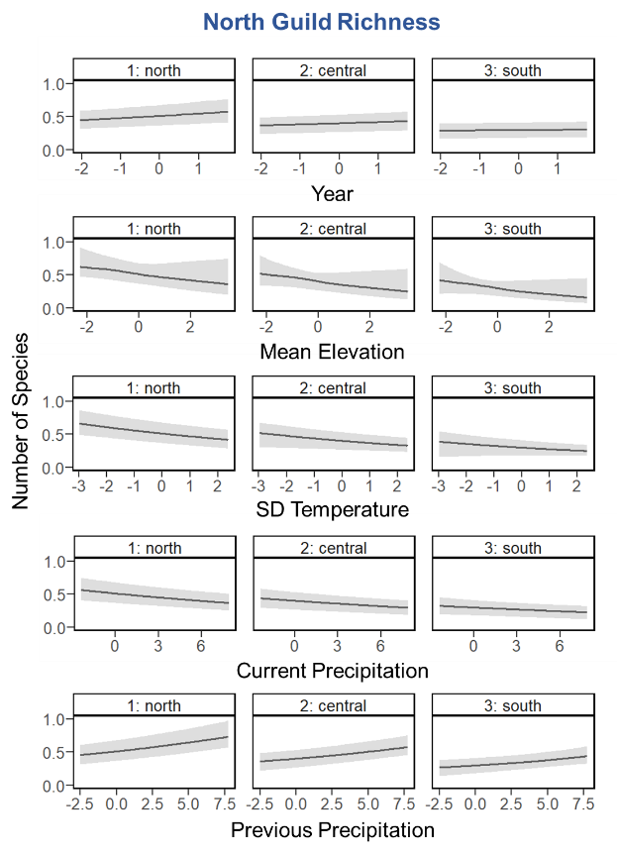

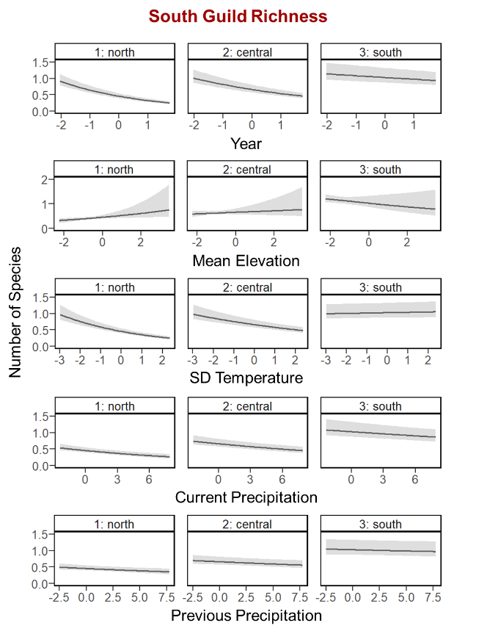

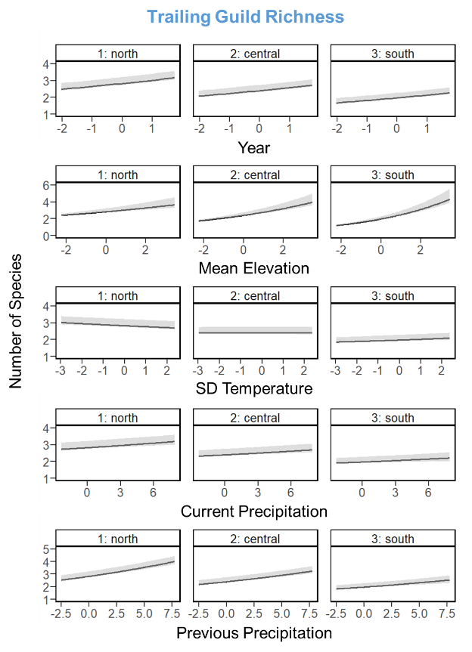

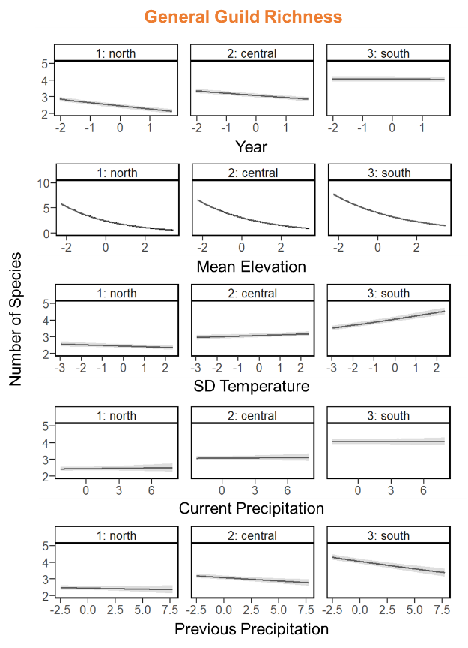

Figure 7. Plots of the effects of the two-way interactions between an index of latitude and the other predictor variables of interest (Table 2) on the median expected number of species (black line) belonging to each guild (see Appendix A for guild designations and associated forest songbird species), with 95% credible intervals (gray shading). The predictor variables are scaled, such that zero is the mean value, and reflect the range of the data. Because mean breeding season (i.e., 15 May to 30 June) temperature during the year of data collection was highly correlated with latitude, it was used as an index such that the north, central, and south plots correspond to the mean breeding season temperatures across all sampling sites in the Hubbard Brook Experimental Forest (14.3°C), Monongahela National Forest (16.3°C), and the 2 North Carolina National Forests (18.6°C), respectively.

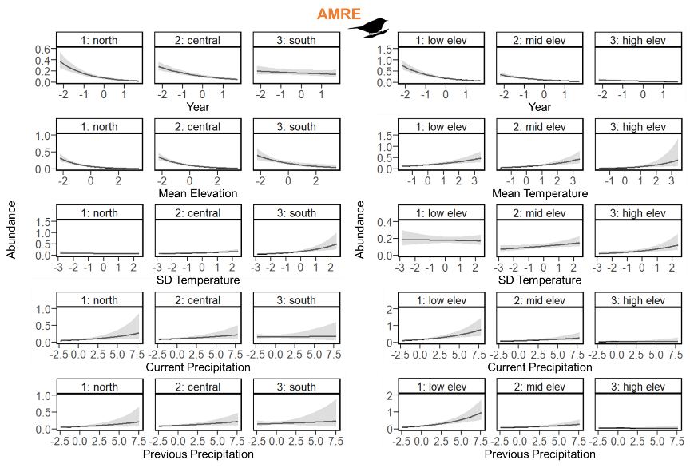

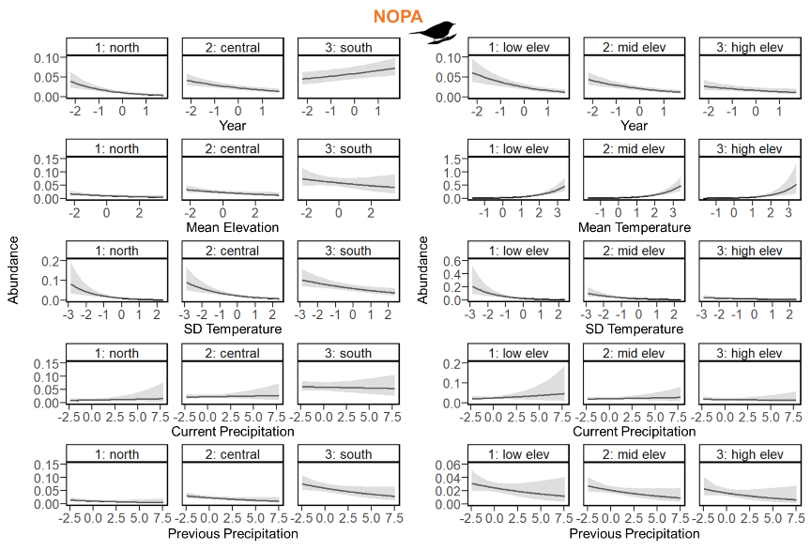

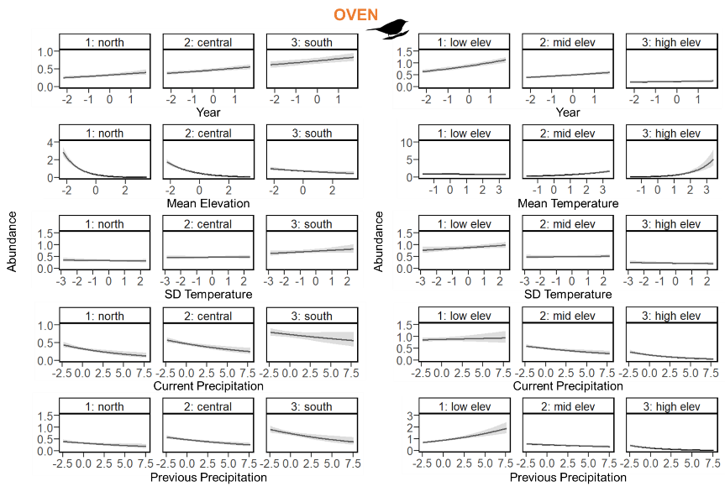

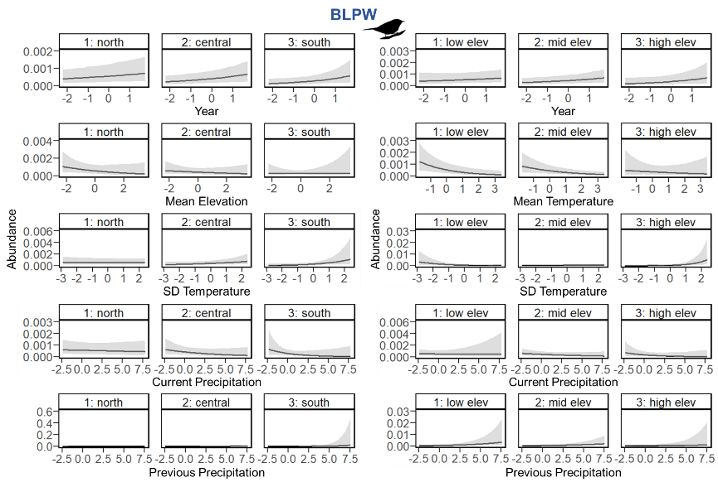

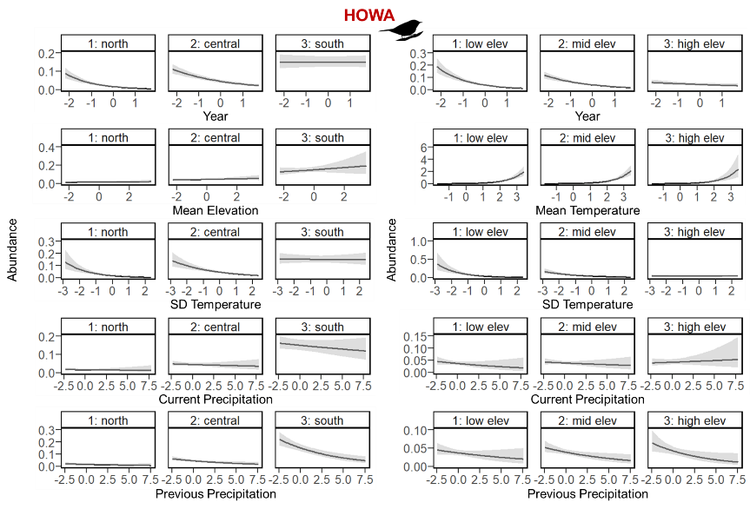

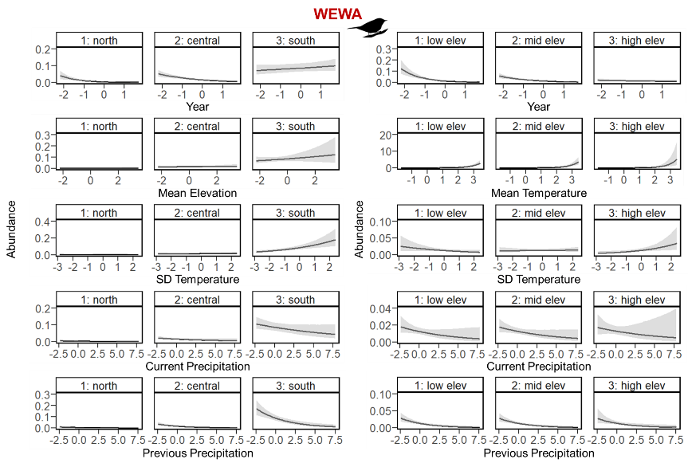

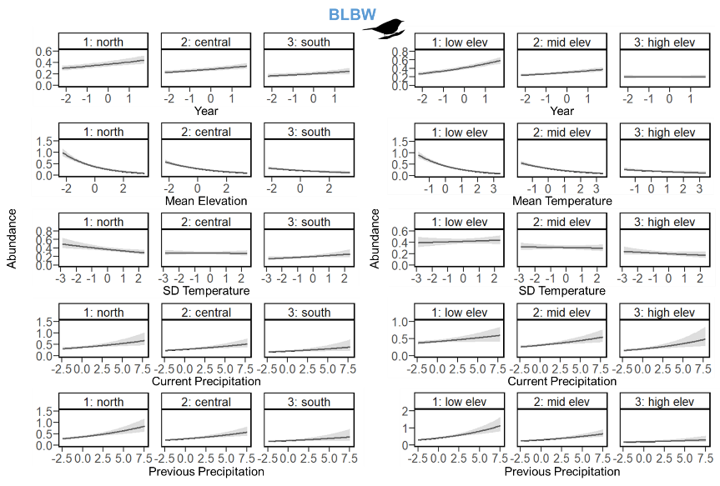

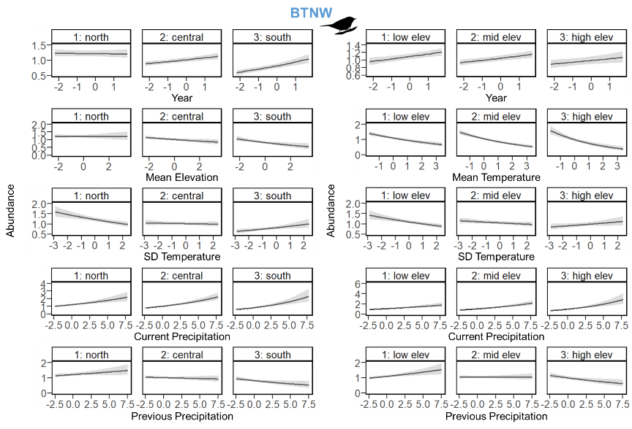

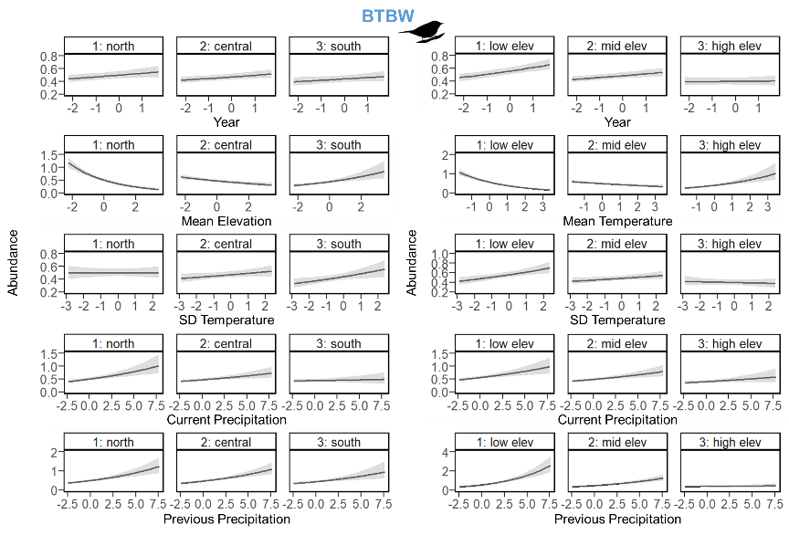

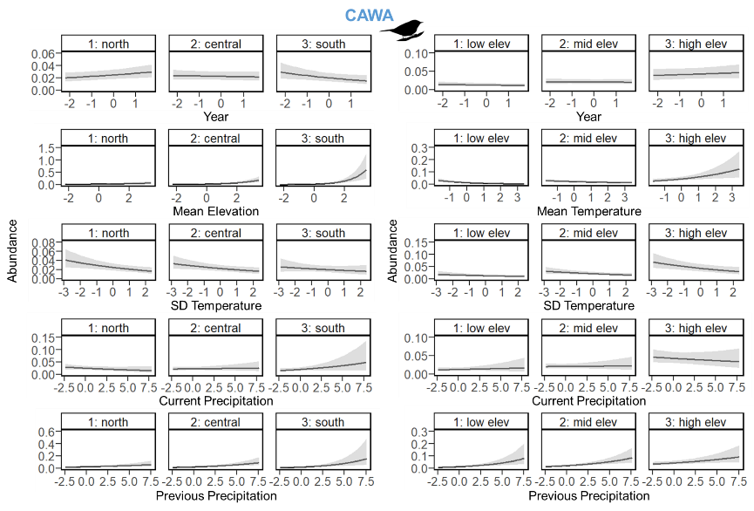

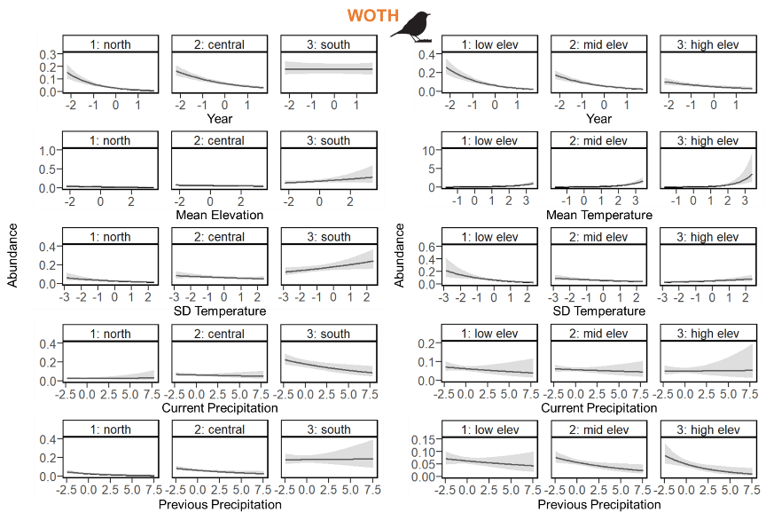

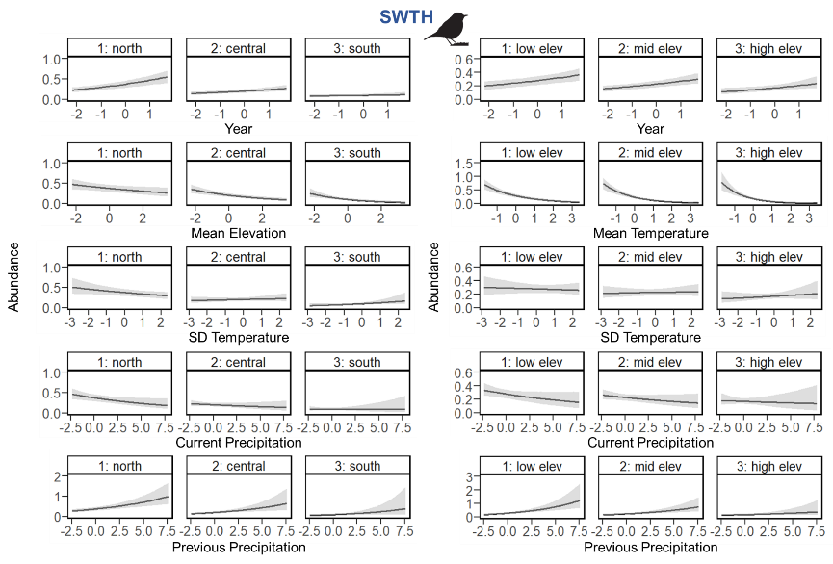

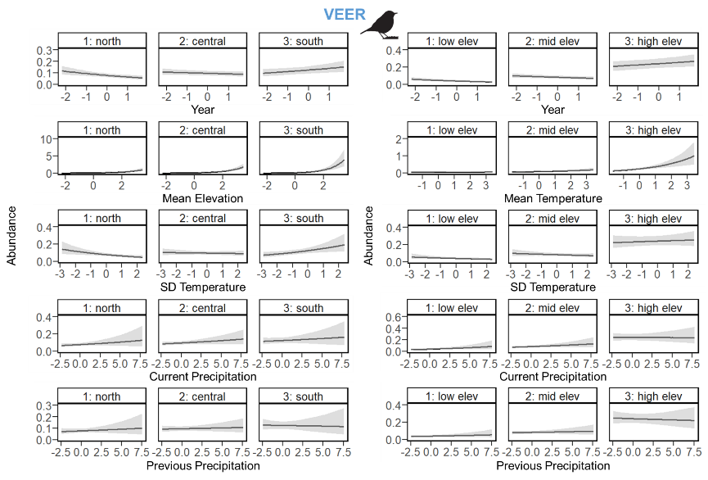

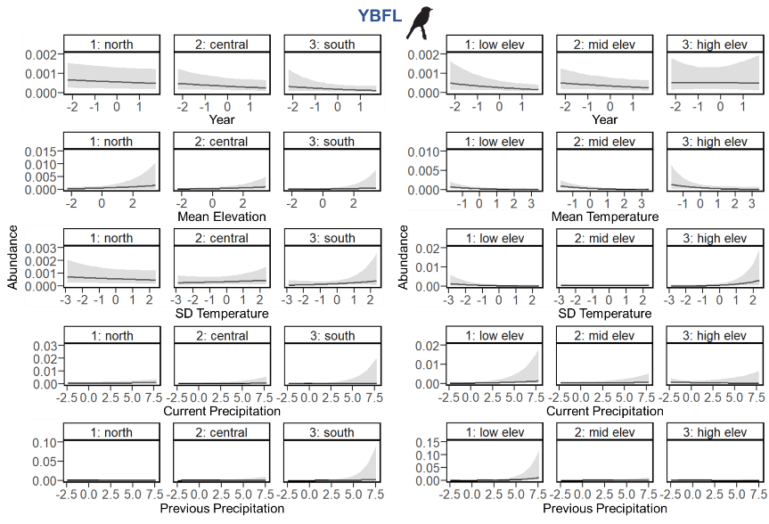

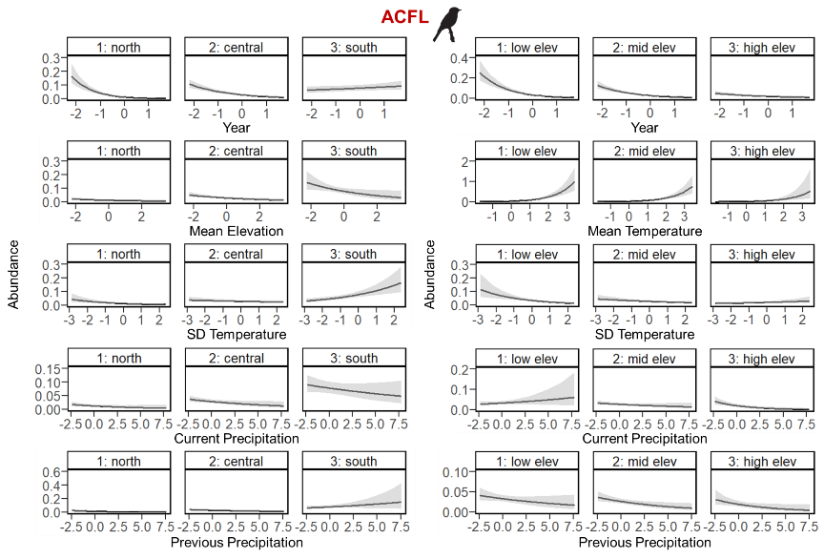

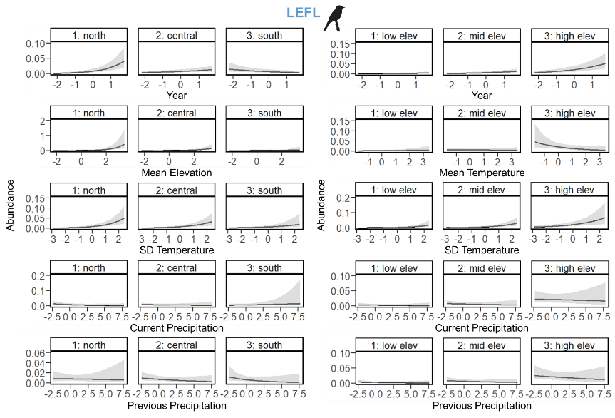

Figure 8. Plots of the effects of the two-way interactions between an index of latitude (left) or elevation (right) and the other predictor variables of interest (Table 2) on the median expected count (i.e., abundance; portrayed by black line) for each of the focal species (Table 1), with 95% credible intervals (gray shading). The predictor variables are scaled, such that zero is the mean value, and reflect the range of the data. Because mean breeding season (i.e., 15 May to 30 June) temperature during the year of data collection was highly correlated with latitude, it was used as an index such that the north, central, and south plots correspond to the mean breeding season temperatures across all sampling sites in the Hubbard Brook Experimental Forest (14.3°C), Monongahela National Forest (16.3°C), and the 2 North Carolina National Forests (18.6°C), respectively. Low, mid, and high elevation (elev) plots correspond respectively to 585.8 m, 844.3 m, and 1214.3 m, which are the 15th, 50th, and 85th percentiles of the elevation data across all sampling sites. Color of the 4-letter species code indicates its guild designation (dark blue = north guild, red = south guild, light blue = trailing guild, and orange = general guild), and the bird silhouette indicates its taxonomic family (warbler, thrush, or flycatcher).

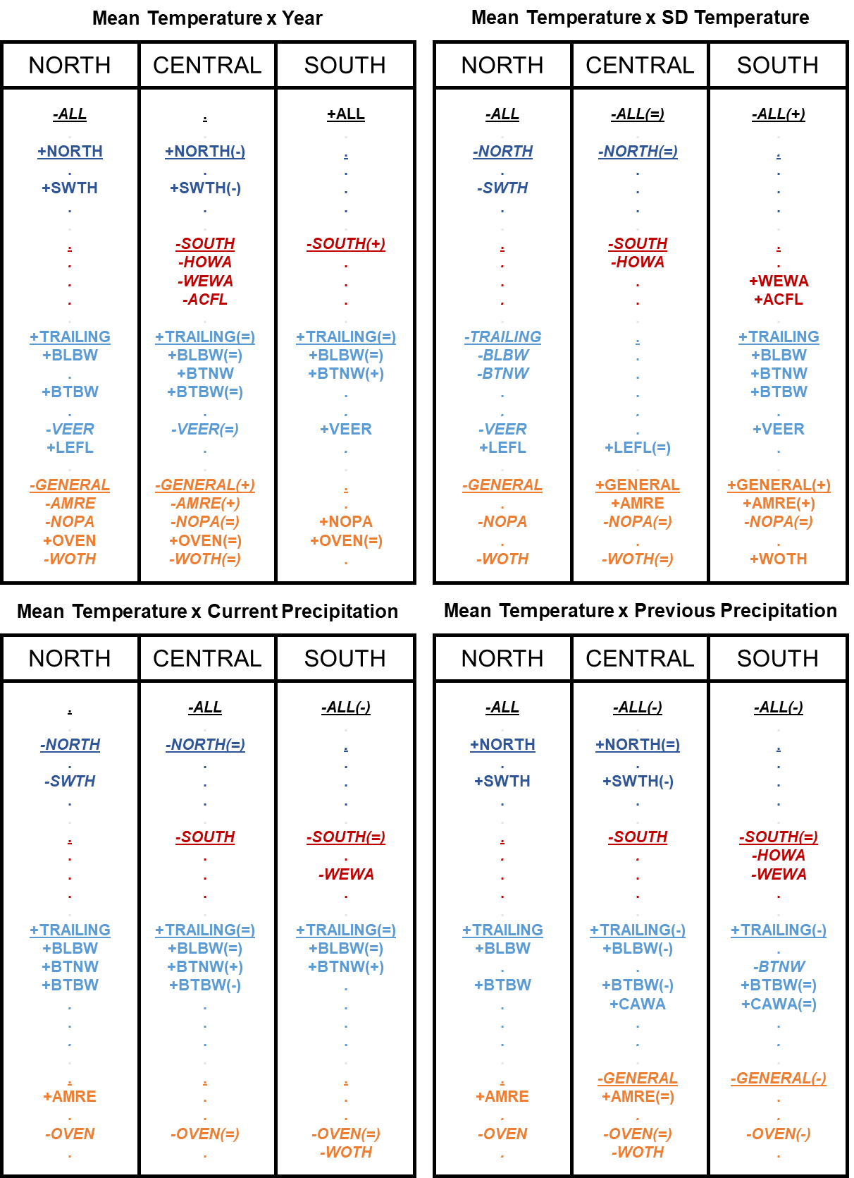

Figure 9. Compilation of combined results for the two-way interactions between year / SD temperature / current precipitation / previous precipitation and an index of latitude (i.e., mean temperature) for all guilds and focal forest songbird species. Because mean breeding season (i.e., 15 May to 30 June) temperature during the year of data collection was highly correlated with latitude, it was used as an index such that the north, central, and south groupings correspond to the mean breeding season temperatures across all sampling sites in the Hubbard Brook Experimental Forest (14.3°C), Monongahela National Forest (16.3°C), and the 2 North Carolina National Forests (18.6°C), respectively. Guilds and species codes are color-coded and organized by guild designation (black = ALL = overall species richness, dark blue = NORTH = north guild, red = SOUTH = south guild, light blue = TRAILING = trailing guild, and orange = GENERAL = general guild); guilds are additionally underlined. Bold font indicates significance of the slope coefficients for the temporal or climate variables, whereas dots indicate non-significance. Positive slope coefficients are signified with a preceding plus sign, while negative slope coefficients are signified with a preceding minus sign and italicized font. The plus, equal, or minus symbol in the parentheses following the guild or species code indicates whether that slope coefficient was greater than, equal to, or less than the corresponding slope coefficient with the same sign (positive or negative) in the latitudinal grouping directly to the left.

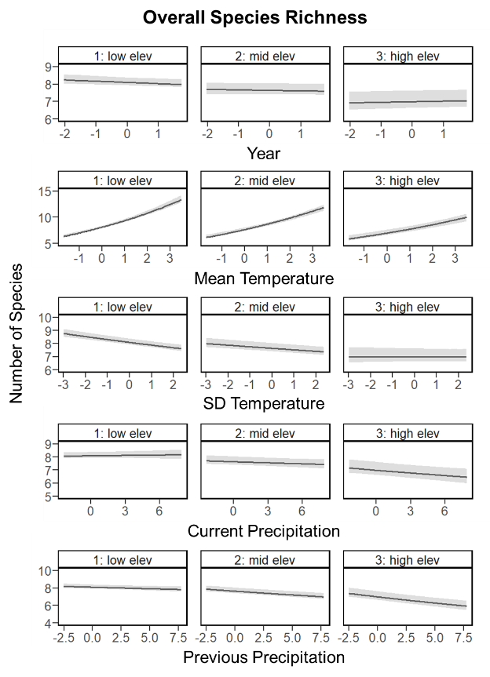

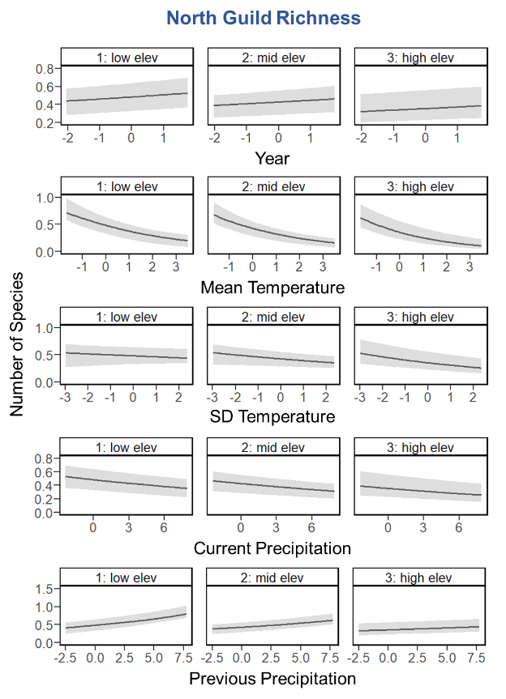

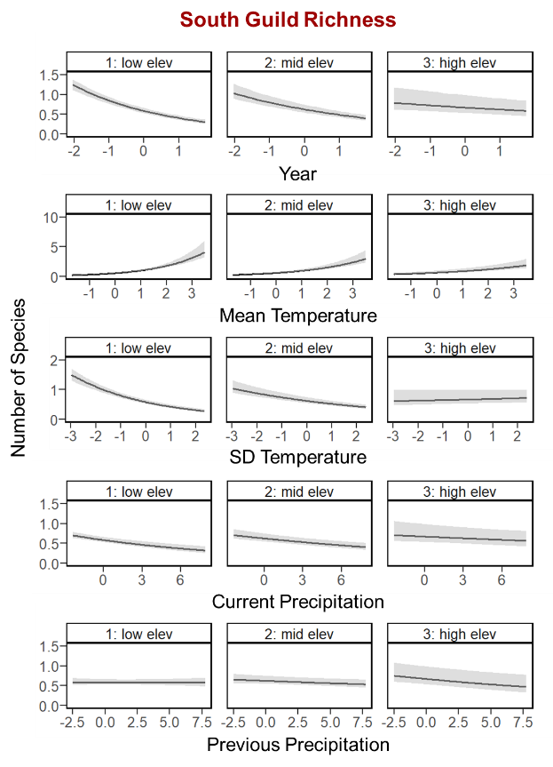

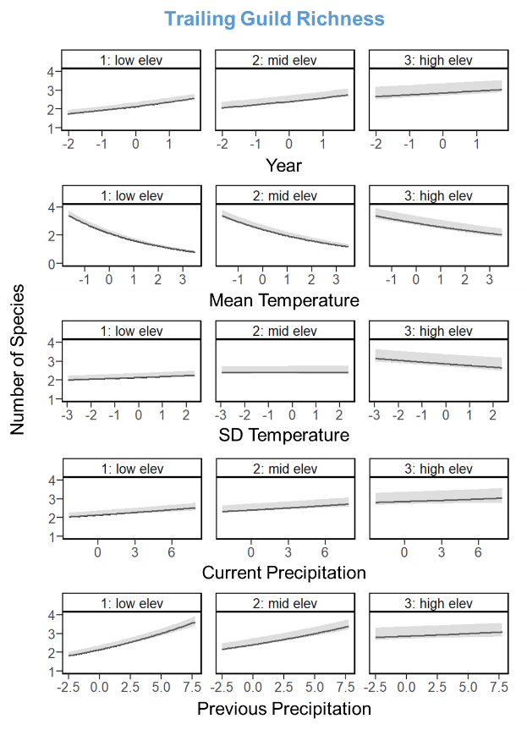

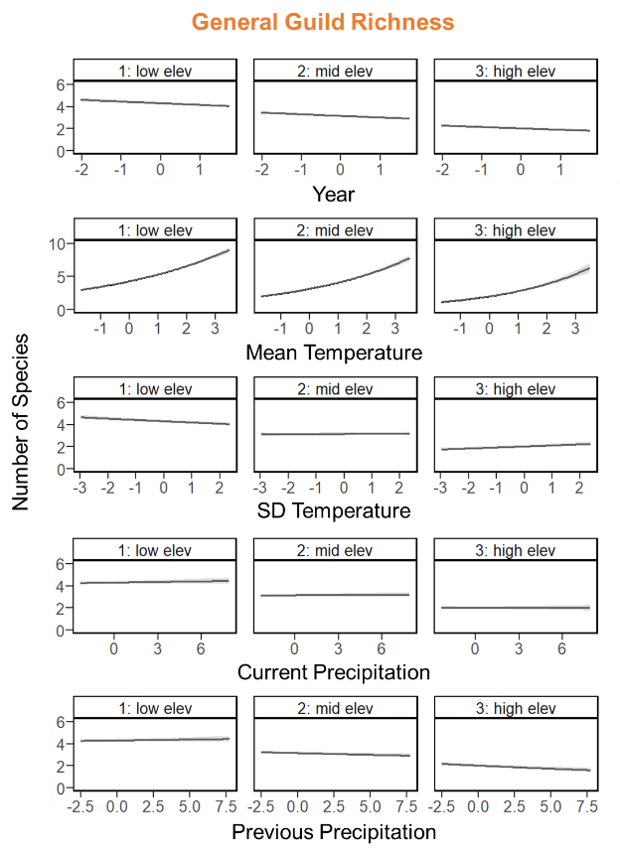

Figure 10. Plots of the effects of the two-way interactions between elevation and the other predictor variables of interest (Table 2) on the median expected number of species (black line) belonging to each guild (see Appendix A for guild designations and associated forest songbird species), with 95% credible intervals (gray shading). The predictor variables are scaled, such that zero is the mean value, and reflect the range of the data. Low, mid, and high elevation (elev) plots correspond respectively to 585.8 m, 844.3 m, and 1214.3 m, which are the 15th, 50th, and 85th percentiles of the elevation data across all sampling sites.

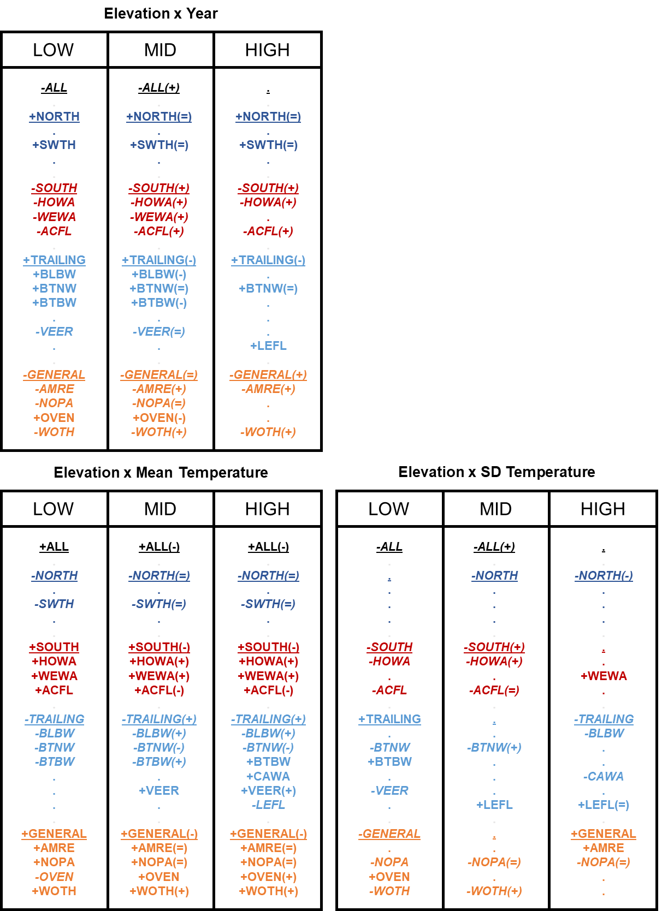

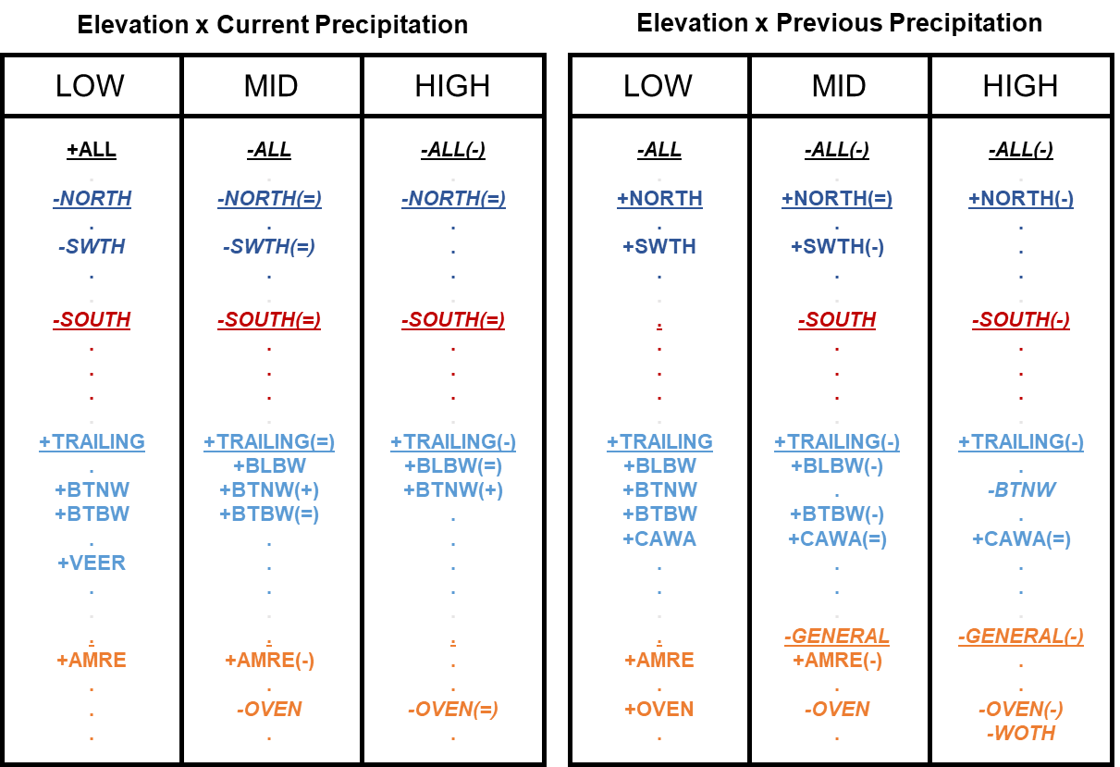

Figure 11. Compilation of combined results for the two-way interactions between year / mean temperature / SD temperature / current precipitation / previous precipitation and elevation for all guilds and focal forest songbird species. Low, mid, and high elevation groupings correspond respectively to 585.8 m, 844.3 m, and 1214.3 m, which are the 15th, 50th, and 85th percentiles of the elevation data across all sampling sites. Guilds and species codes are color-coded and organized by guild designation (black = ALL = overall species richness, dark blue = NORTH = north guild, red = SOUTH = south guild, light blue = TRAILING = trailing guild, and orange = GENERAL = general guild); guilds are additionally underlined. Bold font indicates significance of the slope coefficients for the temporal or climate variables, whereas dots indicate non-significance. Positive slope coefficients are signified with a preceding plus sign, while negative slope coefficients are signified with a preceding minus sign and italicized font. The plus, equal, or minus symbol in the parentheses following the guild or species code indicates whether that slope coefficient was greater than, equal to, or less than the corresponding slope coefficient with the same sign (positive or negative) in the elevational grouping directly to the left.

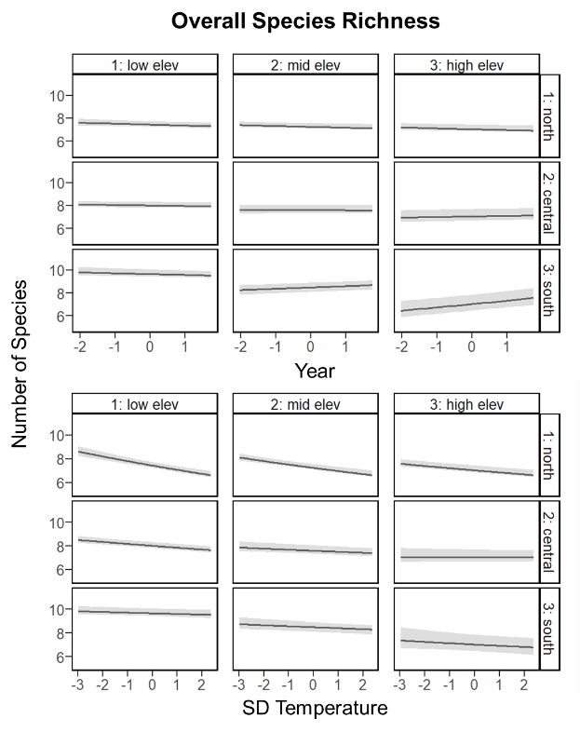

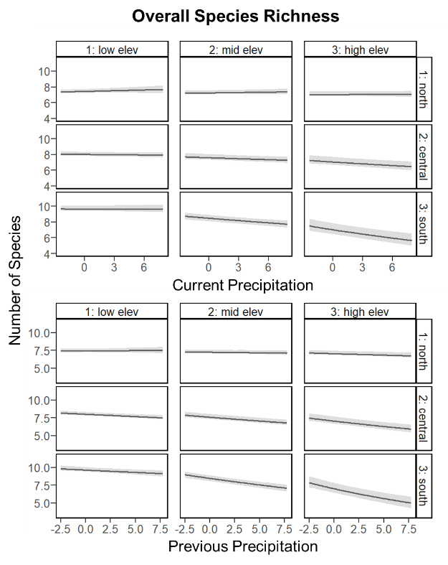

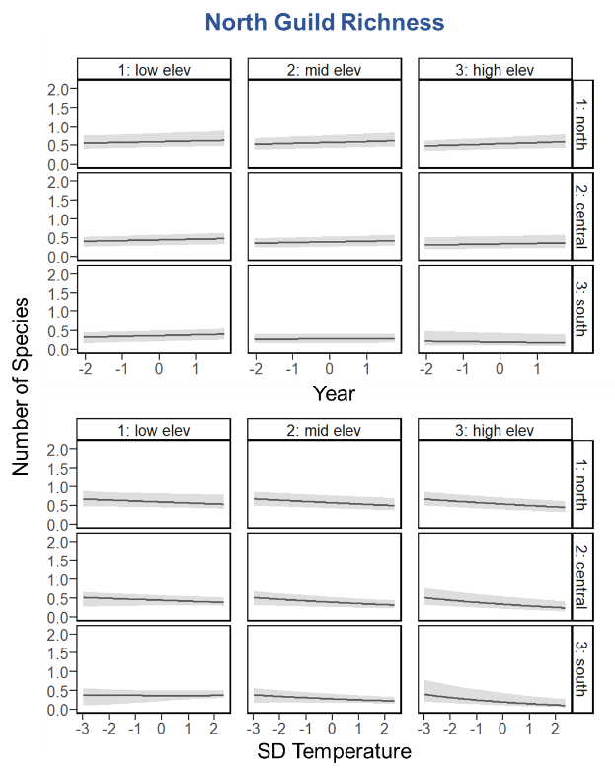

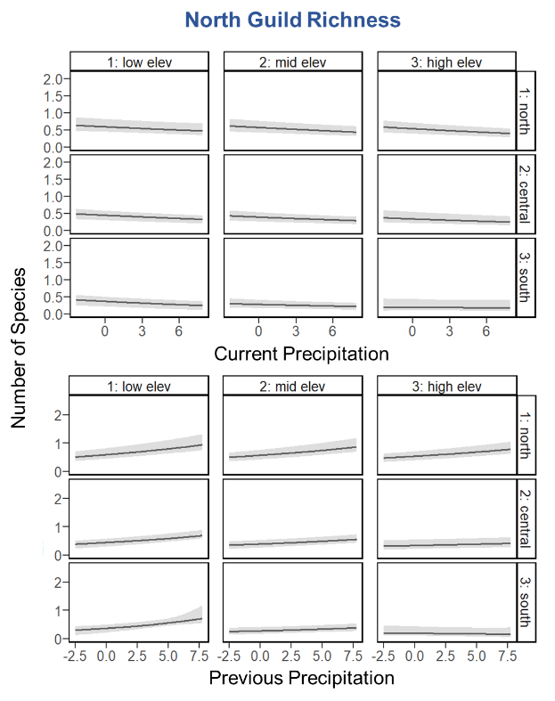

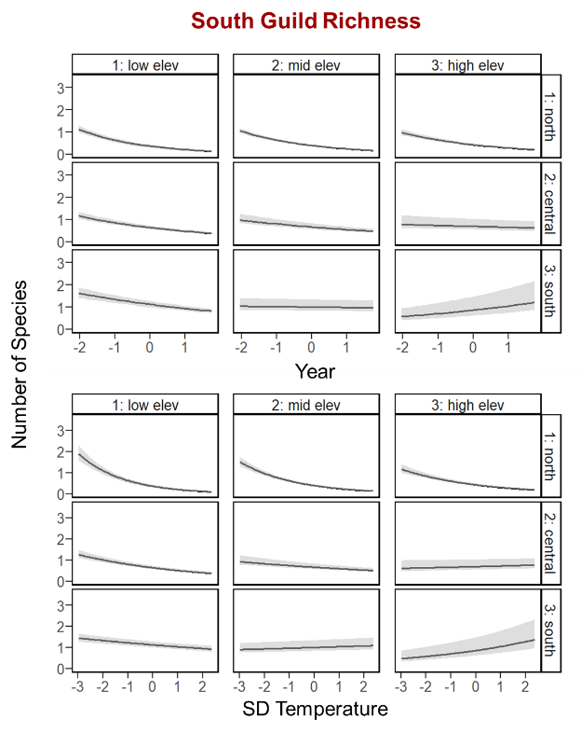

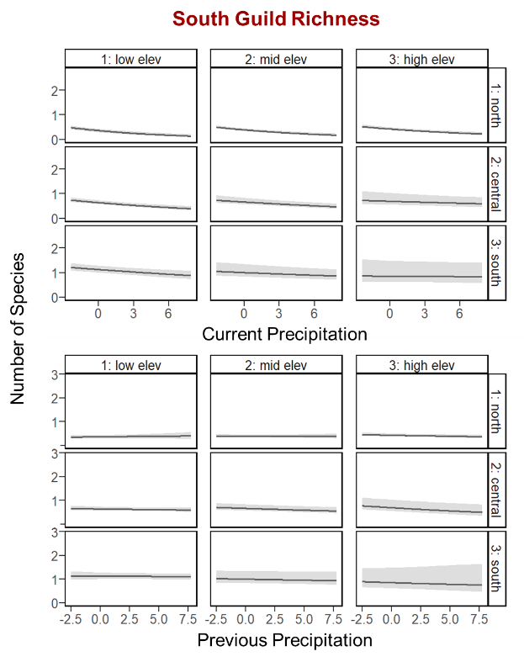

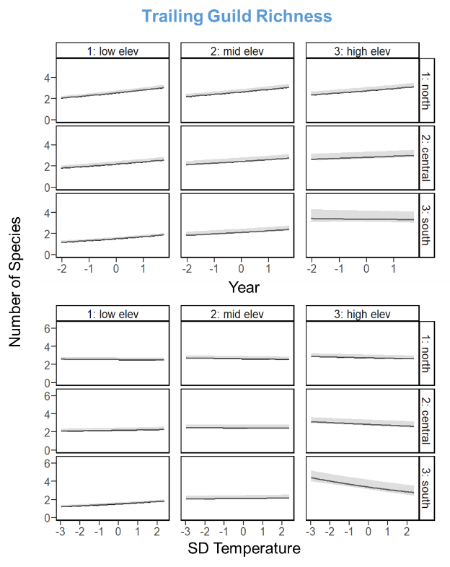

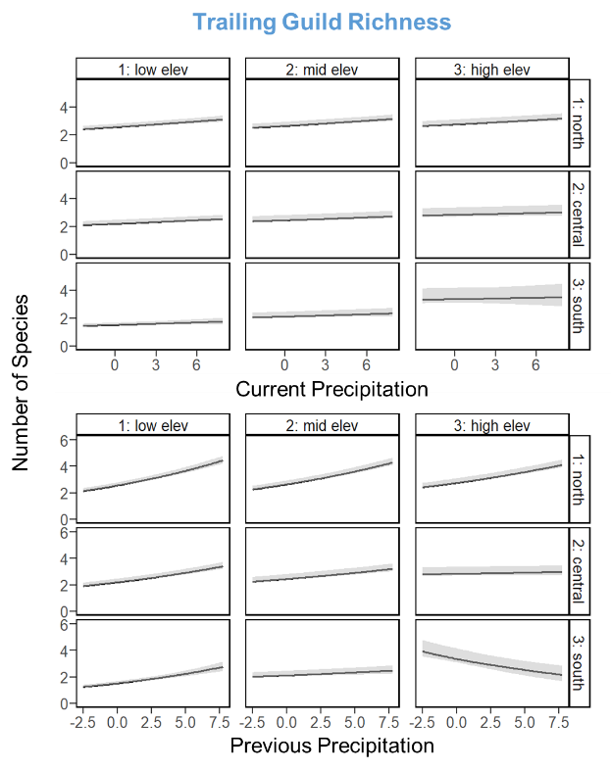

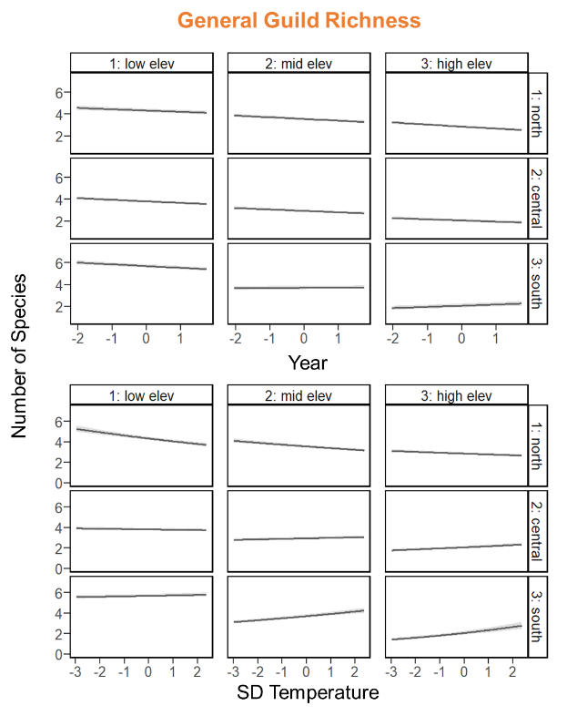

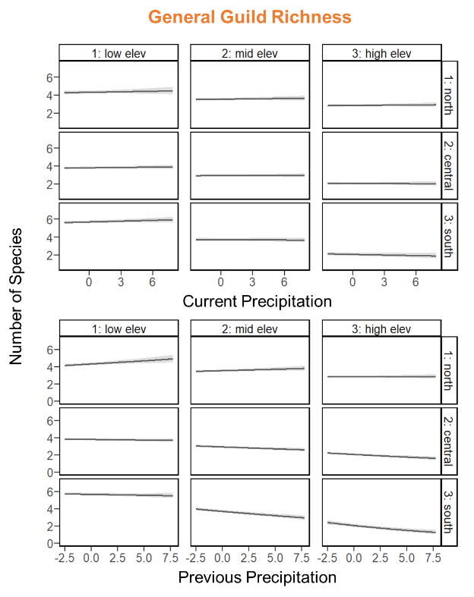

Figure 12. Plots of the three-way interactions between an index of latitude, elevation, and the other predictor variables of interest (Table 2) on the median expected number of species (black line) belonging to each guild (see Appendix A for guild designations and associated forest songbird species), with 95% credible intervals (gray shading). The predictor variables are scaled, such that zero is the mean value, and reflect the range of the data. Because mean breeding season (i.e., 15 May to 30 June) temperature during the year of data collection was highly correlated with latitude, it was used as an index such that the north, central, and south plot rows correspond to the mean breeding season temperatures across all sampling sites in the Hubbard Brook Experimental Forest (14.3°C), Monongahela National Forest (16.3°C), and the 2 North Carolina National Forests (18.6°C), respectively. Meanwhile, the low, mid, and high elevation (elev) plot columns correspond respectively to the 15th, 50th, and 85th percentiles of the elevation data across all sampling sites within the Hubbard Brook Experimental Forest (north; low elev = 461.4 m, mid elev = 609.1 m, high elev = 773.1 m), Monongahela National Forest (central; low elev = 706.7 m, mid elev = 927.3 m, high elev = 1226.4 m), or the 2 North Carolina National Forests (south; low elev = 546.4 m, mid elev = 977.4 m, high elev = 1566.3 m).

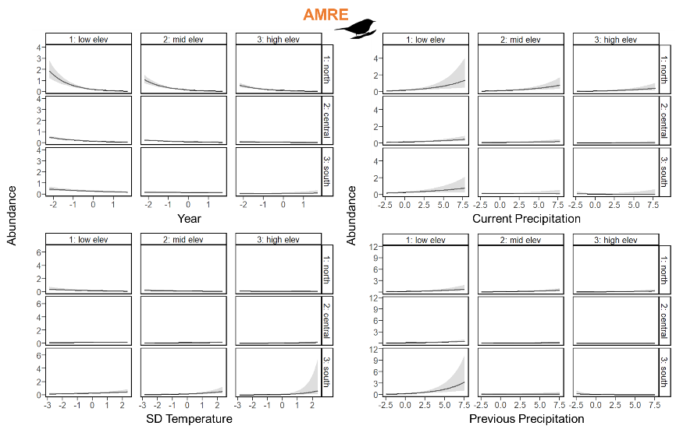

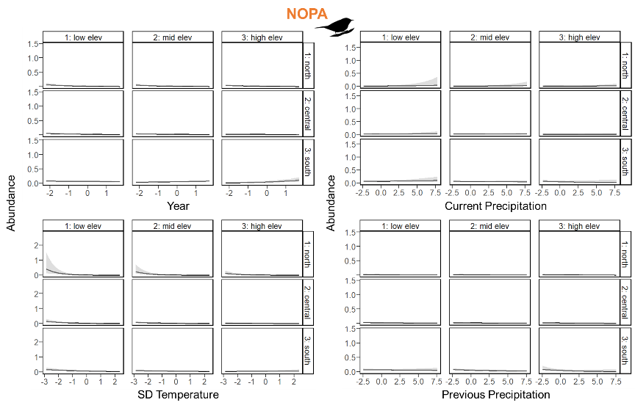

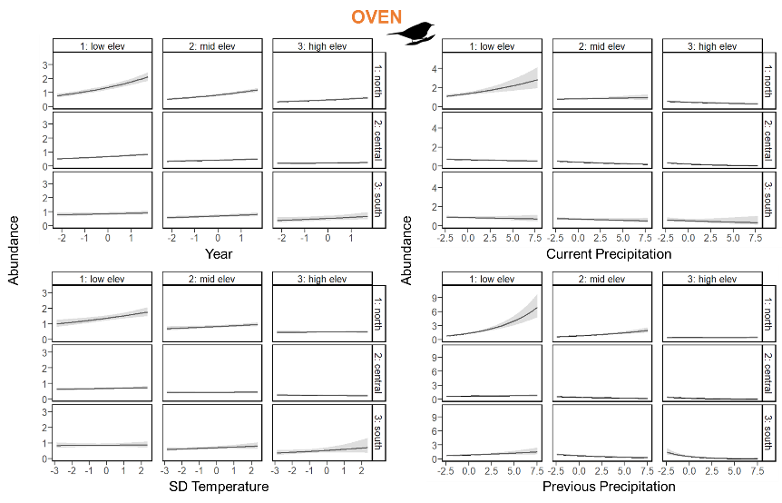

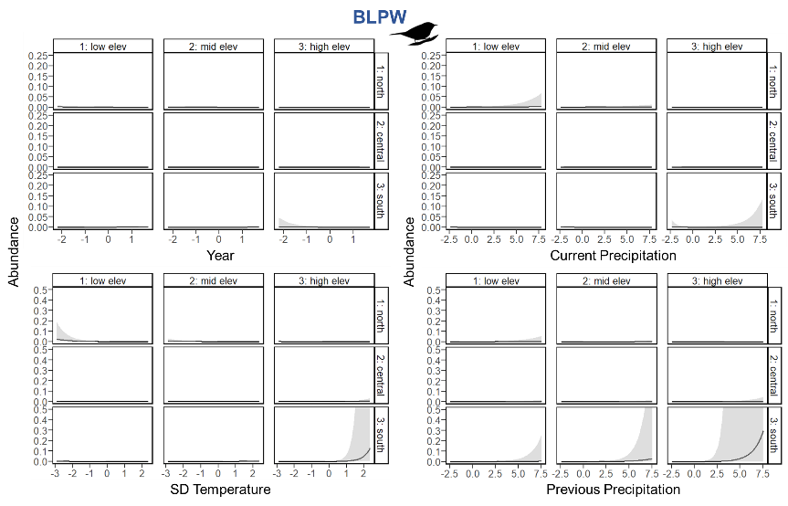

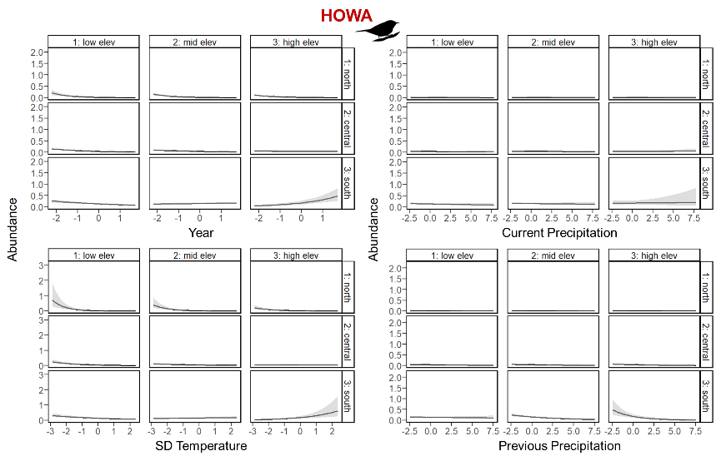

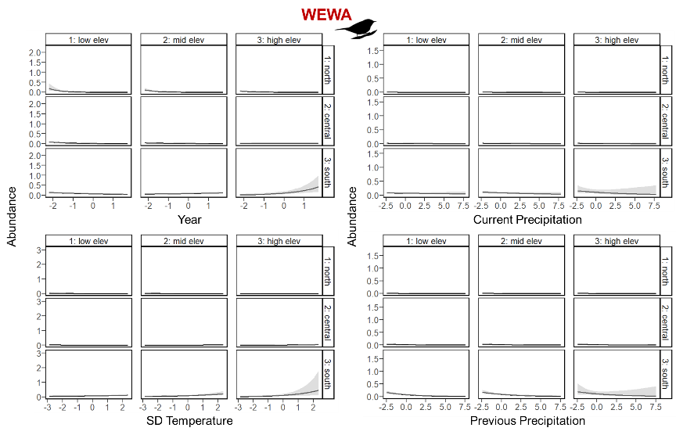

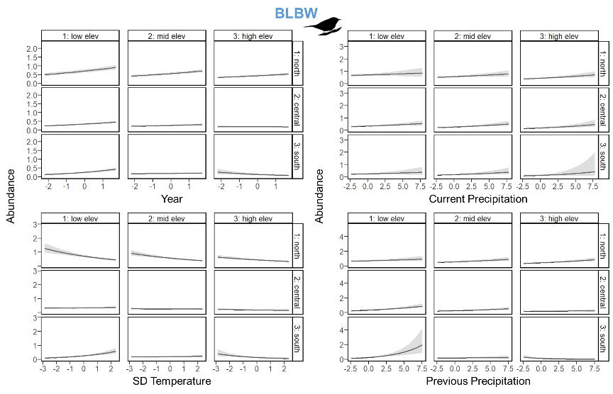

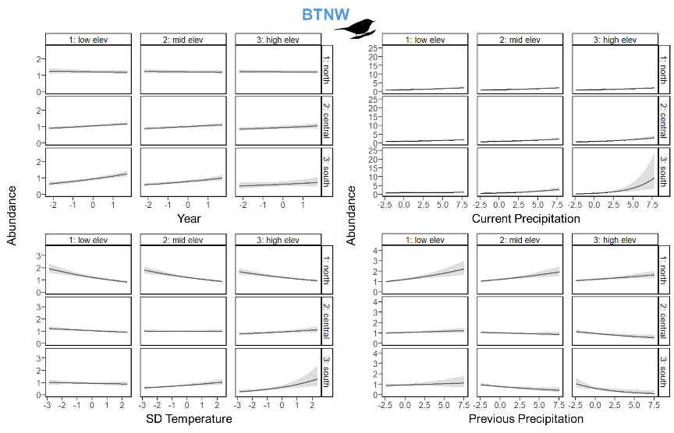

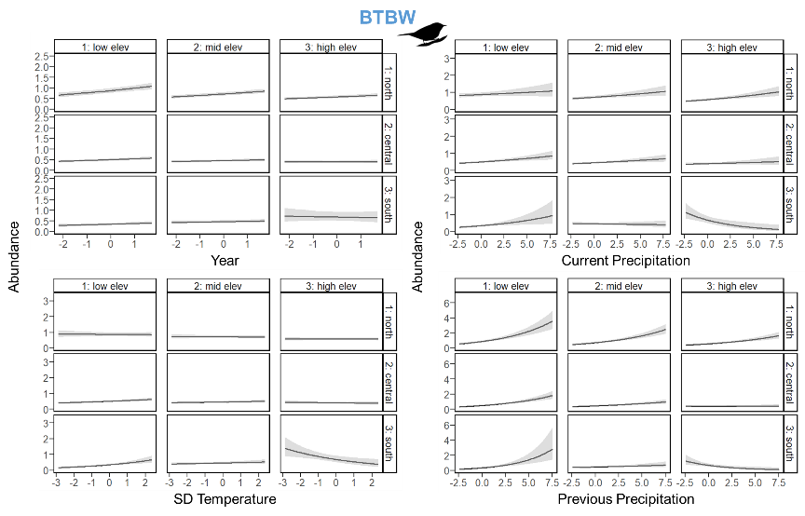

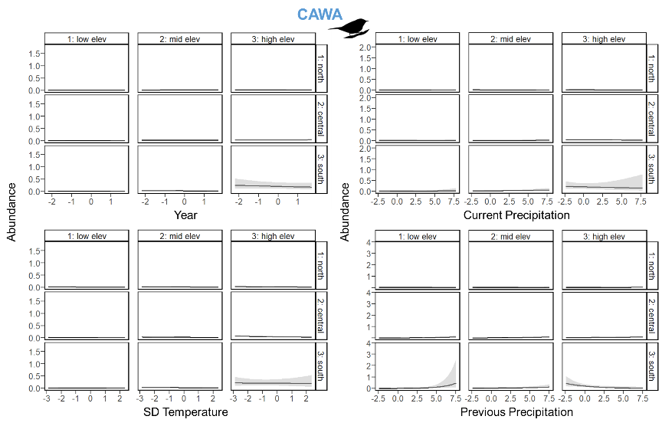

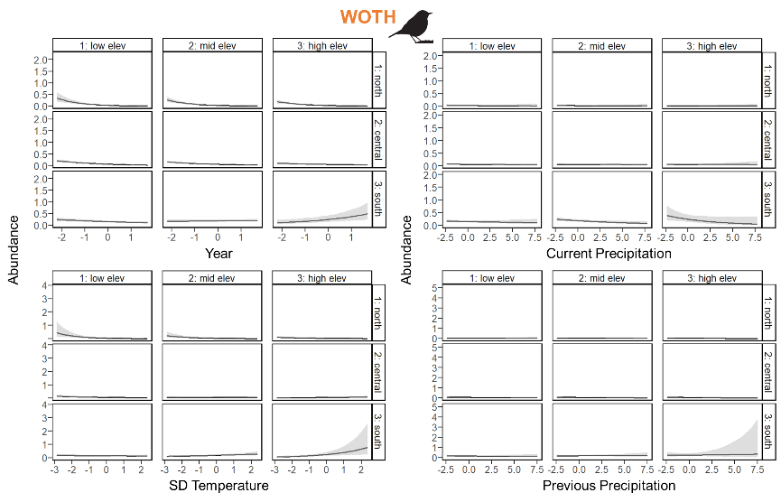

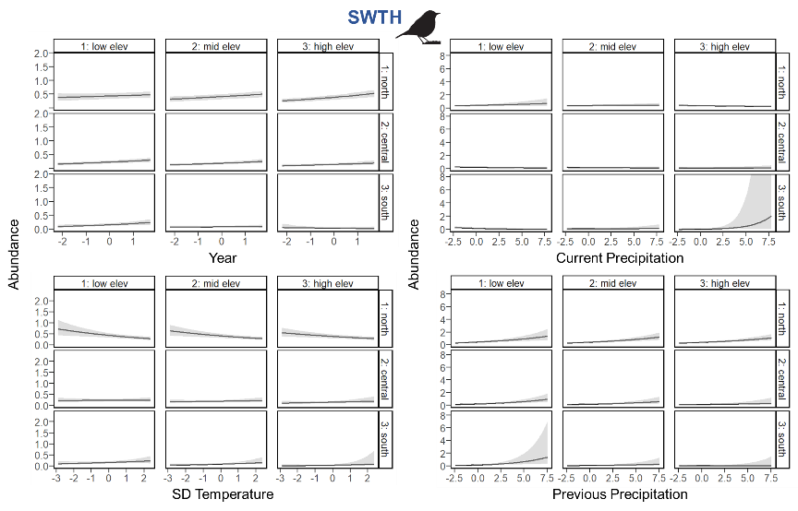

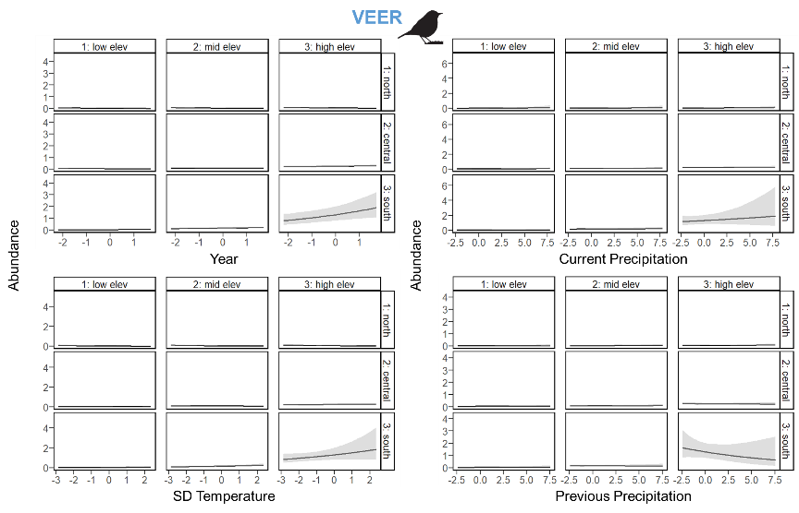

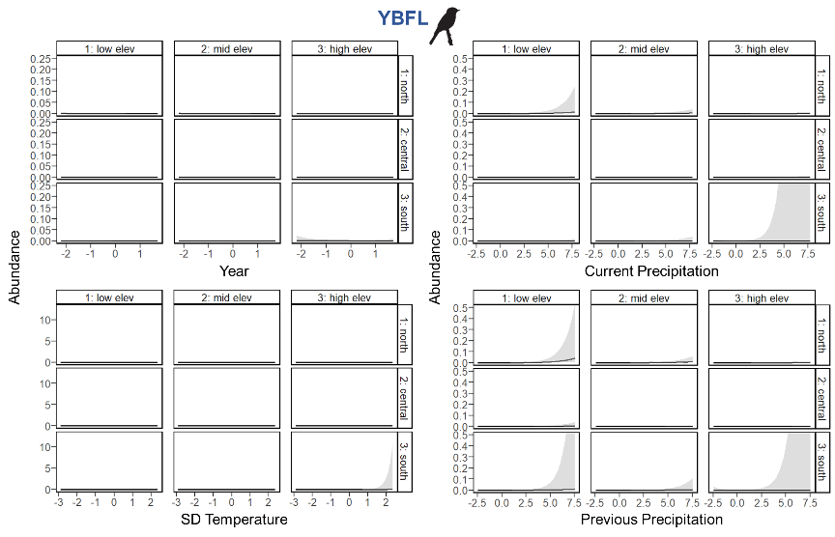

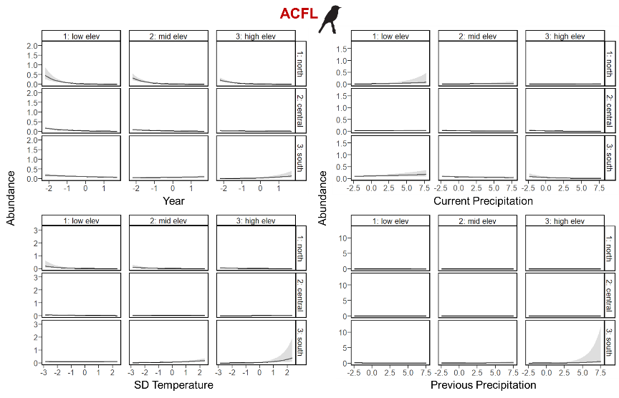

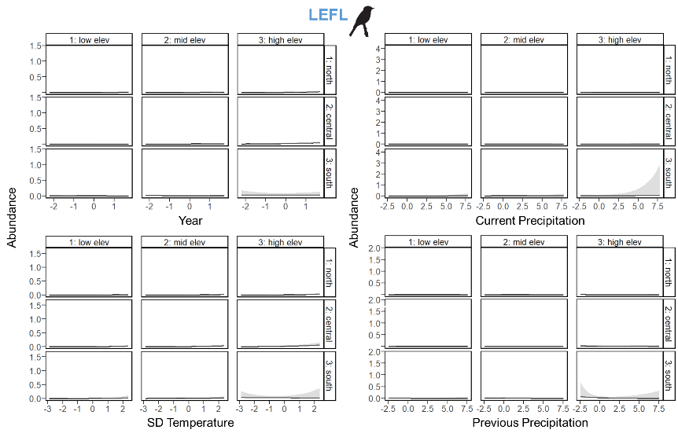

Figure 13. Plots of the three-way interactions between an index of latitude, elevation, and the other predictor variables of interest (Table 2) on the median expected count (i.e., abundance; portrayed by black line) for each of the focal species (Table 1), with 95% credible intervals (gray shading). The predictor variables are scaled, such that zero is the mean value, and reflect the range of the data. Because mean breeding season (i.e., 15 May to 30 June) temperature during the year of data collection was highly correlated with latitude, it was used as an index such that the north, central, and south plot rows correspond to the mean breeding season temperatures across all sampling sites in the Hubbard Brook Experimental Forest (14.3°C), Monongahela National Forest (16.3°C), and the 2 North Carolina National Forests (18.6°C), respectively. Meanwhile, the low, mid, and high elevation (elev) plot columns correspond respectively to the 15th, 50th, and 85th percentiles of the elevation data across all sampling sites within the Hubbard Brook Experimental Forest (north; low elev = 461.4 m, mid elev = 609.1 m, high elev = 773.1 m), Monongahela National Forest (central; low elev = 706.7 m, mid elev = 927.3 m, high elev = 1226.4 m), or the 2 North Carolina National Forests (south; low elev = 546.4 m, mid elev = 977.4 m, high elev = 1566.3 m). Color of the 4-letter species code indicates its guild designation (dark blue = north guild, red = south guild, light blue = trailing guild, and orange = general guild), and the bird silhouette indicates its taxonomic family (warbler, thrush, or flycatcher).

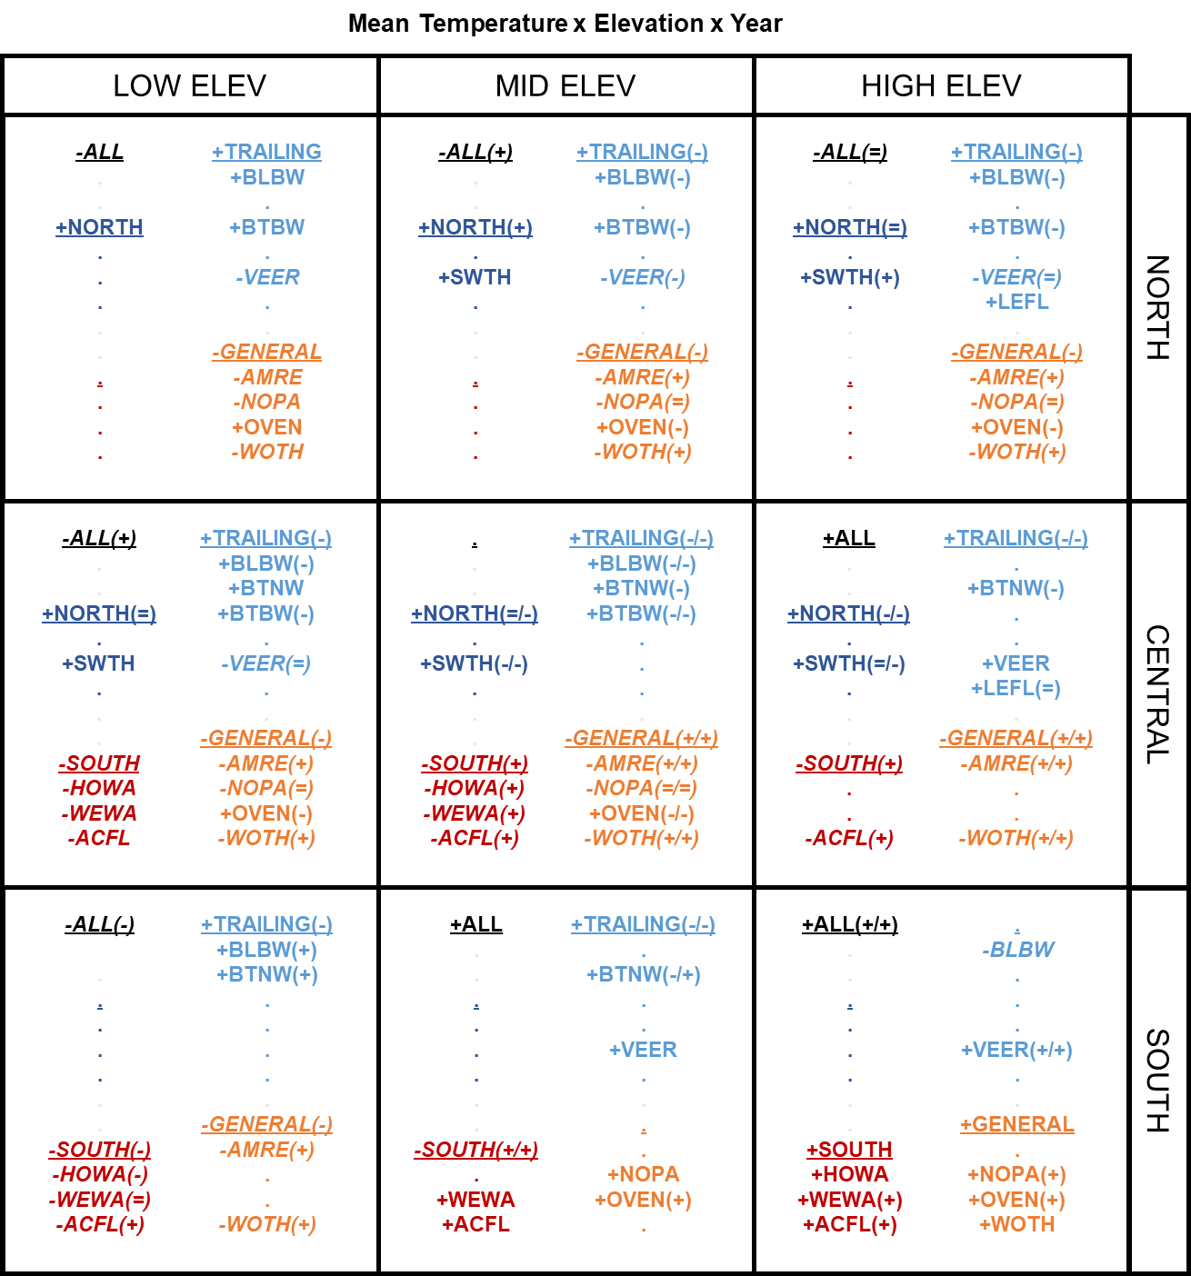

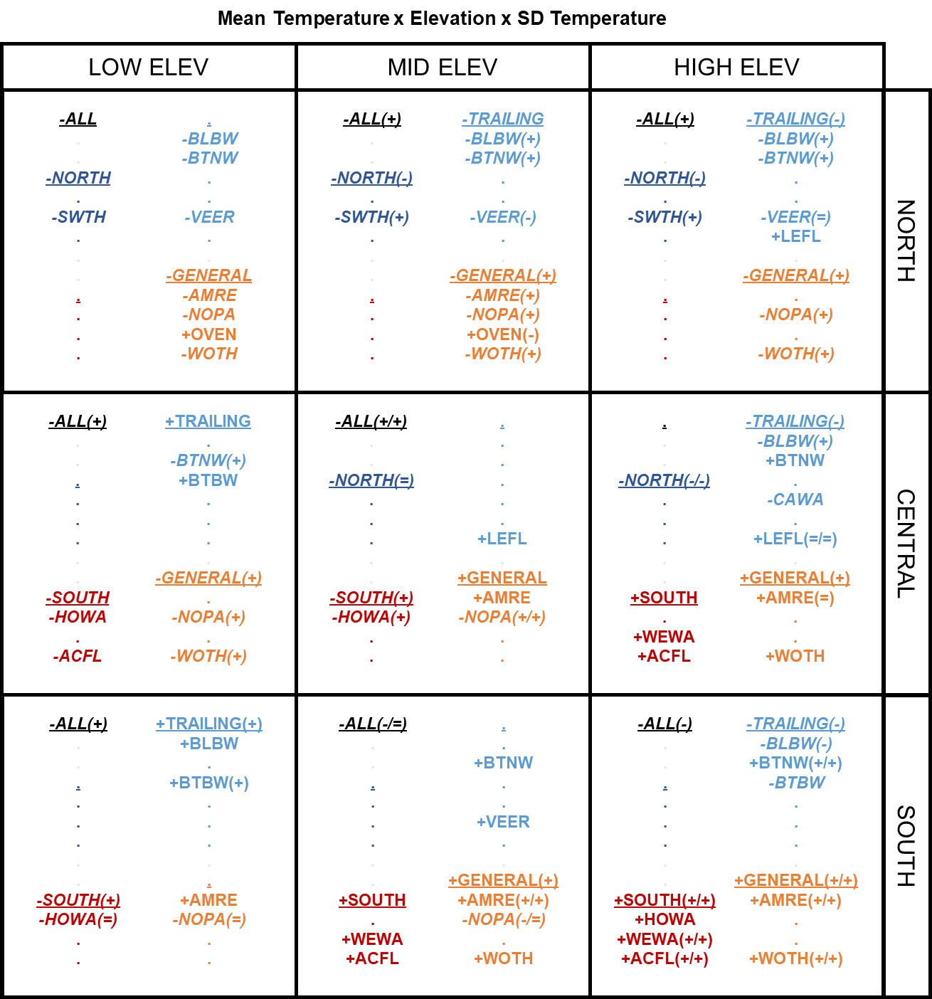

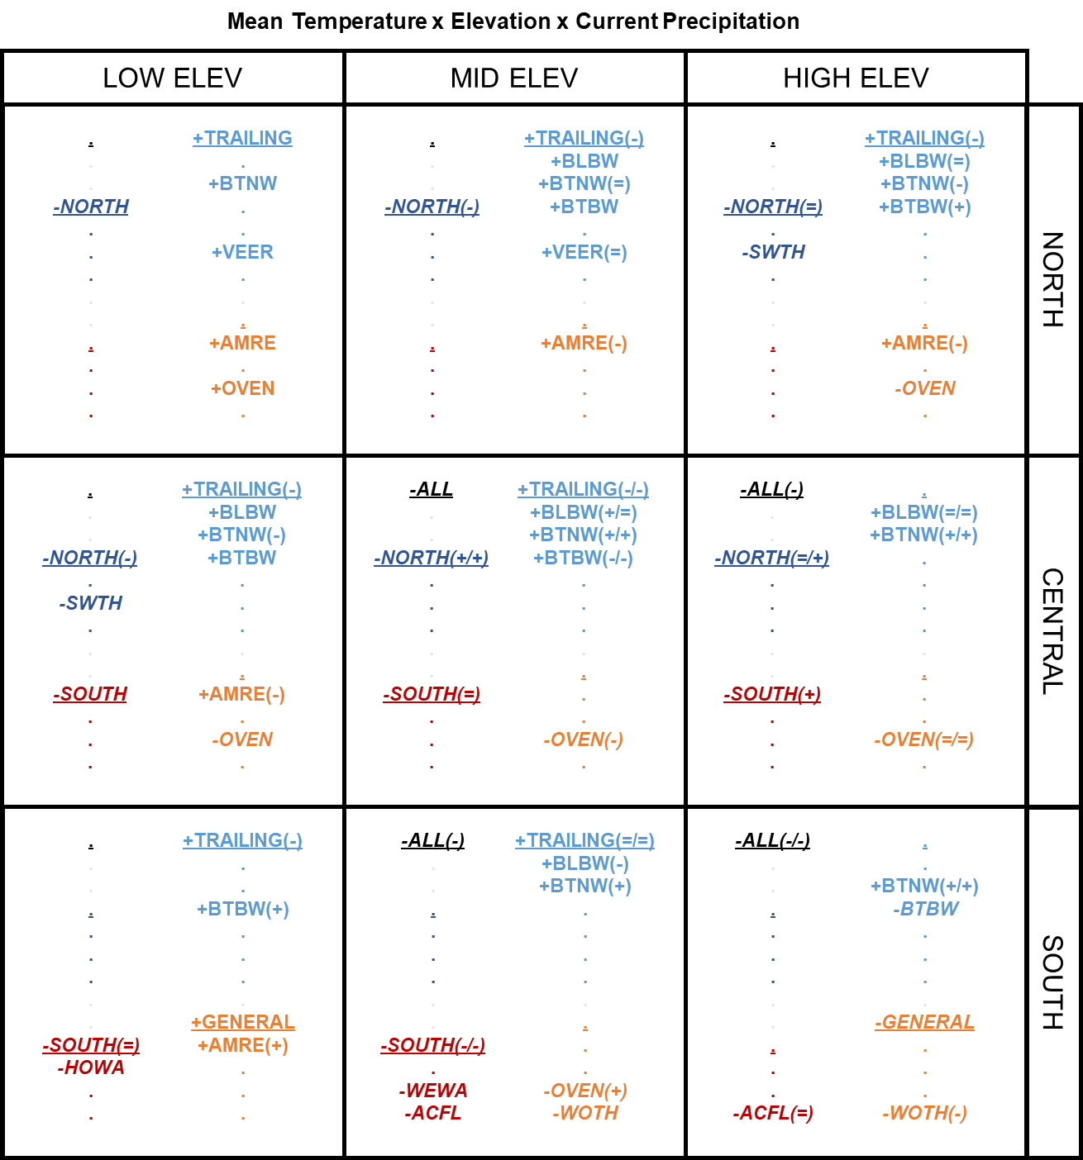

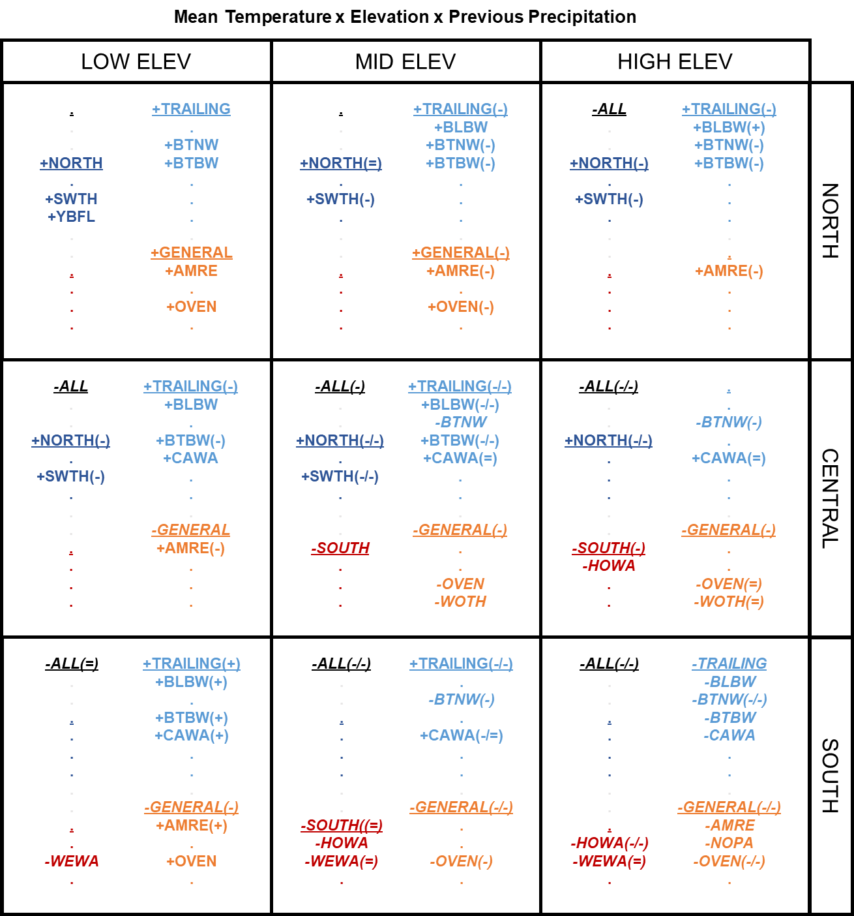

Figure 14. Compilation of combined results for the three-way interactions among an index of latitude, elevation, and year / SD temperature / current precipitation / previous precipitation for all guilds and focal forest songbird species. Because mean breeding season (i.e., 15 May to 30 June) temperature during the year of data collection was highly correlated with latitude, it was used as an index such that the north, central, and south plot rows correspond to the mean breeding season temperatures across all sampling sites in the Hubbard Brook Experimental Forest (14.3°C), Monongahela National Forest (16.3°C), and the 2 North Carolina National Forests (18.6°C), respectively. Meanwhile, the low, mid, and high elevation (elev) plot columns correspond respectively to the 15th, 50th, and 85th percentiles of the elevation data across all sampling sites within the Hubbard Brook Experimental Forest (north; low elev = 461.4 m, mid elev = 609.1 m, high elev = 773.1 m), Monongahela National Forest (central; low elev = 706.7 m, mid elev = 927.3 m, high elev = 1226.4 m), or the 2 North Carolina National Forests (south; low elev = 546.4 m, mid elev = 977.4 m, high elev = 1566.3 m). Guilds and species codes are color-coded and organized by guild designation (black = ALL = overall species richness, dark blue = NORTH = north guild, red = SOUTH = south guild, light blue = TRAILING = trailing guild, and orange = GENERAL = general guild); guilds are additionally underlined. Bold font indicates significance of the slope coefficients for the temporal or climate variables, whereas dots indicate non-significance. Positive slope coefficients are signified with a preceding plus sign, while negative slope coefficients are signified with a preceding minus sign and italicized font. The plus, equal, or minus symbols in the parentheses following the guild or species code indicate whether that slope coefficient was greater than, equal to, or less than the corresponding slope coefficient with the same sign (positive or negative) in the elevational grouping directly to the left (first symbol if 2 present) or in the latitudinal grouping directly above (second symbol if 2 present).

**Appendix A**

Table of the 40 forest songbird species considered in the guild richness analyses.

Table A1. List of the common name, scientific name, 4-letter species code, relative frequency, taxonomic family, and guild designation of all 40 forest songbird species considered for the guild richness analyses. Relative frequency is the number of detections across all point count surveys from all sampling sites in all 3 study regions. The guild designation indicates the extent of the species’ range within the Appalachian Mountains, such that: species in the north guild are only found in the Northern or Central Appalachians; species in the south guild are only found in the Southern or Central Appalachians; species in the trailing guild have trailing-edge populations that are found throughout the Appalachian Mountains but are limited to higher elevations in the Southern Appalachians; and species in the general guild are found throughout the Appalachian Mountains.

|  |  |  |  |  |  |
| --- | --- | --- | --- | --- | --- |
| **Common Name**  **(*Scientific Name*)** | **Species Code** | **Relative Frequency** | **Taxonomic Family** | **Guild Designation** | **Focal Species** |
| Blackpoll warbler  (*Setophaga striata*) | BLPW | 2,220 | Parulidae | north | 1 |
| Swainson's thrush  (*Catharus ustulatus*) | SWTH | 4,465 | Turdidae | north | 1 |
| Yellow-bellied flycatcher  (*Empidonax flaviventris*) | YBFL | 1,360 | Tyrannidae | north | 1 |
| Evening grosbeak  (*Coccothraustes vespertinus*) | EVGR | 64 | Fringillidae | north | 0 |
| Hermit thrush  (*Catharus guttatus*) | HETH | 2,880 | Turdidae | north | 0 |
| Northern waterthrush  (*Parkesia noveboracensis*) | NOWA | 42 | Parulidae | north | 0 |
| Pine siskin  (*Spinus pinus*) | PISI | 125 | Fringillidae | north | 0 |
| Purple finch  (*Haemorhous purpureus*) | PUFI | 554 | Fringillidae | north | 0 |
| Ruby-crowned kinglet  (*Corthylio calendula*) | RCKI | 39 | Regulidae | north | 0 |
| Yellow-rumped warbler  (*Setophaga coronata*) | YRWA | 5,132 | Parulidae | north | 0 |
| Acadian flycatcher  (*Empidonax virescens*) | ACFL | 1,154 | Tyrannidae | south | 1 |
| Hooded warbler  (*Setophaga citrina*) | HOWA | 1,677 | Parulidae | south | 1 |
| Worm-eating warbler  (*Helmitheros vermivorum*) | WEWA | 750 | Parulidae | south | 1 |
| Cerulean warbler  (*Setophaga cerulea*) | CERW | 127 | Parulidae | south | 0 |

Table A1. Continued.

|  |  |  |  |  |  |
| --- | --- | --- | --- | --- | --- |
| **Common Name**  **(*Scientific Name*)** | **Species Code** | **Relative Frequency** | **Taxonomic Family** | **Guild Designation** | **Focal Species** |
| Kentucky warbler  (*Geothlypis formosa*) | KEWA | 42 | Parulidae | south | 0 |
| Swainson's warbler  (*Limnothlypis swainsonii*) | SWWA | 56 | Parulidae | south | 0 |
| Yellow-throated warbler  (*Setophaga dominica*) | YTWA | 93 | Parulidae | south | 0 |
| Blackburnian warbler  (*Setophaga fusca*) | BLBW | 15,776 | Parulidae | trailing | 1 |
| Black-throated blue warbler  (*Setophaga caerulescens*) | BTBW | 21,244 | Parulidae | trailing | 1 |
| Black-throated green warbler  (*Setophaga virens*) | BTNW | 21,055 | Parulidae | trailing | 1 |
| Canada warbler  (*Cardellina canadensis*) | CAWA | 1,807 | Parulidae | trailing | 1 |
| Least flycatcher  (*Empidonax minimus*) | LEFL | 288 | Tyrannidae | trailing | 1 |
| Veery  (*Catharus fuscescens*) | VEER | 1,830 | Turdidae | trailing | 1 |
| Blue-headed vireo  (*Vireo solitarius*) | BHVI | 5,691 | Vireonidae | trailing | 0 |
| Brown creeper  (*Certhia americana*) | BRCR | 2,780 | Certhiidae | trailing | 0 |
| Dark-eyed junco  (*Junco hyemalis*) | DEJU | 4,787 | Passerellidae | trailing | 0 |
| Golden-crowned kinglet  (*Regulus satrapa*) | GCKI | 4,980 | Regulidae | trailing | 0 |
| Red-breasted nuthatch  (*Sitta canadensis*) | RBNU | 2,225 | Sittidae | trailing | 0 |
| Red crossbill  (*Loxia curvirostra*) | RECR | 74 | Fringillidae | trailing | 0 |
| Winter wren  (*Troglodytes hiemalis*) | WIWR | 4,397 | Troglodytidae | trailing | 0 |
| American redstart  (*Setophaga ruticilla*) | AMRE | 1,631 | Parulidae | general | 1 |
| Northern parula  (*Setophaga americana*) | NOPA | 779 | Parulidae | general | 1 |
| Ovenbird  (*Seiurus aurocapilla*) | OVEN | 18,707 | Parulidae | general | 1 |
| Wood thrush  (*Hylocichla mustelina*) | WOTH | 1,095 | Turdidae | general | 1 |
| Black-and-white warbler  (*Mniotilta varia*) | BAWW | 2,201 | Parulidae | general | 0 |

Table A1. Continued.

|  |  |  |  |  |  |
| --- | --- | --- | --- | --- | --- |
| **Common Name**  **(*Scientific Name*)** | **Species Code** | **Relative Frequency** | **Taxonomic Family** | **Guild Designation** | **Focal Species** |
| Louisiana waterthrush  (*Parkesia motacilla*) | LOWA | 171 | Parulidae | general | 0 |
| Pine warbler  (*Setophaga pinus*) | PIWA | 249 | Parulidae | general | 0 |
| Red-eyed vireo  (*Vireo olivaceus*) | REVI | 20,618 | Vireonidae | general | 0 |
| Scarlet tanager  (*Piranga olivacea*) | SCTA | 2,798 | Cardinalidae | general | 0 |
| White-breasted nuthatch  (*Sitta carolinensis*) | WBNU | 1,194 | Sittidae | general | 0 |

**Appendix B**

JAGS model code for the guild richness analyses

model {

### PRIORS

# COMMUNITY-LEVEL MODEL PARAMETERS (JUST FOR OCCUPANCY)

community.occupancy.a ~ dlogis(0,1) #this assumes a logistic prior

community.occupancy.tau ~ dgamma(1,1)

# COMMUNITY-LEVEL PARAMETERS FOR SITE COVARIATE SLOPE COEFFICIENTS

for (sitecov in 1:n.sitecovs) {

mu.alpha[sitecov] ~ dnorm(0, 0.1)

tau.alpha[sitecov] ~ dgamma(1,1)

}

# COMMUNITY-LEVEL PARAMETERS FOR DETECTION COVARIATE SLOPE COEFFICIENTS

for (detcov in 1:n.detcovs) {

mu.beta[detcov] ~ dnorm(0, 0.1)

tau.beta[detcov] ~ dgamma(1,1)

}

# SPECIES-SPECIFIC PRIORS FROM THE COMMUNITY-LEVEL PRIOR DISTRIBUTIONS

for (species in 1:n.species) {

# INTERCEPTS

alpha0[species] ~ dnorm(community.occupancy.a, community.occupancy.tau)

beta0[species] ~ dnorm(0, 0.1)

# SLOPE COEFFICIENTS FOR SITE COVARIATES

for (sitecov in 1:n.sitecovs) {

alpha[species, sitecov] ~ dnorm(mu.alpha[sitecov], tau.alpha[sitecov])

}

# SLOPE COEFFICIENTS FOR DETECTION COVARIATES

for (detcov in 1:n.detcovs) {

beta[species, detcov] ~ dnorm(mu.beta[detcov], tau.beta[detcov])

}

}

# NOTES: Loop over all species.

# PARAMETERS FOR IMPUTATION OF DETECTION COVARIATES

for (region in 1:n.regions) {

# TIME

time.mu[region] ~ dnorm(0, 1) #NOTE: Normal distribution

time.tau[region] ~ dgamma(1, 1)

# WIND CODE

wind.prob[region] ~ dbeta(1, 1)

# SKY CODE

sky.prob[region] ~ dbeta(1, 1)

}

# NOTES: Loop over each study region.

### LIKELIHOOD

# IMPUTATION OF DETECTION COVARIATES

for (site in 1:n.sites){

for (year in 1:n.years[site]) {

for (replicate in 1:n.replicates[site, year]) {

time[site, year, replicate] ~ dnorm(time.mu[region[site]],

time.tau[region[site]])

wind[site, year, replicate] ~ dbern(wind.prob[region[site]])

sky[site, year, replicate] ~ dbern(sky.prob[region[site]])

}

}

}

# NOTES: Loop over sites, years, and replicates.

for (species in 1:n.species) {

# Loop to estimate the Z matrix (true site occurrence) for each species at

# each site

for (site in 1:n.sites){

for (year in 1:n.years[site]) {

# OCCUPANCY MODEL

logit(psi[site, year, species]) <- alpha0[species] +

inprod(alpha[species, 1:n.sitecovs],

sitecov.array[site, year, 1:n.sitecovs])

# ESTIMATING OCCUPANCY

Z[site, year, species] ~ dbern(psi[site, year, species])

# Loop to estimate detection each species at each site during each

# sampling replicate

for (replicate in 1:n.replicates[site, year]) {

# DETECTION MODEL

logit(p[site, year, replicate, species]) <- beta0[species] +

beta[species, 1] * day[site, year, replicate] +

beta[species, 2] * time[site, year, replicate] +

beta[species, 3] * wind[site, year, replicate] +

beta[species, 4] * sky[site, year, replicate]

# MODEL PROBABILITY OF DETECTION FOR 1 MINUTE

p.adjusted[site, year, replicate, species] <- 1 - (1 –

p[site, year, replicate, species]) ^ exponent.array[site,

year, replicate]

# ESTIMATING PROBABILITY OF DETECTION

mu.p[site, year, replicate, species] <- p.adjusted[site, year,

replicate, species] * Z[site, year, species]

Y[site, year, replicate, species] ~ dbern(mu.p[site, year,

replicate, species])

}

# NOTES: Loop over each replicate for each site (variable number of

# replicates depending on site and year).

} #end year loop

} #end site loop

} #end species loop

### DERIVED QUANTITIES

# Loop to determine site-level richness estimates for the whole community and # for subsets or assemblages of interest per year

for (site in 1:n.sites) {

for (year in 1:n.years[site]) {

site.species.richness[site, year] <- sum(Z[site, year, 1:n.species])

north.guild.richness[site, year] <- inprod(Z[site, year, 1:n.species],

north.guild[1:n.species])

south.guild.richness[site, year] <- inprod(Z[site, year, 1:n.species],

south.guild[1:n.species])

trailing.guild.richness[site, year] <- inprod(Z[site, year,

1:n.species], trailing.guild[1:n.species])

general.guild.richness[site, year] <- inprod(Z[site, year,

1:n.species], general.guild[1:n.species])

}

}

}

**Appendix C**

JAGS model code for the focal species analyses

model {

### PRIORS

for (species in 1:n.species) {

# INTERCEPTS

alpha0[species] ~ dnorm(0, 0.01) #intercept for abundance model

#(site covariates)

beta0[species] ~ dnorm(0, 0.01) #intercept for detection model

#(detection covariates)

# RANDOM SITE EFFECT

tau.rse[species] ~ dgamma(0.01, 0.01) #for random site effects

for (site in 1:n.sites){

random.site.effect[species, site] ~ dnorm(alpha0[species],

tau.rse[species]) #for random site effects

}

# NOTES: Loop over the number of unique sites

# SLOPE COEFFICIENTS FOR SITE COVARIATES

for (alpha.index in 1:n.alphas) {

alpha[species, alpha.index] ~ dnorm(0, 0.01)

#create a slope coefficient for each site covariate in the abundance

#model

}

# SLOPE COEFFICIENTS FOR DETECTION COVARIATES

for (detcov in 1:n.detcovs) {

beta[species, detcov] ~ dnorm(0, 0.01)

#create a slope coefficient for each detection covariate in the

#detection model

}

}

# NOTES: Loop over each focal species.

# PARAMETERS FOR IMPUTATION OF DETECTION COVARIATES

for (region in 1:n.regions) {

# TIME

time.mu[region] ~ dnorm(0, 0.01)

time.tau[region] ~ dgamma(0.1, 0.1)

# NOTE: Normal distribution.

# WIND CODE

wind.prob[region] ~ dbeta(1, 1)

# SKY CODE

sky.prob[region] ~ dbeta(1, 1)

}

# NOTES: Loop over each study region.

### LIKELIHOOD

# IMPUTATION OF DETECTION COVARIATES

for (site in 1:n.sites){

for (year in 1:n.years[site]) {

for (visit in 1:n.visits[site,year]) {

time[site, year, visit] ~ dnorm(time.mu[region[site]],

time.tau[region[site]])

wind[site, year, visit] ~ dbern(wind.prob[region[site]])

sky[site, year, visit] ~ dbern(sky.prob[region[site]])

}

}

}

# NOTES: Loop over sites, years, and visits.

# ESTIMATE ABUNDANCE AND DETECTION PROBABILITY

for (species in 1:n.species) {

# Loop to estimate N (true abundance) for each species at each site

for (site in 1:n.sites) {

for (year in 1:n.years[site]) {

# ABUNDANCE MODEL

log(lambda[site, year, species]) <- alpha[species, 1] *

sitecov.array[site, year, 1] + #year

alpha[species, 2] * sitecov.array[site, year, 2] + #elevation

alpha[species, 3] * sitecov.array[site, year, 3] + #aspect

alpha[species, 4] * sitecov.array[site, year, 4] + #TPI

alpha[species, 5] * sitecov.array[site, year, 5] +

#dominant forest type == Deciduous

alpha[species, 6] * sitecov.array[site, year, 6] +

#proportion of forest within 1 km

alpha[species, 7] * sitecov.array[site, year, 7] +

#mean current temperature

alpha[species, 8] * sitecov.array[site, year, 8] +

#SD temperature

alpha[species, 9] * sitecov.array[site, year, 9] +

#total current precip

alpha[species, 10] * sitecov.array[site, year, 10] +

#total previous precip

alpha[species, 11] * sitecov.array[site, year, 2] *

sitecov.array[site, year, 1] + #elevation x year

alpha[species, 12] * sitecov.array[site, year, 2] *

sitecov.array[site, year, 7] +

#elevation x mean current temperature

alpha[species, 13] * sitecov.array[site, year, 2] *

sitecov.array[site, year, 8] + #elevation x SD temperature

alpha[species, 14] * sitecov.array[site, year, 2] *

sitecov.array[site, year, 9] +

#elevation x total current precip

alpha[species, 15] * sitecov.array[site, year, 2] *

sitecov.array[site, year, 10] +

#elevation x total previous precip

alpha[species, 16] * sitecov.array[site, year, 7] *

sitecov.array[site, year, 1] +

#mean current temperature x year

alpha[species, 17] * sitecov.array[site, year, 7] *

sitecov.array[site, year, 8] +

#mean current temperature x SD temperature

alpha[species, 18] * sitecov.array[site, year, 7] *

sitecov.array[site, year, 9] +

#mean current temperature x total current precip

alpha[species, 19] * sitecov.array[site, year, 7] *

sitecov.array[site, year, 10] +

#mean current temperature x total previous precip

alpha[species, 20] * sitecov.array[site, year, 2] *

sitecov.array[site, year, 7] * sitecov.array[site, year, 1] + #elevation x mean current temperature x year

alpha[species, 21] * sitecov.array[site, year, 2] *

sitecov.array[site, year, 7] * sitecov.array[site, year, 8] + #elevation x mean current temperature x SD temperature

alpha[species, 22] * sitecov.array[site, year, 2] *

sitecov.array[site, year, 7] * sitecov.array[site, year, 9] + #elevation x mean current temperature x total current precip

alpha[species, 23] * sitecov.array[site, year, 2] *

sitecov.array[site, year, 7] * sitecov.array[site, year, 10] + #elevation x mean current temperature x total previous precip

random.site.effect[species, site] #random site effect

# ESTIMATING ABUNDANCE

N[site, year, species] ~ dpois(lambda[site, year, species])

for (visit in 1:n.visits[site,year]) {

# OBSERVATION PROBABILITY

Y[site, year, visit, 1, species] ~ dbin(p.adjusted[site, year,

visit, 1, species], N[site, year, species])

z[site, year, visit, 1, species] <- N[site, year, species] –

Y[site, year, visit, 1, species]

for (i in 2:3) {

Y[site, year, visit, i, species] ~ dbin(p.adjusted[site, year,

visit, i, species], z[site, year, visit, i-1, species])

z[site, year, visit, i, species] <- N[site, year, species] –

sum(Y[site, year, visit, 1:i, species])

}

# Loop to estimate detection each species at each site during

# each sampling replicate

for (replicate in 1:3) {

# DETECTION MODEL

logit(p[site, year, visit, replicate, species]) <-

beta0[species] + beta[species, 1] * day[site, year, visit] + beta[species, 2] * time[site, year, visit] +

beta[species, 3] * wind[site, year, visit] +

beta[species, 4] * sky[site, year, visit]

# MODEL PROBABILITY OF DETECTION FOR 1 MINUTE

p.adjusted[site, year, visit, replicate, species] <- 1 - (1 –

p[site, year, visit, replicate, species]) ^ exponent.array[site, year, visit, replicate]

}

# NOTES: Loop over each replicate for each site (variable number

# of replicates depending on site and year).

} # end visit loop

} #end year loop

} # end site loop

} # end site loop

}

**Appendix D**

Table of model information for overall species richness, the 4 guild designations, and the 16 focal forest songbird species considered in the guild richness and focal species analyses.

Table D1. List of the 4 guild designations and 16 focal forest songbird species (sorted by guild and family), with corresponding model information that includes the number of chains (Chains), total iterations (Total), burn-in (Burn), thinning rate (Thin), and resulting posterior iterations (Posterior).

|  |  |  |  |  |  |  |  |
| --- | --- | --- | --- | --- | --- | --- | --- |
| **Guild** | **Family** | **Species** | **Chains** | **Total** | **Burn-In** | **Thin** | **Posterior** |
| ALL |  |  | 3 | 3,500 | 2,500 | 1 | 3,000 |
| NORTH | |  | 3 | 3,500 | 2,500 | 1 | 3,000 |
|  | Parulidae | BLPW | 3 | 34,000 | 31,000 | 3 | 3,000 |
|  | Turdidae | SWTH | 3 | 19,000 | 16,000 | 3 | 3,000 |
|  | Tyrannidae | YBFL | 3 | 30,000 | 27,000 | 3 | 3,000 |
| SOUTH | |  | 3 | 3,500 | 2,500 | 1 | 3,000 |
|  | Parulidae | HOWA | 3 | 19,000 | 16,000 | 3 | 3,000 |
|  | Parulidae | WEWA | 3 | 14,000 | 11,000 | 3 | 3,000 |
|  | Tyrannidae | ACFL | 3 | 34,000 | 31,000 | 3 | 3,000 |
| TRAILING | |  | 3 | 3,500 | 2,500 | 1 | 3,000 |
|  | Parulidae | BLBW | 3 | 5,000 | 2,000 | 3 | 3,000 |
|  | Parulidae | BTNW | 3 | 5,000 | 2,000 | 3 | 3,000 |
|  | Parulidae | BTBW | 3 | 5,000 | 2,000 | 3 | 3,000 |
|  | Parulidae | CAWA | 3 | 23,000 | 20,000 | 3 | 3,000 |
|  | Turdidae | VEER | 3 | 19,000 | 16,000 | 3 | 3,000 |
|  | Tyrannidae | LEFL | 3 | 20,000 | 17,000 | 3 | 3,000 |
| GENERAL | |  | 3 | 3,500 | 2,500 | 1 | 3,000 |
|  | Parulidae | AMRE | 3 | 23,000 | 20,000 | 3 | 3,000 |
|  | Parulidae | NOPA | 3 | 14,000 | 11,000 | 3 | 3,000 |
|  | Parulidae | OVEN | 3 | 5,000 | 2,000 | 3 | 3,000 |
|  | Turdidae | WOTH | 3 | 23,000 | 20,000 | 3 | 3,000 |

**Appendix E**

Comparison of temporal trends in focal forest songbird species abundance from my study results and 2 public datasets.

Table E1. Comparison of temporal trends in the abundance of the 16 focal forest songbird species (grouped by climate-related guild designation; Table 1) from my study results (SR), 1993–2019 North American Breeding Bird Survey data (BBS), and 2007–2021 eBird trends data (EB). The significance (determined using 95% credible intervals) and direction (positive or negative) of the temporal trend is indicated by color (gold = increasing, blue = decreasing) and capitalization (all uppercase = significant, all lowercase = not significant). Significance was not available for the EB data. No relationship is indicated by a 0, and unavailable or inapplicable trends are denoted with triple dash symbol. FULL refers to the Northern, Central, and Southern Appalachians for the SR data, the Atlantic Northern Forest Bird Conservation Region and Appalachian Mountains Bird Conservation Region for the BBS data, and the Appalachian Mountains region (Figure 1) for the EB data. NORTH / CENTRAL / SOUTH refers to the Northern / Central / South Appalachians for the SR data, the states of NH / WV / NC for the BBS data, and the regions encompassing and surrounding the HBEF / MNF / NCNF for the EB data.

|  |  |  |  |  |  |  |  |  |  |  |  |  |
| --- | --- | --- | --- | --- | --- | --- | --- | --- | --- | --- | --- | --- |
| **Species** | **FULL** | | | **NORTH** | | | **CENTRAL** | | | **SOUTH** | | |
|  | SR | BBS | EB | SR | BBS | EB | SR | BBS | EB | SR | BBS | EB |
| BLPW | **INC** | dec | --- | 0 | **DEC** | --- | --- | --- | --- | --- | --- | --- |
| SWTH | **INC** | dec | dec | **INC** | inc | 0 | **INC** | inc | dec | --- | --- | --- |
| YBFL | dec | **DEC** | --- | 0 | **DEC** | --- | --- | --- | --- | --- | --- | --- |
| HOWA | **DEC** | **INC** | dec | --- | --- | --- | **DEC** | dec | dec | 0 | dec | inc |
| WEWA | **DEC** | inc | dec | --- | --- | --- | **DEC** | **DEC** | dec | inc | inc | dec |
| ACFL | **DEC** | **DEC** | dec | --- | --- | --- | **DEC** | **DEC** | dec | inc | dec | inc |
| BLBW | **INC** | **DEC** | 0 | **INC** | dec | inc | **INC** | inc | inc | **INC** | dec | 0 |
| BTNW | **INC** | dec | dec | dec | **DEC** | dec | **INC** | **inc** | 0 | **INC** | **inc** | inc |
| BTBW | **INC** | dec | dec | **INC** | dec | dec | **INC** | dec | 0 | inc | dec | dec |
| CAWA | dec | **DEC** | dec | 0 | **DEC** | 0 | 0 | dec | 0 | 0 | dec | dec |
| VEER | **DEC** | **DEC** | dec | **DEC** | **DEC** | dec | **DEC** | inc | dec | **INC** | inc | dec |
| LEFL | **INC** | **DEC** | dec | **INC** | **DEC** | dec | 0 | dec | dec | 0 | dec | dec |
| AMRE | **DEC** | dec | dec | **DEC** | dec | dec | **DEC** | inc | 0 | dec | **DEC** | 0 |
| NOPA | **DEC** | **INC** | inc | **DEC** | **INC** | **INC** | **DEC** | dec | inc | **INC** | **DEC** | inc |
| OVEN | **INC** | inc | dec | **INC** | **DEC** | dec | **INC** | dec | inc | **INC** | dec | 0 |
| WOTH | **DEC** | **DEC** | 0 | **DEC** | **DEC** | dec | **DEC** | **DEC** | inc | 0 | **DEC** | inc |